Đề thi tiếng Anh lớp 5 cuối học kì 2 năm 2020 - Đề 3
I. Find the word which has a different sound in the underlined part
1. A. bean | B. tea | C. wear | D. pea
2. A. skip | B. picnic | C. tennis | D. pastime
3. A. gram | B. packet | C. cake | D. can
II. Choose the odd one out:
1. A. face | B. eye | C. month | D. leg
2. A. sing | B. song | C. draw | D. read
III. Look at the pictures and write
1. My father is a(n) _______ | 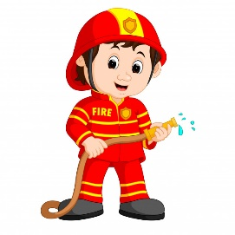
2. The little boy is _____________ at the moment | 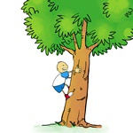
3. Would you like a(n) __________?
4. Those are his ________
5. My brother can _________ | 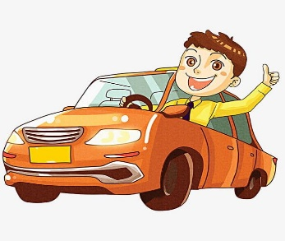
IV. Put a correct preposition in each blank
1. Lan is standing near the store and she is waiting _______the bus
2. I agree _____you about that
3. I have English _____Wednesday and Friday
4. Look ____the picture _____ the wall, please!
5. My father works for a company _____Monday _______ Friday
V. Choose the best answer A, B, C or D
1. Quan is in the bed and feels very hot. He has _________
A. backache B. fever C. toothache D. stomachache
2. That is Kien. He is a _______
A. engineer B. doctors C. teachers D. student
3. My father and my mother _____ in the living room
A. Is B. Are C. Am D. Isn’t
4. How many people are there in ______family?
A. Your B. You C. Yours D. Be
5. I go skating ______ a week
A. One B. Two C. Twice D. Second

VI. Read the passage and answer the question
Next month, Quan and his friends are going to Ha Long Bay. They are going to travel by bus. They are going to stay in a hotel and have seafood there. They are going to swim and takes photos. Furthermore, they are going to buy some souvenirs for their families and friends.
1. When are Quan and his friends going to go?
_______________________________
2. Where are they going to go?
_______________________________
3. How are they going to travel?
_______________________________
4. Are they going to stay in a house?
_______________________________
5. Who are they going to buy some souvenirs for?
_______________________________
VII. Reorder the words to have correct sentences:
- here/ far/ is/ How/ it/ from/?
……………………………………………………………………………………………………………….
- What/ your/ brother/ do/ does/ the/ spring/ in/?
……………………………………………………………………………………………………………….
- you/ What/ doing/ are/ stove/ with/ the/ ?
……………………………………………………………………………………………………………….
- going/ I’m/ food/ cook/ to/ some/.
……………………………………………………………………………………………………………….
- any/ street/ There/ the/ aren’t/ on/ trees.
……………………………………………………………………………………………………………….

