ENGLISH 6 – REVISION FOR THE FINAL TEST
PART A: THEORY

I. Vocabulary

- TV programmes

- Sports and games

- Cities and landmarks

- Types of houses and appliances in the house

- Things that can be reduced, reused and recycled.

II. Pronunciation

- sound /θ/ and / ð/

- sound /e/ and /æ/

- sound /əʊ/ and /aʊ/

- Stress in two - syllable words

III. Grammar
- Wh – question : câu hỏi Wh- question
- What: Cái gì - Things
- Where: Ở đâu - Places
- When: Khi nào - Time
- Why: Tại sao - Reasons
- Which: Lựa chọn - Choices
- Who: Ai - Subject
- Whom: Ai - Object
- Whose: Của ai - Possession
- How: Như thế nào - Manner, process
- Conjunctions in compound sentences : Liên từ nối
Conjunctions (các từ nối): and, but, because, or, so, therefore, however có chức năng nối các từ, các mệnh đề, các câu lại với nhau.
- The past simple tense: Thì quá khứ đơn
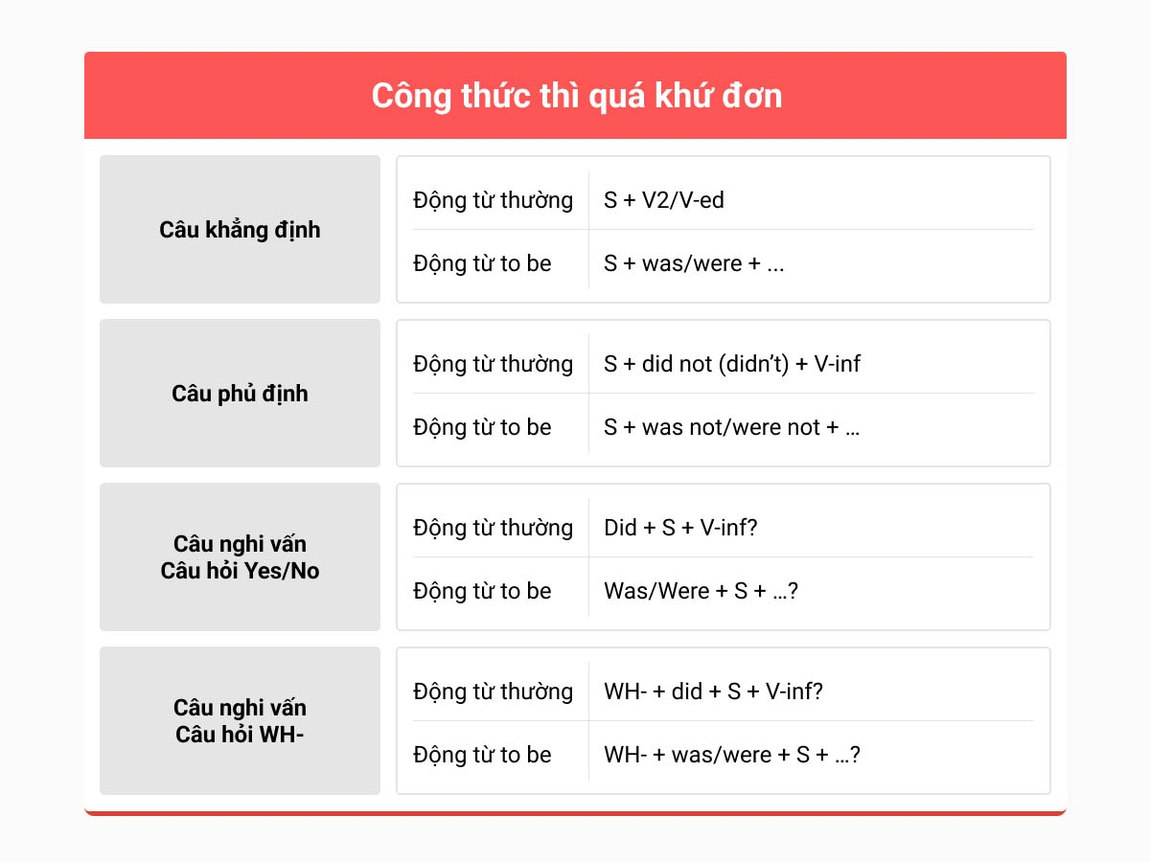
Dấu hiệu nhận biết thì quá khứ đơn:

- yesterday (hôm qua)

- last night/ last week/ last month/ last year (tối qua/ tuần trước/ tháng trước/ năm ngoái)

- ago: cách đây (two hours ago: cách đây 2 giờ/ two weeks ago: cách đây 2 ngày …)

- when: khi (trong câu kể)
5. Imperatives : so sánh

6. Possessive adjectives : tính từ sở hữu

7. Posessive pronouns : Đại từ sở hữu
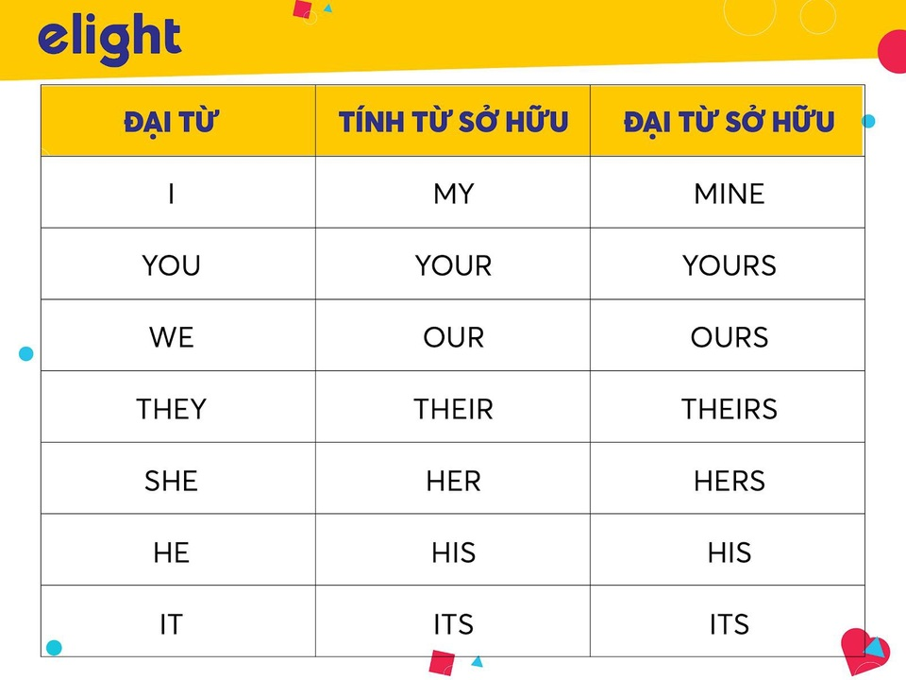
8. Future simple tense : tương lai đơn
Khẳng định: S+ will + V1
Phủ định: S + won’t + V1
Nghi vấn: Will + S + V1?

- Might for possibility
Khẳng định: S+ might + V1
Phủ định: S + might not + V1
Nghi vấn: Might+ S + V1?

9. Articles; a, an, the
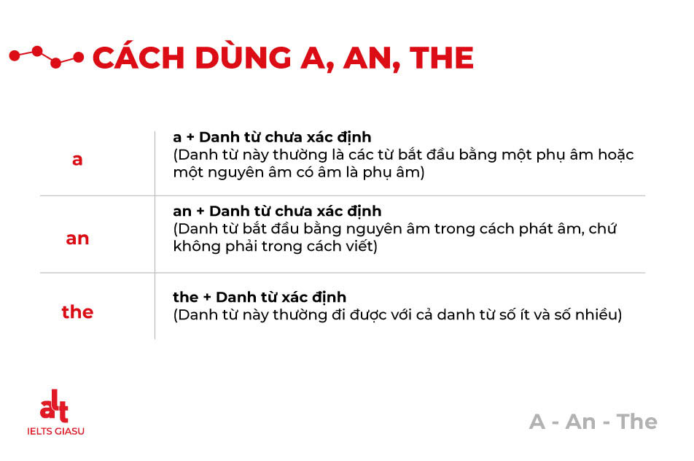
10. Conditional sentence type 1: câu điều kiện loại 1
If + S + V (s,es), S + will + V nguyên thể
PART B: PRACTICE
I. PRONUNCIATION
Find the word which has a different sound in the part underlined.
1. A. them B. their C. thin D. though
2. A. thank B. that C. breath D. third
3. A. healthy B. everything C. rather D. bath
4. A. pear B. hear C. nearly D. dear
5. A. repair B. share C. fear D. spare
6. A. teacher B. reason C. idea D. feature
7. A. marry B. fair C. chair D. hair
8. A. really B. near C. bear D. appear
9. A. borrow B. close C. work D. cold
10. A. sport B. clothes C. rainbow D. bowling
Choose a word that has different stressed syllable from others.
1. A. robot B. villa C. city D. mistake
2. A. outside B. under C. below D. behind
3. A. picture B. robot C. bedroom D. alike
4. A. kitchen B. arrive C. housework D. palace
5. A. palace B. village C. maintain D. mountain
6. A. smartphone B. flower C. never D. believe
7. A. water B. idea C. action D. future
8. A. machine B. ocean C. column D. village
9. A. repeat B. surround C. believe D. happen
10. A. classmate B. tonight C. future D. mobile
II. VOCABULARY & GRAMMAR
1. If we ___________ waste paper, we will save a lot of trees.
A. repeat B. recycle C. rewrite D. remark
2. Did Minh _____________________dinner at Nam Trang restaurant last week?
A. eats B. eating C. ate D. eat
3. What can we do ____________ air pollution?
A. reduce B. to reduce C. reducing D. to reducing
4. Why do you often forget to________the lights when you go out of the classroom?
A. turn on B. turn off C. close D. shut down
5. If we plant more trees in the schoolyard, the school will become a ____________ place.
A. darker B. greener C. dirtier D. more polluted
6. Do you think we should put a ____________ bin in every classroom in order to keep it clean?
A. reusable B. recycled C. recycling D. recyclable
7. Lan __________ me a pairs of sports shoes on my last birthday.
A. gives B. is giving C. gave D. given
8. Next week our class is having a discussion about finding ____ways to reuse old items before throwing them away.
A. interested B. surprising C. useless D. creative
9. It's a good idea to____________ our clothes with our friends or cousins.
A. change B. swap C. turn D. send
10. If people turn off all electric appliances in one hour all over the world, they can save lots of____
A. electric B. electrical C. electrician D. electricity
11. We also watch films ____________ smart phones.
A. in B. at C. on D. to
12. I might have a smart phone ____________ the Internet.
A. surf B. to surf C. surfing D. to surfing
13. Do you think we will ____________ holiday to the Moon?
A. go B. go on C. go on the D. go for
14.We might have robots ____________ our meals.
A. cook B. to cook C. cooking D. to cooking
15.A hi-tech robot will help us ____________ children while we are away.
A. look out B. look at C. look after D. look in
16.I would like to have my house by the_________ so we can see the beach from my window.
A. mountains B. city C. sea D. countryside
17.We might have a _________ TV to watch TV programs from space.
A. wireless B. remote C. automatic D. local
18.The house will have a super smart TV to send and ____________ emails.
A. post B. give C. receive D. buy
19. The people here are____________
A. friendly B. delicious C. polluted D. long
20. He likes playing table tennis, ____________ he can’t play it.
A. and B. but C. so D. or
21. In the future, we won’t go on holiday to the beach but we ________ go on holiday to the moon.
A. must B. can’t C. might D. won’t
22.If we cut down more forests, there________ more floods.
A. are B. were C. have been D. will be
23.Trang took a lot of pictures when she___________ in Nha Trang City.
A. is B. was C. are D. were
24. Minh is very busy, _________ he can't go out with you.
A. because B. but C. so D. and
25. Mrs. Nga is living next to my apartment. ____ husband is a teacher of Hung Vuong Secondary School
A. Her B. My C. His D. Your
26. I___________ Lan in front the movie theater yesterday .
A. see B. will see C. have seen D. saw
27. Trang wants___________ a nice shirt for her father.
A. buy B. buys C. to buy D. buying
28. If people pollute the air, we ___________ breathing problem .
A. have B. has C. are having D. will have
29. ___________ do they go to the zoo ? - Twice a month.
A. How often B. How C. How long D. how much
30. Mai usually takes care___________ her younger brother.
A. at B. to C. of D. from
31. They should___________ the smoke by riding bikes to work.
A. reduce B. to reduce C. reducing D. reduces
32. We ___________ a movie tonight.
A. see B. will see C. sees D. saw
33. The animated film is on VTV2_________ 8p.m.
A. on B. to C. at D. from
34. HTV7 is a popular TV __________ in Viet Nam.
A. channel B. remote C. set D. nation
35. Hello Fatty can both entertain and _______ a young audience.
A. educate B. education C. educator D. educational
36. My father first __________ Da Lat in 2010.
A. visited B. went C. go D. been
37. If the weather __________ good, I __________ camping with classmates.
A. is / will go B. is / go C. will be / go D. will be / will go
38. I love ________ programme. It makes me laugh a lot.
A. comedy B. news C. cartoon D. educational
39.______________walk in the rain. It’s not good for your health.
A. Won’t B. Can’t C. Don’t D. Mustn’t
40. _______ you climb Mount Fansipan last summer?
A. Do B. Did C. Are D. Have
WH – QUESTIONS
I. Put the correct Wh-question words into the blanks.
1. _____________ do you want to eat? – Pasta and cheese.
2. _____________ does John go to the beach? – By car.
3. _____________ floors does your school have? – Four.
4. _____________ do you get up? – Early in the morning.
5. _____________ is it from your house to school? – About 1 km.
6. _____________ do you have lunch with? – My friends.
7. _____________ does your sister usually get up? – Seven o’clock.
8. _____________ cap do you often borrow? – My brother’s cap.
9. _____________ does she sometimes come to work late? – Because she misses the train.
10. _____________ do you go shopping? – Once a week.
11. _____________ are the posters? – In my bed.
12. _____________ is this pullover? – Twenty dollars.
II. Make questions for the underlined parts.
1. They live in the city center.
=> ________________________________________________________
2. I like “Tom and Jerry” because it’s very interesting.
=> ________________________________________________________
3. They do their homework at night.
=> ________________________________________________________
4. That is an English book.
=> ________________________________________________________
5. I like carrots.
=> ________________________________________________________
6. They travel to work by car.
=> ________________________________________________________
7. Linda speaks French very well.
=> ________________________________________________________
8. Music makes people different from all other animals.
=> ________________________________________________________
CONJUNCTIONS: AND, SO, BUT, BECAUSE, ALTHOUGH
I. Complete the sentences with and, so, but or because.
1. I didn’t feel well, _____________I stay at home.
2. He liked her _____________ she was very nice.
3. I liked Spain, _____________ I wanted to go home.
4. She likes swimming _____________ jogging.
5. We were late _____________ there was an accident.
6. I lost my money, _____________ I couldn’t buy anything.
II. Join each pair of sentences, using words in the brackets.
1. Nathan missed the bus. He was late for school. (Because)
=> __________________________________________________
2. Keep the food covered. The flies will contaminate it. (or)
=> __________________________________________________
3. Julie has a guitar. She plays it very well. (and)
=> __________________________________________________
4. I need to study hard. I can get a good score on the test. (so)
=> __________________________________________________
5. He seemed a friendly person. I didn’t like him. (Although)
=> __________________________________________________
6. The food looks delicious. It tastes horrible. (but)
=> __________________________________________________
7. Mason fell. The floor was wet. (because)
=> __________________________________________________
8. Anna took a part-time job. She needed some money. (so)
=> __________________________________________________
THE SIMPLE PAST
I. Complete the sentences with the past form of the verbs in brackets.
1. You are late! The lesson (start) __________ ten minutes ago.
2. We (move) __________ to new house in 2001.
3. Max (tidy) __________ his room last Friday.
4. Jack (play) __________ basketball with his cousins last weekend.
5. Peter (read) __________ three books last month.
6. They (leave) __________ the party early last night.
7. I (go) __________ to the restaurant with a client yesterday.
8. My sister (get) __________ married last Sunday.
II. Complete the following sentences using the words given.
1. It/ be/ cloudy/ yesterday/.//
__________________________________________
2. In 1990,/ we/ move/ to another city/. //
__________________________________________
3. My mother/ make/ two cakes/ four days ago/.//
__________________________________________
4. Nancy/ not/ watch TV/ last night/.//
__________________________________________
5. When/ you/ get/ first gift/?//
__________________________________________
IMPERATIVES
I. Write the negative form of the following imperatives.
1. Go straight.
__________________________________________
2. Look at the map.
__________________________________________
3. Walk to the corner.
__________________________________________
4. Pass the bank.
__________________________________________
5. Make some noise.
__________________________________________
II. Rearrange the words to make meaningful imperatives.
1. drive/ fast/ Don’t/ too/.//
__________________________________________
2. attention/ her/ pay/ to/ Don’t /. //
__________________________________________
3. late/ school/ be/ for/ Don’t/.//
__________________________________________
4. open/ book/ 26/./ down/ Sit/ and/ page/ your//
__________________________________________
THE SIMPLE FUTURE
I. Complete the sentences with will or won’t and one of the words in the box.
be pay go watch
cure use check recognize
1. New medicines ______________ diseases like Parkinson’s and Alzheimer’s.
2. A personal computer ______________ your voice and follow your commands.
3. Cars _________ petrol or diesel, but other fuels like electricity, and natural gas.
4. We ______________ TV on large, flat screen.
5. Computers ______________ necessary because your TV will do everything.
6. We ______________ for everything with an electronic card.
7. We ______________ to the doctor so often.
8. Robots at home ______________ our health and warn us of the problems.
II. Choose the correct answer.
1. Don’t leave your keys on the table. You will / won’t forget it.
2. Susan will / won’t be very happy if she passes the exam.
3. I’m afraid I will / won’t be able to come tomorrow.
4. I’m told you are ill. I hope you will / won’t feel better again.
5. I’m sure you will / won’t like that film. It’s very frightening. Let’s choose another one.
6. Turn on your laptop tonight. We will / won’t chat a little bit.
7. You needn’t wear your cap. It will / won’t be sunny today.
8. I am really tired. I will / won’t have a rest.

MODAL VERB: MIGHT
Complete the sentences with might or might not.
1. The sky looks cloudy. ~ It ______________ rain.
2. I _____________ watch the football game on Sunday; I am too busy.
3. You should ask him. He __________ know Susan’s telephone number.
4. Jenny ______________ be in the office - I can’t reach her at home.
5. I have a lot of homework to do, so I ___________ go to her party this weekend.
6. Where will you travel next year? ~ We _______ go to Egypt, but we’re not sure yet.
7. Don’t go any closer - it ______________ be safe.
8. You should introduce yourself; he ______________ remember you.
9. We __________ visit my cousin in Australia next month but we don’t know yet.
10. She _____________ be on time for work because of the public transport strike.
THE FIRST CONDITIONAL
I. Choose the correct answer.
1. If she (reads/ read) in bad light, she will ruin her eyes.
2. I will get angry if you (make/ will make) more mistakes.
3. If you study hard, you (pass/ will pass) this year’s exam.
4. If they don’t invite me, I (don’t go/ won’t go).
5. If you don’t go to the party, I (am/ will be) very upset.
6. If you make trouble, I (will send/ will sent) you to the principal.
7. If he (will call/ calls) you, will you answer the phone?
8. If I bake a cake, (will you/ do you) have some?
II. Complete the sentences with the correct form of the verbs in the brackets.
1. She will call you if she (have) _____________ time.
2. Fiona (get) ____________ angry if John arrives late again.
3. If everyone (recycle) ______ paper, metal and glass, we (not produce) _________ so much rubbish
4. If you (not water) _____________ plants, they (die) _____________.
5. We (save) ____________ thousands of trees if we (not waste) ____________ so much paper.
6. What (happen) ___________ if we (keep) _______ polluting the environment.
7. If we (not stop) _______ cutting down so many trees, we (endanger) _________ our oxygen supply
8. If people (dump) ____chemicals into rivers, they (not be) _____able to swim in them in the future.
READING
Read the following passage and mark the letter A, B, C, or D on your answer sheet to indicate the correct word or phrase that best fits each of the numbered blanks.
Michael Jordan was born (1) _______ February 17, 1963. He is considered one of the best basketball players ever. He led the Chicago Bulls to six National Basketball Association (NBA) championships, and won the NBA's Most Valuable Player Award five (2) _______.
Jordan (3) _______ studying at the University of North Carolina (UNC) in 1981. He soon (4) ______ an important member of the school's basketball team. In 1982, with Jordan scoring the final basket, the team defeated Georgetown University and became the champion. He was the College Player of the Year in 1983 and in 1984.
In 1984, Jordan became a member of the U.S. Olympic (5) __ team. The team won the gold medal that year.
1: A. on B. in C. at D. from
2: A. time B. times C. days D. years
3: A. start B. starts C. started D. has started
4: A. become B. becoming C. became D. becomes
5: A. basketball B. football C. volleyball D. tennis
Read the following passage and mark the letter A, B, C, or D on your answer sheet to indicate the correct answer to each of the questions.
Tokyo is Japan's capital and the world's most populous city. Today it is home for more than 15.1 million people. The most popular public transportation in Tokyo is train and subway. About 40 million people travel by train and subway daily.
Tokyo offers many choices of shopping, entertainment, culture and dining to its visitors. Tourists can learn about the city’s history in historic districts like Asakusa. They can also visit excellent museums, historic temples and gardens. Tokyo also has a number of attractive green spaces in the city centre and its outskirts. Harajuku, a neighbourhood in Shibuya, is known internationally for its young fashion and cosplay. Tokyo Disneyland is another famous landmark of Tokyo.
1. How many people travel by train and subway in Tokyo every day?
A. More than 15.1 million people B. About 40 million people
C. Less than 15.1 million people D. About 55 million people
2. The word “it” in paragraph 1 refers to _______.
A. Japan B. Tokyo C. the transportation D. the subway
3. If tourists are interested in the city’s history, where should they go?
A. Historic districts (like Asakusa)
B. Excellent museums, historic temples and gardens
C. Historic districts and excellent museums
D. Historic districts (like Asakusa), excellent museums, historic temples and gardens
4. What is Harajuku best known for?
A. Attractive green spaces B. Tokyo Disneyland
C. Famous landmark of Tokyo D. Young fashion and cosplay
5. Which of the following is NOT true about Tokyo?
A. It is the world's most populous city.
B. It is the capital of Japan.
C. It has a population of more than 40 million people.
D. It has a number of attractive green spaces.

--- THE END ---

