PHẦN C.
ĐỀ KIỂM TRA ĐỊNH KỲ
ĐỀ KIỂM TRA CUỐI KỲ 45’
SECOND TERM TEST 1
A. WRITTEN TEST
LISTENING
Task 1: People are talking about some amazing homes around the world. Listen and choose the correct answer A, B, C or D. TRACK 21
1. The see-through house are made of ______________.
A. wood B. tree C. glass D. concrete
2. Architect Sou Fujimoto designed it for ______________.
A. his boss B. a friend C. his daughter D. a couple
3. The house was inspired from ______________.
A. the girl who lives in the trees B. the man who lives in the trees
C. a normal Japanese house D. the couple who love nature
4. The couple like the house because they love ______________.
A. plenty of daylight
B. no privacy in the house
C. the feeling of being surrounded by the natural world
D. the ideas living on the trees

Task 2: Listen to a talk about television then choose the correct answer A, B, C or D. TRACK 22
5. When was the first Australian TV broadcast?
A. in 1956 B. in 1965 C. in 1966 D. in 1955
6. How were the pictures on a TV then?
A. The pictures on a TV were black only.
B. The pictures on a TV were white only.
C. The pictures on a TV were colourful.
D. The pictures on a TV were black and white only.
7. Where can you find out the time of your favourite TV show?
A. TV guides B. ABC channel C. ABS channel D. Western Australia
8. How long do episodes on TV usually last for?
A. either 30 minutes or a full hour B. about 30 minutes
C. usually in an hour D. In a series
LANGUAGE FOCUS
Find the word whose underlined part is pronounced differently from that of the others.
9. A. nice B. wireless C. living D. hi-tech
10. A. shout B. mouse C. ought D. house
Mark the letter A, B, C or D to indicate the word that differs from the other three in the position of primary stress in each of the following questions.
11. A. arrive B. doctor C. happy D. builder
12. A. apply B. allow C. letter D. Improve
Circle the correct answer (A, B, C or D) to complete each sentence.
13. Super cars will ______________ water in the future.
A. run at B. run on C. travel by D. go by
14. ______________ sport in the world is football. Everybody loves it.
A. The most B. The most popular C. The popularest D. More popular
15. A hi-tech robot will help us ______________ children while we are away.
A. look in B. look at C. look after D. look out
16. Do you think that our future houses will be ______________ space?
A. on B. at C. to D. in
17. Your car is still in the garage; it ______________ ready by next Thursday.
A. has been B. will be C. was D. is
18. Our future robots will be able to help us ______________ the gardening.
A. plant B. try C. make D. do
19. We might have a ______________ to watch TV programmes from space.
A. automatic washing machine B. remote control C. wireless TV D. local television
20. ______________ you ever ______________ to Venice?
A. Did-was B. Has-been C. Was-be D. Have-been
21. The Louvre is a famous ______________ in Paris.
A. place of interest B. city C. continent D. Capital
22. Merlion is the ______________ of Singapore.
A. design B. tower C. symbol D. city
READING
Read the passage and decide which answer (A, B, c or D) best fits each space.
I would like to live in one of the (23) ______________ modern houses in the world. It will produce all the energy it needs from the (24) ______________ energy, the wind energy, but not from gas, or oil. There will be modem electronic (25) ______________ in the kitchen such as a smart fridge, a dishwasher, a microwave oven, and so on. The house will also have a hi-tech TV that helps US to watch TV programmes from space. A home robot will be able to do all of (26) ______________, so our life will become more comfortable than ever (27) ______________.
23. A. much B. more C. most D. almost
24. A. solar B. sunny C. cloudy D. sun
25. A. equip B. tools C. machines D. appliances
26. A. the homework B. job C. homework D. the housework
27. A. after B. until C. before D. then

Read the passage and answer the questions given.
The “City of lights” or the “City of romance”, a center of art and architecture, and the home of fashion as we have known about it, Paris is one of the world’s greatest capitals. With a past that is as exciting as its present, Paris is undoubtedly the most popular tourist destination in the world.
The most famous spot in Paris is the Effiel Tower. It is the symbol of Paris, and indeed of France. An engineering marvel, it is the place tourists head to first start their journey of Paris. Standing beside the River Seine, it is a sight to behold, especially at night when the Tower are bright with the lights. It is the tallest building in the city of Paris. It was built by gifted architect Gustave Effiel between the years 1887 and 1889. You can spend some memorable time at this breathtaking structure by dining on one of its floors.
Yet another famous landmark of Paris is the Louvre. The Louvre Museum, made more popular by the movie Da Vinci Code, has some of the greatest collections of art in its possession. The museum also has various exhibits from ancient Egypt, Mesopotamia, and Greece. Art lovers can see some of the best pieces of art, including Picasso’s Mona Lisa.
28. What is the passage about?
___________________________________________________________________________________
29. How many landmarks are mentioned in the passage? What are they?
___________________________________________________________________________________
30. How long did it take to complete the Eiffel Tower?
___________________________________________________________________________________
31. What does the Louvre Museum have?
___________________________________________________________________________________
WRITING

Complete the second sentence so that it means the same as the sentence above.
32. I last played tennis in July.
I haven’t
33. No one in the class is more hard-working than Jamie.
Jamie is
34. The students started to collect old clothes for their charity programme last week.
The students have
35. I won’t be able to do anything unless I have a quiet room.
If I don’t have

Complete the sentences using the words given.
36. In the future/ we /will not / go on holiday/to/ the beach / but/ we/ go on holiday/might/ to the Moon.
___________________________________________________________________________________
37. housework / help / Robots / do / the / will / me /.
___________________________________________________________________________________
38. They / enjoy / stay / a farm / during / summer vacation.
___________________________________________________________________________________
39. My aunt / have / small garden / and / she / grow / flowers / vegetables.
___________________________________________________________________________________
40. We / live / happier and healthier life / if / keep / our environment / clean.
___________________________________________________________________________________

B. SPEAKING TEST
Now I’m going to ask you four questions about the city you have been to. Are you ready?
1. Have you ever been to a different city? Where is it?
2. When did you go there?
3. What was special about the city?
4. Where do you prefer to live, the city you visited or your own city?

SECOND TERM TEST 2
A. WRITTEN TEST
LISTENING
Task 1: People are talking about some amazing homes around the world. Listen and choose the correct answer A, B, C or D. TRACK 23
1. You can stay in a _______________ house in Germany.
A. one-metre-square B. one hundred-metre square.
C. ten-metre-square D. two-metre-square
2. The purpose Van Bo Le-Mentzel built this house is _______________.
A. to live a comfortable life B. to sell for others
C. to warn to the world housing shortage. D. to draw his life on it
3. The house is a _______________ on wheel.
A. stone structure B. wooden structure
C. paper structure D. look door and window
4. Franz drom Munich found _______________ when he spent a night on it.
A. extremely uncomfortable B. comfortable
C. a bit uncomfortable D. a bit comfortable
Task 2: Ken and Linh arc talking about their dream houses. Listen to their conversation and decide whether the following statements are true (T) or false (F). TRACK 24
Statements | T | F
5. Linh’s dream house has a swimming pool and a garden.
6. Ken’s house is the same as Linh’s.
7. Ken’s house is in the countryside.
8. There is a nice park view at the back and a city view in front of the house in Ken's dream house.
LANGUAGE FOCUS
Choose the word whose underlined part is pronounced differently from that of the others.
9. A. widely B. bicycle C. might D. children
10. A. houseboat B. crowded C. postcard D. locate
Mark the letter A, B, C or D to indicate the word that differs from the other three in the position of primary stress in each of the following questions.
11. A. environment B. incredible C. supermarket D. Antarctica
12. A. economy B. biology C. examinee D. ecology
Circle the correct answer (A, B, C or D) to complete each sentence.
13. Paris is considered as ______________ place of interest of France.
A. the more famous B. the famousest C. most famous D. the most famous
14. I think in the future, engines won’t ______________ oil or gas anymore.
A. run at B. run in C. go by D.run on
15. My future house will be ______________ the mountains.
A. on B. from C. in D. at
16. Jerry ______________ here since 1999.
A. has lived B. living C. have lived D. are lived
17. The Nobel Peace Prize is ______________ in Stockholm.
A. awarding B. awarded C. included D. making
18. A ______________ will take care of children when you are away.
A. modem fridge B. automatic washing machine
C. hi-tech robot D. wireless TV
19. Gustave Eiffel designed Eiffel Tower in 1889. Now, almost 7 million visitors visit it every year. That makes it the most visited ______________ in the world
A. creature B. bell C. restaurant D. landmark
20. I am still not sure where to go on my holiday. I think I ______________ go to Da Lat.
A. might B. could C. can D. ought to
21. In the future, an automatic washing machine will help us ______________ our clothes and ______________ them ready to put on.
A. wash-made B. wash-make C. to wash-makes D. washing-making
22. Choose the sentence that has the same meaning with the sentence: “The car is so expensive!”
A. What car expensive! B. What is an expensive car!
C. What an expensive car! D. What a car expensive!
READING

Read the passage and decide which answer (A, B, C or D) best fits each space.
Kuala Lumpur is the (23) ______________ of Malaysia. It is a really great place to visit because there are lots of shopping malls, restaurants, bars, and affordable hotels. Tourists may go to the City Center where (24) ______________ attractions in Kuala Lumpur are found. The Dataran Merdeka is located here. This is the place where Malaysians usually (25) ______________ their Independence Day. Many (26) ______________ such as the National Museum and the Islamic Arts Museum are located here, as well. Kuala Lumpur is also a nice place for walking. Street signs are vastly prominent and city maps are in all places. And Sunday afternoons are surprisingly (27) ______________ for a huge city like this.
23. A. capital B. country C. continent D. village
24. A. more B. most C. the most D. much
25. A. celebrates B. are celebrating C. celebration D. celebrate
26. A. hospitals B. stadiums C. parks D. museums
27. A. noisy B. exciting C. fantastic D. Quiet
Read the passage and answer the questions given.

The Year 2030
Hi! My name is Lam. In 2030,1 will live in Viet Nam, on the one hundred and fifty- second floor of a tall apartment building. It will have a shiny white surface on the outside to reflect the sunlight and to keep it cool. On the inside, it will have central air conditioning. The big screen for me to watch movies will also be a fish tank. When it is switched off, I can see my pet fish swimming happily in it.
I will own a sky restaurant. My restaurant will be in Mid-air. My customers will take a special lift in a capsule to enter my restaurant.
In 2030, Viet Nam will still be a beautiful country. However, the grass and trees are unlike those today. They will be mostly in shades of yellow or brown. Life in this time will not appear too different from today, except that the weather will become hotter.
28. What is the passage about?
___________________________________________________________________________________
29. Which floor of the apartment will Lam live?
___________________________________________________________________________________
30. How will customers enter Lam’s restaurant?
___________________________________________________________________________________
31. What will grass and trees be like in 2030?
___________________________________________________________________________________
32. What will the weather be like in 2030?
___________________________________________________________________________________
WRITING

Complete the sentence so it means the same as the sentence above.
33. We started living here ten years ago.
We have
34. No sports are more popular than football.
Football is

Use the words given to make complete sentences.
35. In the future / we / have / automatic washing machine /clean dishes / without water.
___________________________________________________________________________________
36. I think /I / not / live / city / in the future.
___________________________________________________________________________________

Write a short paragraph to describe your house or apartment. You should write about 50 - 70 words basing on the following questions.
Do you live in a house or an apartment?
Where is it? (a city, a town, a country or a village)
Who do you live with?
How many rooms are there in your house/ apartment? What are they?
Is there a garden?
Are the neighbours nice/ friendly/ noisy...?
Do you like your house/ apartment?
___________________________________________________________________________________
___________________________________________________________________________________
___________________________________________________________________________________
___________________________________________________________________________________
___________________________________________________________________________________
___________________________________________________________________________________
___________________________________________________________________________________

B. SPEAKING TEST

Now, let’s talk about your favourite robot in the future. Are you ready?
1. Do you like robots? Why/ Why not?
2. What kind of robots will we have in the future?
3. What will robots look like?
4. What will robots be able to do?

SECOND TERM TEST 3
Giaoandethitienganh.info sưu tầm
A. WRITTEN TEST
LISTENING

Task 1: Listen to a man talking about unusual places to live in Holland then complete the text with NO MORE THAN three words or a number. TRACK 25
One unusual place to live is a (1) _____________. Amsterdam in Holland is famous for its houseboats - there are about (2) _____________ of them. They have everything that a normal house has: a living room, (3) _____________, kitchen, bathroom and even sometimes a terrace on the (4) _____________. They are cheaper than houses and people who live on houseboats enjoy being close to nature. Some houseboats can be moved to other parts of the river, while others are permanently in one place.
Task 2: Listen to the conversation between the interviewer and Alex. They are talking about how to protect the environment. Listen carefully then choose the correct answer A, B, C or D for each question below. TRACK 26
5. How old is Alex?
A. nine B. nineteen C. seven D. ten
6. According to Alex, how can we save water?
A. Don’t drink water and eat outside.
B. Don’t use too much water when washing dishes, taking a bath or watering trees.
C. Don’t water the trees everyday.
D. Use much water when we are at home and save electricity.
7. What is the second suggestion of Alex to save the environment?
A. Keep the garbage in your bag. B. Don’t litter.
C. Don’t drink or eat something outside. D. Recycle trash.
8. Why shouldn’t we waste paper?
A. Because we can save the forests where animals live.
B. Because we can cut down trees to make paper.
C. Because we can use it to write.
D. Because we can sell them to a recycling center.
LANGUAGE FOCUS
Choose the word whose underlined part is pronounced differently from that of the others.
9. A. this B. them C. weather D. thirsty
10. A. match B. children C. hi-tech D. church

Choose the word that is stressed differently from that of the other words.

11. A. schedule B. viewer C. programme D. automatic

12. A. famous B. competition C. weatherman D. badminton

Choose the best answer A, B, C or D to fill in the blank.
13. VTV is a _____________ television channel in Viet Nam, and it attracts millions of viewers.
A. wide B. international C. local D. national
14. Because it doesn’t snow in my country, we cannot _____________ skiing.
A. play B. do C. have D. go
15. Yesterday, Mark and I _____________ to the cinema but we any films at all.
A. went - saw B. went - didn’t see C. go - see D. gone - haven’t seen
16. One of the most famous _____________ of Australia is the Sydney Opera House.
A. signs B. tags C. symbols D. logos
17. I am studying at a school which is _____________ by many tall old trees.
A. surrounded B. surrounding C. surrounds D. surroundings
18. I _____________ to Nha Trang 3 times so far.
A. have been B. has been C. am D. am
19. Who wants To Be a Millionaire is a kind of _____________.
A. game shows B. talk shows C. reality shows D. music programmes
20. John likes funny movies he doesn’t like scary movies.
A. so B. but C. or D. because

Mark the letter A, B, C or D to indicate the most suitable question to complete each of the following exchanges.
21. “_____________” - “My future house will be in the mountains.”
A. Where do you live?
B. What type of future house would you like to live in?
C. Where will your future house be?
D. Will robots replace humans?
22. “What did you watch on TV last night, Phong?” - “_____________”
A. Last night I watched a basketball match on TV.
B. My favourite sport is football.
C. I play sports every afternoon.
D. My favourite basketball player is LeBron James.

Mark the letter A, B, C or D to indicate the word CLOSEST in meaning to the underlined word in each of the following questions.
23. Fresh air doesn’t exist in New Delhi. It is the most polluted city on Earth right now.
A. dirty B. clean C. famous D. amazing
24. Hoi An is one of the oldest cities in Viet Nam.
A. most historic B. most beautiful C. most boring D. most modern

Mark the letter A, B, C or D to indicate the word(s) OPPOSITE in meaning to the underlined word(s) in each of the following questions.
25. Wearing goggles when swimming is good because they protect my eyes, but sometimes I feel uncomfortable with them.
A. comfortable B. educational C. unpleasant D. smart
26. The streets were very noisy throughout the night.
A. crowded B. busy C. quiet D. empty
READING
Put a word from the box in each gap to complete the following passage.
In 20 years, everything will be different. Computers will talk to all the (27) _____________ in our kitchen. Fridges will have computers, too. You won’t go to the supermarket to (28) _____________ food. You will tell the fridge what you want (29) _____________ and fridge will know what food to buy. Your fridge will talk to the computer at the supermarket. After that, the food will (30) _____________ at your house. How will it arrrive? It won’t be quick. A teenager (31) _____________ cycle to your house with your food! Will you know that will happen in the future? No one really knows, but it’s great to imagine!
27. A. appliances B. bowl C. chair D. cupboard
28. A. buy B. bought C. buys D. buying
29. A. eating B. to eat C. eats D. have eaten
30. A. arrive B. speak C. pack D. pick
31. A. can B. should C. will D. must

Read the following passage and mark the letter A, B, C, or D to indicate the correct answer to each of the questions.
Water polo is a new sport at our school, but we have a good team now. We practice after school on Thursday at the Northside Pool and we’re doing well in the National Schools Competition. There are 7 players in a water polo team. The game is a bit like football because each team scores a goal with a ball. But in water polo you don’t use your feet - you catch and throw the ball with one hand. And you never stop swimming. A game lasts 32 minutes, and in that time you swim up and down a 30-metre pool lots of times. If you aren’t fit, water polo isn’t the sport for you! For me, it’s great, because I love being in the water and I can swim fast. I also enjoy being part of a team. We have some excellent players and we’re all good friends. So it’s fun, and it’s also a fantastic way to get fit.
32. People play water polo _____________.
A. in a stadium B. in a swimming pool
C. at the beach D. in the mountains
33. In each team, there are _____________.
A. 7 players B. 8 players C. 9 players D. 10 players
34. In a water polo game, players _____________.
A. don’t use their feet B. catch and throw the ball with one hand
C. swim for 32 minutes D. Both A and B are correct
35. A game of water polo lasts _____________.
A. 30 minutes B. 32 minutes C. 35 minutes D. 40 minute
36. The writer thinks playing water polo with his friends is _____________.
A. fun and it’s a fantastic way to get fit.
B. not much fun although it’s fantastic.
C. fun but he can’t get fit.
D. boring because he doesn’t get on well with his friends.
WRITING

Rewrite the following sentences so that it means the same as the first. Use the word in brackets.
37. This is the first time I ate spaghetti. (NEVER)
_______________________________________________________________________________
38. Cartoons are colorful and funny so many children love watching them. (BECAUSE)
_______________________________________________________________________________
39. It’s not good for children to spend too much time watching television. (SHOULD NOT)
_______________________________________________________________________________
40. We turn off the tap when brushing the teeth. We will save a lot of water. (IF)
_______________________________________________________________________________

B. SPEAKING TEST

Now I’m going to ask you four questions about your dream house. Are you ready?
1. How many rooms will there be in your dream house?
2. How will you use each room?
3. What neighbourhood do you want to live in?
4. What appliances do you want to have?

SECOND TERM TEST 4
A. WRITTEN TEST
LISTENING
Task 1: Jack and Andy are talking about their dream house. Listen and choose the correct answer. TRACK 27
1. Jack’s dream house is ________________.
A. an apartment in the city B. a countryside cottage
C. a house on the sea D. an apartment in the countryside
2. Jack likes being outside so he wants to have ________________
A. a game room B. a study room C. two big balconies D. a park view
3. Andy doesn’t live in the city because she ________________.
A. likes a quiet place B. likes to live in a big house
C. likes being outside D. likes doing gardening
4. Andy’s house will have ________________.
A. a game room, white walls and a garden
B. a nice garden, white walls and many trees outside
C. a kichen and big garden
D. a garden near the beach with many trees
Task 2: Listen to people talking about robots then complete the text with NO MORE THAN three words. TRACK 28
Robots are big business in Japan.
Japanese have a (5) ________________image of robots.
They think robots are helpful and cute.
Westerners think robots are a little (6) ________________.
They worry that robots will take over and (7) ________________the world.
Professor Ishiguro believes that robots will become popular in price no different from owning a (8) ________________.
LANGUAGE FOCUS
Choose the word whose underlined part is pronounced differently from that of the others.
9. A. space B. locate C. bakery D. cottage
10. A. washes B. forests C. dresses D. fridges

Choose the word that is stressed differently from that of the other words.

11. A. study B. busy C. become D. parent

12. A. information B. competition C. entertainment D. attraction

Choose the best answer A, B, C or D to fill in the blank.
13. My family enjoys watching game shows ___________ they are very exciting and interesting.
A. so B. because C. but D. and
14. VTV ___________ millions of viewers. It is a national television channel in Viet Nam.
A. attract B. attracts C. attracting D. attraction
15. Manchester United was on the top of the league. They ___________ most of their matches.
A. won B. lost C. saw D. played
16. I think in the future, a/an ___________ will help you to wash dirty clothes and even iron them as well.
A. automatic dishwasher B. automatic washing machine
C. hi-tech robot D. helicopter
17. My uncle ___________ in the new apartment for a month.
A. has lived B. lives C. lived D. will live
18. I’ll get the news tomorrow, so I ___________ phone and tell you.
A. won’t B. will C. will be D. would
19. If you want to look ___________, you should play sports regularly.
A. sporty B. sports C. sport D. sporting
20. ___________ happens when water in lakes, rivers and oceans is polluted.
A. Air pollution B. Water pollution
C. Soil pollution D. Noise pollution
Mark the letter A, B, C or D to indicate the most suitable question to complete each of the following exchanges.
21. “The car in the future will probably run on water.” - “___________”.
A. That’s so sad. B. Amazing! C. So terrible D. I’m so sorry.
22. “How much time do you spend watching TV?” - “___________”.
A. Yes. It’s a great way to improve your English.
B. 2 or 3 hours every evening.
C. I like Sports programme most.
D. I don’t like them because they are really boring.

Mark the letter A, B, C or D to indicate the word CLOSEST in meaning to the underlined word in each of the following questions.
23. The smart watch was too expensive for me to buy.
A. cheap B. high-priced C. low-priced D. inexpensive
24. Disney Channel is a famous TV channel for children.
A. popular B. boring C. educational D. useful

Mark the letter A, B, C or D to indicate the word(s) OPPOSITE in meaning to the underlined word(s) in each of the following questions.
25. We didn’t go camping last weekend. The weather was awful.
A. interesting B. terrible C. historic D. nice
26. In the future, robots might take care of kids when you’re not at home.
A. send B. clean up C. ignore D. exercise
READING
Put a word from the box in each gap to complete the following passage.
Tokyo, the (27) _____________ of Japan, is a big city. The city has many factories, large buildings, banks, restaurants, and shops of all sizes. It is a centre for Japanese art, and is home to more (28) _____________ 100 colleges and universities. The city is (29) _____________ a necessary seaport. Most Japanese companies have their offices in Tokyo. At the heart of Tokyo is the Imperial Palace. This is the place (30) _____________ the Emperor of Japan lives with his family. Tokyo is one of the biggest and (31) _____________ cities in the world.
27. A. continent B. capital C. village D. harbor
28. A. the B. this C. that D. than
29. A. but B. also C. and D. or
30. A. what B. when C. where D. who
31. A. most crowded B. more crowded C. crowds D. Crowded
Read the following passage and mark the letter A, B, C, or D to indicate the correct answer to each of the questions.
In the future, people will build houses on the Moon. The best place for houses in a Moon town will be underground. Underground houses will be safe, and the temperatures will not be very high during daytime and not very low at night.
Moon homes may be balloons with oxygen, and people will wear oxygen masks when they are away from home because the Moon has no air around it. The house might have beds, tables, and chairs, so people will sleep, eat, and work in their home. Moon-house building will be easy.
32. In a Moon town, the best place for house is _____________.
A. in the air B. a balloon C. on the ground D. underground
33. The underground houses will be _____________.
A. safe B. dangerous C. unsafe D. noisy
34. People wear oxygen masks when they stay on the Moon because _____________.
A. the Moon is too large
B. people sleep, eat, and work outside their houses
C. the Moon houses are full of air
D. the Moon has no air around it
35. The writer thinks the temperature will be _____________.
A. comfortable B. too hot C. too cold D. Both B and c are correct
36. The writer thinks moon-house building will be _____________.
A. difficult because they don’t have money
B. too difficult for human beings
C. easy
D. not easy
WRITING

Rewrite the following sentences so that it means the same as the first. Use the word in brackets.
37. The last time I went to the cinema was 2 months ago. (HAVEN’T)
________________________________________________________________________________
38. She is tired, but she is still working. (ALTHOUGH)
________________________________________________________________________________
39. Children love fried chicken KFC because it is delicious. (SO)
________________________________________________________________________________
40. We recycle more. We will protect the environment. (IF)
________________________________________________________________________________

B. SPEAKING TEST

Now I’m going to ask you four questions about your favourite sport. Are you ready?
1. What is your favourite sport?
2. How often do you play/watch it?
3. What equipment do you need to play the sport?
4. Why do you like the sport?

SECOND TERM TEST 5
A. WRITTEN TEST
LISTENING

Task 1: Listen to people talking about Tokyo in Japan then choose the correct answer A, B, C or D. TRACK 29
1. How many people live in Tokyo?
A. more than 15.1 million people B. more than 15 million people.
C. more than 15.5 million people. D. over 16.1 million people.
2. What is the most used public transportation in Tokyo?
A. car and motorbike B. train and submarine
C. train and subway D. train and bus
3. If tourists are interested in the city’s history, where should they go?
A. They should go to Asakusa. B. They should go to Harajuku.
C. They should go to outskirts. D. They should go to city center.
4. What is Harajuku best known for?
A. Shopping, entertainment and its culture B. Its history
C. Tokyo Disneyland D. Its young fashion and cosplay
Task 2: Listen to people talking about sports then fill in each gap with no more than three words. TRACK 30
Sports | Where? | How to play?
Royal Soccer | England | no (6) _______________
Chess Boxing | (5) ______________ | combination of chess and  (7) ______________
Cheese Chase | British Isles | chase a (8) ____________ down the hill

LANGUAGE FOCUS
Mark the letter A, B, C or D to indicate the word that differs from the other three in the position of primary stress in each of the following questions.
9. A. robots B. bottle C. rubbish D. design
10. A. tower B. improve C. symbol D. window
Mark the letter A, B, C or D to indicate the word whose underlined part differs from the other three in pronunciation in each of the following questions.
11. A. skin B. wireless B. fight D. wine
12. A. bakery B. locate C. cottage D. space
Mark the letter A, B, C or D to indicate the answer for these questions.
13. _____________ I help you? – Yes, I’d like _____________ cabbage
A. Can / some B. Could / a C. Can / an D. Can / any
14. Are there _____________ onions in the basket? – Yes, there are.
A. sone B. any C. many D. an
15. The _____________ is a person who makes people laugh a lot.
A. singer B. comic B. comedian D. musician
16. My father spends a lot of spare time _____________ around the world.
A. travel B. to travelling C. travelled D. travelling
17. There are a lot of clouds in the sky so it _____________ rain later.
A. might B. can C. could D. is
18. She’s not very happy. Her exam results are _____________ than her sister’s.
A worse B. bad C. good D. better
19. A _____________ can wash our dirty clothes and make them ready for you to put on.
A. smart washing machine B. teacher robot
B. smart dishwasher D. hi-tech robot

Identify the mistake in each sentence
20. There isn’t any books on the table.
A. isn’t B. any C. books D. on
21. We are very interested on the history of Vietnam.
A. are B. interested C. on D. the
22. People start to use computers about 50 years ago.
A. start B. use C. about D. years
READING

Complete the passage with the best option.
Scientists predict the places and the ways we live will (23) ______________ a lot in the future.
Our houses in the future will be larger and more eco-friendly. Around our houses, there will be a lot of green trees. We will only (24) ______________ wind energy or solar energy instead of electricity in our houses.
We will be able to (25) ______________ our future houses with our voices. We can sit at one place and order everything we want. For example, when it is dark, we will ask to (26) ______________ the lights or TV when we want to watch a program on it. It will (27) ______________ our lives more comfortable and more interesting.
23. A. change B. be change C. changed D. changing
24. A. using B. make C. use D. reduce
25. A. do B. control C. change D. turn
26. A. turn on B. turn off C. get on D. get off
27. A. do B. make C. doing D. making

Choose true, false or no information.
The Clock Tower of the Palace of Westminster - officially named Saint Stephen’s Tower - is commonly known as the Big Ben. It is one of London’s most famous landmarks.
The clock inside the tower was installed in the middle of the nineteenth century. It is the largest clock in the world. The name Big Ben actually refers to the largest of the clock’s five bells. The clock faces have a diameter of almost 7.5m. The hour hand is 2.7m long and the minute hand measures 4.25m long.
The clock, designed by Edmund Beckett Denison, has a remarkable accuracy. It is known for its reliability because it has rarely failed during its long-life span. Even after the nearby House of Commons was destroyed by bombing during World War II, the clock kept on chiming.
28. Saint Stephen’s Tower is the largest tower in the world.
A. True B. False
29. Big Ben actually refers to the smallest of the clock’s five bells.
A. False B. True
30. The Clock Tower (Big Ben) is one of the most famous places in London.
A. False B. True
31. The Clock is very accurate.
A. True B. False
32. The clock has often failed during its long-life span.
A. True B. False
WRITING

Rewrite the following sentences without changing the meaning, using the word given.
33. People will be able to save our environment if we stop making it polluted. (ability)
People will have
34. He promises to give away his clothes to the poor people. (will)
He promises that
35. I want to have a lot of money to travel around the world. (will)
If I have
36. I want to have a private tutor. I will learn better. (will)
If I have

Rearrange the following words and punctuation marks to complete the sentences.
37. If/ reduce/ we/ smokes/ cars/ from/ and/ motorbikes/ air/, the/ will/ be/ less polluted.
_________________________________________________________________________________
38. take/ this/ probably/ he/ environment/will/ part/ in/ campaign.
_________________________________________________________________________________
39. on / My / will / the / future / ocean / house / be /.
_________________________________________________________________________________
40. we/ if/ our/ plant/ environment/ be/ greener/ more/ trees/ will.
_________________________________________________________________________________

B. SPEAKING TEST

Now I’m going to ask you four questions about the city you have been to. Are you ready?
1. Have you ever been to a big city? Where is it?
2. When did you go there?
3. What was special about the city?
4. Where do you prefer to live, the city you visited or your own city?

SECOND TERM TEST 6
A. WRITTEN TEST
LISTENING
TASK 1: Listen to a talk about Ken’s dream house. Decide if the statements are true (T) or false (F). TRACK 31
Statement | T | F
1. Ken’s dream house will be traditional.
2. There will be a medium theatre in his house.
3. His house has a swimming pool.
4. His room is on the first floor.

Task 2: Listen to Lee and Phuc talking about winter sports. Fill in the gap with suitable words. TRACK 32
Phuc intends to stay (5) ______________ today.
Lee suggests going (6) ______________.
Lee doesn’t have ice skates so they go (7) ______________ instead.
But the closest place to play is an hour away. At last, they go (8) ______________.
LANGUAGE FOCUS

Mark the letter A, B, C or D to indicate the word that differs from the other three in the position of primary stress in each of the following questions.

9. A. dedicate B. impressive C. reminder D. descendant

10. A. preparation B. scientific C. electronic D. geography

Mark the letter A, B, C or D to indicate the word whose underlined part differs from the other three in pronunciation in each of the following questions.

11. A. channels B. forests C. postcards D. machines

12. A. thing B. three C. thanks D. breathe

Mark the letter A, B, C or D to indicate the correct answer to each of the following questions.
13. Thousands of deer and animals are killed on the road by vehicles in the evening because the glare of cars blinds them is the effect of _____________.
A. visual pollution B. thermal pollution C. light pollution D. air pollution
14. My family enjoys watching horror movies _____________ they are very exciting and thrilling.
A. but B. and C. so D. because
15. I feel like _____________ tonight. What about you?
A. go B. going C. to go & going D. to go
16. By the end of this centure, everyone _____________ with telepathy devices.
A. communicate B. communicates C. is communicating D. will be communicating
17. Speech is the fastest method of _____________ among people.
A. communicate B. communicating C. communication D. communicative
18. Will robots be able _____________ our voices?
A. recognized B. recognizes C. recognizing D. to recognize
19. We can watch TV programmes from other countries by _____________ wireless TV.
A. use B. used C. using D.to use

Identify the mistake in each sentence.
20. She should reuses this bottle to contain water because it is still new and clean.
A. reuses B. to contain C. because D. is
21. Electricity can be reduced if people turned off all the electric appliances in one hour.
A. Electricity B. turned off C. appliances D. one hour
22. She would likes some milk and bananas.
A. She B. likes C. some D. milk and bananas
READING

Read the following passage and mark the letter A, B, c or D to indicate the correct answer to each of the questions.
Large cities often have problems that small towns and rural areas do not have. Two of the biggest problems are heavy traffic and the pollution that cars create. Of course, traffic problems and pollution are not only found in big cities. However, the higher populations and larger number of cars on the roads in cities can make the problems happen more often and with more noticeable effects.
One of the most common traffic problems the large cities have is congestion. As the population of a city increases, so does the number of cars on the road. Cities cannot always improve the number and size of their roads and highways to keep up with the number of cars. The result is traffic congestion, or traffic jams.
When traffic jams happen, cars that are stuck in the congestion continue to run their engines. This creates pollution and is a big problem. Pollution causes health problems for the people in cities and also hurts the environment.
23. Where do traffic problems and pollution frequently happen?
A. Big cities B. Rural areas C. Small towns D. Remote villages
24. According to the passage, what causes traffic congestion in big cities?
A. Too many cars on the roads B. Careless drivers
C. Less traffic signs on the streets D. A lot of city dwellers
25. The high number of cars is caused by ______________.
A. traffic congestion B. the population C. urban planning D. environmental pollution
26. Why is pollution a big problem?
A. Because it causes health problems.
B. Because it causes health problems and it has bad effects on the environment.
C. Because it has bad effects on the environment.
D. All are incorrect.
27. Which of the followings is NOT true?
A. Pollution causes health and environmental problems.
B. Pollution is a major problem in big cities.
C. Traffic jams cause pollution.
D. Only big cities have the problem of pollution.

Read the following passage and mark the letter A, B, C or D to indicate the correct answer to each of the questions.
TOM. I have worked in IT for 17 years and have seen it grow and develop. It’s a fantastic tool and most businesses rely on it these days and it’s also great for keeping in touch with friends, relatives and doing your shopping, etc. The only downside is that it wasn’t regulated correctly from day one and there are some shocking sites and big scams going on. The Internet is now so big that I think it is difficult to get it under control.
SARA. The Internet itself is like any other invention. Neither good nor bad. It’s how it’s used that makes the difference. To me, the Internet is the greatest technological invention of all time. Before the Internet, the world was a huge place and people on opposite sides of the world could only communicate by snail mail or occasional phone calls as these were too expensive for regular use. The world has become a much smaller place and the places we cannot visit have become alive to US because of it.
28. The Internet has made the world smaller.
A. SARA B. TOM
29. The Internet is good for people to keep in touch.
A. SARA B. TOM
30. The bad sites make the Internet bad.
A. TOM B. SARA
31. The Internet had made one kind of communication cheaper.
A. TOM B. SARA
32. Whether Internet is good or bad depends on the use of it.
A. TOM B. SARA
WRITING
Mark the letter A, B, C, or D to indicate the sentence that is closest in meaning to each of the following questions.
33. Don’t miss seeing the Opera House when you are in Sydney.
A. Don't forget to see the Opera House when you are in Sydney.
B. Do forget to see the Opera House when you are in Sydney.
C. Don't forget to see the Opera House when you were in Sydney.
D. Not forget to see the Opera House when you were in Sydney.
34. Landline telephones are predicted not to be used in 2030.
A. People will be using landline telephones in 2030.
B. People won’t be using landline telephones in 2030.
C. People won’t using landline telephones in 2030.
D. People won’t be used landline telephones by 2030.
35. I don’t feel like chatting online at the moment.
A. I prefer not chatting online at the moment.
B. I prefer not to chat online at the moment.
C. Both A&B
D. I am not chatting online at the moment.
36. Sarah does a lot of indoor activities in summer.
A. Sarah took part in a lot of indoor activities in summer.
B. Sarah does in a lot of indoor activities in summer.
C. Sarah takes part in a lot of indoor activities in summer.
D. Sarah takes care in a lot of indoor activities in summer.
Mark the letter A, B, C, or D to indicate the sentence that is made from the words given.
37. If/ we/ use/ pesticides/ indiscriminately/ water pollution/ worse.
A. If we use pesticides indiscriminately, water pollution will be much worse.
B. If we use pesticides indiscriminately, water pollution will much worse.
C. If we used pesticides indiscriminately, water pollution will be much worse.
D. If we use pesticides indiscriminately, water pollution be much worse.
38. Worker robots/ become/ more/ popular/ industries.
A. Worker robots becoming more popular in industries.
B. Worker robots are becoming popularer in industries.
C. Worker robots are becoming more popular in industries.
D. Worker robots is becoming more popular in industries.
39. Robodex/ be/ largest/ robot/ exhibition/ world.
A. Robodex is the large robot exhibition in the world.
B. Robodex is the largest robot exhibition in the world.
C. Robodex is largest robot exhibition in the world.
D. Robodex is the larger robot exhibition on the world.
40. If/ we/ go/ school/ bus/we /reduce/ air pollution.
A. If we go to school by bus, we would reduce air pollution.
B. If we went to school by bus, we will reduce air pollution.
C. If we go to school by bus, we will reduce air pollution.
D. If we go to school by bus, we will reducing air pollution.

B. SPEAKING TEST
Giaoandethitienganh.info sưu tầm

Now I’m going to ask you some questions about your favourite games. Are you ready?
1. What is your favourite game?
2. How often do you play/ watch it?
3. What equipment do you need to play this game?
4. Why do you like this game?

SECOND TERM TEST 7
A. WRITTEN TEST
LISTENING
Task 1: Listen to Phu talking about his town. Listen carefully then fill in the blank with the right place. TRACK 33
I live in a small town in the North of Hanoi! There’s a nice Japanese (1) ______________ and an Italian café near my house. If you like sport, there’s a (2) ______________ and there’s a nice park. We often go there for exercise.
There’s a three-star (3) ______________ for visitors to the town. And there’s a small (4) ______________ with new films every week, but there aren’t any (5) ______________, so my mother usually buys food and vegetables in an open-air market. I think it’s a livable place.
Task 2: Listen to the conversation between Andie and Bill. Choose the correct answer A, B, C or D. TRACK 34
6. How often does Bill read book?
A. everyday B. almost every night
C. at home D. on Sundays
7. What’s his favorite type of book?
A. book about animals B. book about cars
C. book about science D. book about dogs
8. Where does he read book?
A. around the world B. at home C. in the library D. both B &c
9. Why does Bill bring books on his travel?
A. to watch the map B. to find the bus station
C. to kill his free time D. to buy for visitors
10. How far is it from his house to the nearest bookstore or library?
A. 3 kilometers B. 5 kilometers C. 8 kilometers D. 2 kilometers
READING
Read the text about Olivia’s school and answer these questions.
My Mum Is My Teacher!
My name is Olivia.
It’s 9.30 on Tuesday morning and I’m sudying, but I’m not at school that’s because I’m home-educated. All children in Britain between five and eighteen must have an education. This is usually at school, but it can be at home. School is boring for me because the lessons are really easy, so I stay at home and my mum teaches me.
I study the same subjects as students at school, but I can learn at my level. I’m really good at Maths, so I can take my Maths GCSE in May. People take that exam when they are fifteen or sixteen, but I’m only twelve.
I usually study for five hours a day. I don’t wear uniform. There is a computer in my “classroom” and I do a lot of work using DVDs and the internet. I practise the violin every day and I play in an orchestra once a week.
I love learning at home. I haven’t got any brothers or sisters, but I’m never lonely. I go to a sport club at the weekends and 1 have got many friends. Some of them also study at home, so we sometimes chat online.
GCSE: General Certificate of Secondary Education
11. Why doesn’t Olivia go to school?
___________________________________________________________________________________
12. Who teaches Olivia at home?
___________________________________________________________________________________
13. At what age do students usually take GCSE in Britain?
___________________________________________________________________________________
14. Why does she think the school is boring?
___________________________________________________________________________________
15. How many hours a day does she study?
___________________________________________________________________________________

Read the text and decide the sentences are true (T) or false (F).
I live in a small village called Henfield. There are about 500 people here. The village is quiet and life here is slow and easy. You never have to queue in shops or banks. People never throw their rubbish in the streets, so the village is always clean. The air is also very clean because there’s not much heavy traffic. It's much friendlier here than in a city. Everyone knows everyone and if someone has a problem, there are always people who can help. However, there are some things I don’t like about Henfield. One thing is that there’s not much to do in the evening. We haven’t got any cinemas or theatres. Another problem is that people always talk about each other and everyone knows what everyone is doing. But I still prefer village life to life in a big city.
Statements | T | F
16. The writer’s village has a small population.
17. The air is unpolluted because there is no traffic here.
18. The villagers are very friendly and helpful.
19. There is good nightlife in the village.
20. There isn’t much privacy in the village.
LANGUAGE FOCUS
Choose the correct answer A, B, C or D.
21. Can you ____________ us the ____________ to the post office?
A. show – road B. tell – street C. tell – road D. show – way
22. The boat isn’t moving and the students ____________ in the boat.
A. is studying B. are studying C. study D. to studying
23. Anna often ____________ about grammar and new vocabularies in her not book.
A. makes in B. makes write C. takes down D. makes note
24. Many species of animals are in ____________ and they need our help.
A. dangerous B. extinct C. danger D. riskiest
25. Mark usually learns English on Sunday morning, but today, he ____________ basketball with his friends.
A. is playing B. plays C. is doing D. playing
26. People say that Biofish is ____________ animal in the world.
A. ugly B. uglier C. the uglier D. the ugliest
27. We ____________ new words after reading the text.
A. often review B. review often C. review once D. often revision
28. Massey university is a ____________ school with 1000 students.
A. medium-sized B. sized-medium C. oversized D. middle
Mark the letter A, B, C or D to indicate the word whose underlined part differs from the other three in pronunciation in each of the following questions.
29. A. repeats B. classmates C. amuses D. attacks
30. A. crocodile B. animal C. fish D. milk
WRITING

Rearrange the words to make meaningful sentences.
31. something/ to/ you/ Would/ drink/ like/?
__________________________________________________________________________________
32. the post office/ is/ the/ opposite/ bookshop/.
__________________________________________________________________________________
33. I/old/ like/ places/ because/ are/ usually/ they/ quiet/ and/ peaceful.
__________________________________________________________________________________
34. can/ pass/ please/ some milk,/ you/ me/?
__________________________________________________________________________________
35. to school/ your/ bicycle/ ride/ you/ do/?
__________________________________________________________________________________

Write a short paragraph to describe a place of interest in your village/ town/ city. Use these notes. (36-40)
Name of natural place
Where is it?
How far is it?
How can you get there?
What is it like?
What is special about it?
What can you do there?
__________________________________________________________________________________
__________________________________________________________________________________
__________________________________________________________________________________
__________________________________________________________________________________
__________________________________________________________________________________
__________________________________________________________________________________
__________________________________________________________________________________
__________________________________________________________________________________
__________________________________________________________________________________

B. SPEAKING TEST

I am going to ask you some questions about cities. Are you ready?
1. Name three big cities that you know.
2. Have you ever been to another city?
3. What was special about that city?
4. What city do you always want to visit? Why?

SECOND TERM TEST 8
A. WRITTEN TEST
LISTENING

Task 1: Listen to the talk about Koalas and Cassowary, and fill in the blank with a word or a number. TRACK 35
A. Koalas live and sleep in a tree. They sleep for (1) ___________ hours every day. At night, they eat (2) ___________ from the tree. | 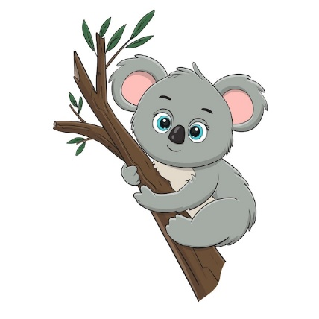
B. The cassowary is a big (3) ___________, but it can’t fly. It lives in the (4) ___________ and it likes fruit and (5) ___________. It doesn’t drink lots of water. | 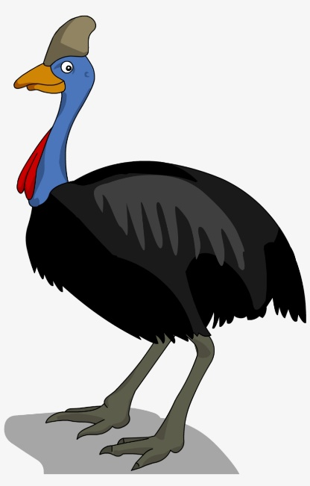

Task 2: Listen to John and Kate talking about the place where they live then choose the correct answer. Number 0 has been done for you. TRACK 36
0. John lives in a ___________ in New York.
A. flat B. house C. hotel D. room
6. New York has got many high buildings, banks, supermarkets and ___________.
A. post offices B. shops C. parks D. Museums
7. It is very ___________ in New York city.
A. quiet B. peaceful C. noisy D. noise
8. Kate is ___________ than John.
A. younger B. older C. taller D. youngest
9. She lives in a ___________ in an area away from Canberra, Australia.
A. town B. city C. village D. house
10. She prefers to live in the countryside because she likes the ___________ air and peaceful life there.
A. cleaner B. dirty C. polluted D. fresh
READING

Read the text then answer the questions.
Whales are the largest animals on Earth. They are bigger than any known dinosaur. A large blue whale can be over 33 metres or 100 feet long. It can weigh nearly as much as 20 school buses. Its heart is big as a small car. Some whales are fairly small. These whales are 1.2 to 1.8 metres. Dolphins are an example of smaller whales.
There are about 75 kinds of whales. Most whales fall into one of two groups. One group has teeth. They are called the toothed whales. The other group does not have teeth and is called Baleen whales. Toothed whales, which include dolphins and porpoises, have jaws lined with sharp event eat seals. The killer whale, or orca, is a well-known toothed whale. Even though it is called a killer whale, there is no evidence one has ever killed a human.
11. What are the largest animals on Earth?
___________________________________________________________________________________
12. How many kinds of whales are there?
___________________________________________________________________________________
13. How long is a large blue whale?
___________________________________________________________________________________
14. Do dolphins have teeth?
___________________________________________________________________________________
15. What is the name of the whale group which doesn’t have teeth?
___________________________________________________________________________________
Read the passage and decide which answer A, B, C or D best fits each space.
It’s Sunday morning. The Browns(16) _____________ in the living room. They are talking about the dinner this evening. David likes beef and Susan does, too. He says that beef (17) _____________ good for children. Their father, Mr. Brown, prefers chicken to beef. He asks his wife to buy (18) _____________ for him. Helen, their youngest daughter
doesn’t want any meat. She would (19) _____________ cakes and sweets. Mrs. Brown doesn’t like beef. She doesn’t like chicken, either. She likes fish, vegetables and fruit. She says that fish and vegetables (20) _____________ good for old men and everybody. At last, they decide to go out for dinner.
16. A. is sitting B. are siting C. sitting D. are sitting
17. A. does B. are C. is D. has
18. A. any B. some C. none D. little
19. A. have B. like C. has D. likes
20. A. have B. do C. are D. is
LANGUAGE FOCUS
Choose the correct answer A, B, C or D.
21. Mike doesn’t have a bike, ____________ he usually goes to school on foot.
A. so B. and C. but D. or
22. I love pop music, ____________ my sister loves it, too.
A. but B. and C. so D. because
23. Monarchs are ____________ famous butterflies in North America.
A. the most B. more C. most D. the more
24. Butterflies have got ____________.
A. enormous wings B. wings enormous C. an enormous wing D. a wing enormous
25. Andie can ____________ German, but she can’t ____________.
A. speaks/ write B. speak/ write C. speaking/ writing D. to speak/ to write
26. How ____________ can some snakes move? - At around twenty-two kilometers an hour.
A. fast B. long C. far D. old
27. Wearing school uniforms is ____________ in my school.
A. compulsory B. force C. option D. compul
28. It is important ____________ warm clothes in winter.
A. wearing B. to wear C. wears D. to wearing
Mark the letter A, B, C or D to indicate the word whose underlined part differs from the other three in pronunciation in each of the following questions.
29. A. pens B. books C. phones D. tables
30. A. painter B. fanner C. flower D. person
WRITING

Rewrite the following sentences using the words in brackets.
31. I am not taller than anyone in the class. (shortest)
__________________________________________________________________________________
32. My dad often drives to work. (car)
__________________________________________________________________________________
33. Servals are fast animals. (run)
__________________________________________________________________________________
34. Servals eat animals like rats, frogs and snakes. (such as)
__________________________________________________________________________________
35. Mark learns English well. (good at)
__________________________________________________________________________________
Write a short paragraph (60-80 words) to describe your pet or your favourite animal.
You should write:
What the pet is
How the pet looks
How the pet’s characters are
Why you like it
__________________________________________________________________________________
__________________________________________________________________________________
__________________________________________________________________________________
__________________________________________________________________________________
__________________________________________________________________________________
__________________________________________________________________________________
B. SPEAKING TEST

Now I'm going to ask you some questions about robots. Are you ready?
1. How many types of robots do you know?
2. What is your favourite type of robot?
3. What will your favourite robot be able to do?
4. Do you want to have a robot in your house, and why?

SECOND TERM TEST 10
A. WRITTEN TEST
LISTENING
TASK 1: People are talking about sports. Listen then decide whether these sentences are true (T) or false (F). TRACK 39
Statements | T | F
1. Mai plays tennis for an hour every day.
2. She plays baseball on Sundays
3. Nick likes energetic sport, so he walks every day.
4. Nick likes going swimming on Sunday.

Task 2: People are talking about robot invention. Listen and choose the correct answer A, B, C or D. TRACK 40
5. The world’s first news-reading robots have been invented by,
A. Chinese scientists
B. Japanese scientists
C. Vietnamese scientists
D. Korea scientists
6. Robots can sound human and have.
A. a sense of responsibility
B. a sense of humour
C. creativity
D. confidence
7. The name “Kodomoroid” is combined from•
A. English and Japanese
B. English for aldult and children
C. Japanese words for child and adult
D. The robots’ creator
8. The robots’ creator didn’t say
A. when robots would really read news on TV
B. when robots could sound human
C. when he read news on TV
D. when children could have a reading robot.
LANGUAGE FOCUS
Mark the letter A, B, C or D to indicate the word that differs from the other three in the position of primary stress in each of the following questions.
9. A. contest B. product C. pollution D. apple
10. A. fantastic B. important C. appropriate D. contact

Mark the letter A, B, C or D to indicate the word whose underlined part differs from the other three in pronunciation in each of the following questions.

11. A. electricity B. energy C. environment D. effect

12. A. graduate B. degree C. doctorate D. kindergarten

Mark the letter A, B, C or D to indicate the correct answer to each of the following questions.
13. “____________ do you think about the life in the Moon?”
A. Why B. Where C. What D. How
14. Last summer, I ____________ fishing with my uncle in the afternoon.
A. went B. go C. going D. goes
15. A super smart TV will help us ____________ things from the supermarket even when we are at home.
A. send B. carry C. buy D. bring
16. Robots will be able to work harder and longer than people ____________ getting tired and complaining.
A. with B. without C. so D. but
17. Sarah first ____________ yoga when she was 16 years old.
A. played B. did C. jumped D. danced
18. Martin Odegaard ____________ a professional footballer at fifteen.

A. became B. grew up C. changed D. dreamed

Identify the mistake in each sentence.
19. We will save our world if we protected our environment.
A. save B. world C. protected D. our
20. Did you ever taste Vietnamese noodles called Pho?
A. Did you ever taste B. Vietnamese
C. noodle D. called
READING
Read the text then choose the correct answer A, B, C or D.
The Fastest Man in the World
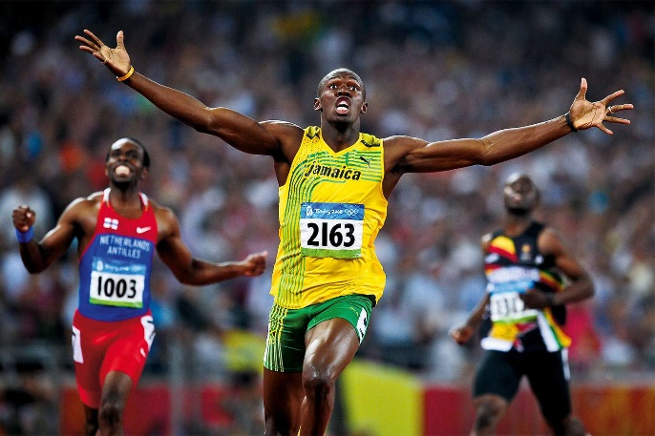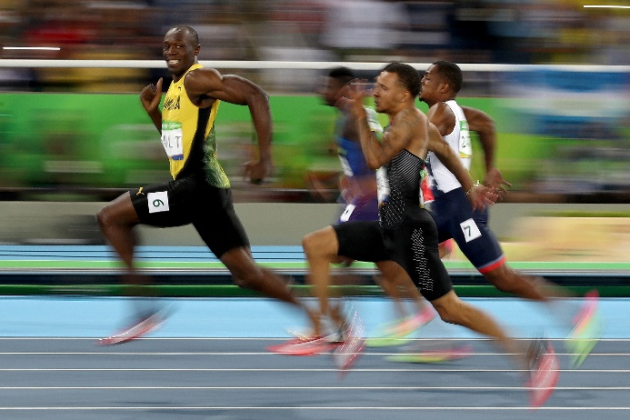
Many people say that Usain Bolt is the world’s fastest man ever. In 2008, he won three gold medals at the Beijing Olympic Games in the men’s 100m, 200m, and 4x100m relay.
He also broke three world records. He was the first person to win these three events at the same Olympics. Then, at the London Olympics in 2012, he won three gold medals again in the same events! This is his story.
Usain Bolt was born in Jamaica on August 21st, 1986. He lived in a small town called Trelawney, where his parents had a small food shop. When he was a child, Usain played cricket and football in the street with his brother, Sadeeki, and sister, Sherine. Usain was very good at cricket, and wanted to play for the West Indies.
Usain loved all sports and was one of the best runners at his school. He won many races and when he was 15, he won a gold medal and two silver medals at the 2002 World Junior Championship in Kingston, Jamaica.
21. Usain is from _____________.
A. Beijing B. London C. Jamaica
22. When he was a child, he liked _____________.
A. dancing and watching TV
B. playing cricket and football
C. running and watching sports
23. He lived in _____________.
A. a big city B. in Trelawney C. London
24. His parents had a _____________.
A. sports shop B. food shop C. restaurant
25. He runs fast because _____________.
A. he is light B. he is thin C. he has long legs.
Read the text then choose the correct answer A, B, C or D.
Tet is a national and (26) _____________ festival in Viet Nam. It is occasion for every Vietnamese to be reunited to think (27) _____________ their past activities and hope for good luck in the year to come. Before Tet all houses are white washed and (28) _____________ with yellow apricot flowers and colorful lanterns. Everybody is looking forward to a more favorable life. On the New Year’s Eve, children are smartly dressed. They are hoping to (29) _____________ money put in small red envelopes as they are wishing longevity (30) _____________ their grandparents and parents.
26. A. traditional B. modern C. summer D. music
27. A. after B. for C. to D. about
28. A. decorates B. decorate C. decorating D. decorated
29. A. buy B. sell C. receive D. make
30. A. from B. with C. to D. for
WRITING

Make all the changes and additions necessary to produce from the followings sets of words and phrases, complete sentences.
Dear Kenny,
31. New York / fantastic/.
___________________________________________________________________________________
32. The / weather / been / perfect/.
___________________________________________________________________________________
33. It / sunny.
___________________________________________________________________________________
34. The /hotel / food / nice.
___________________________________________________________________________________
35. We / Genoa cake/ in / cafe/ in/ old street/.
___________________________________________________________________________________
36. The / Statue of Liberty/ wonderful/.
___________________________________________________________________________________
37. Art & design/ so/ amazing/.
___________________________________________________________________________________
38. I/love/it/.
___________________________________________________________________________________
39. I / have rented/ bike.
___________________________________________________________________________________
40. Tomorrow 11/ cycling/ around/ New York/ discover/ city.
___________________________________________________________________________________
Wish you were here.
Love, Mai Anh

B. SPEAKING TEST

Now I’m going to ask you some questions about your house in the future. Are you ready?
1. What will your dream house be like?
2. How many rooms will there be in your house?
3. How will you use each room?
4. What neighbourhood do you want to live in?
5. What appliances do you want to have?

SECOND TERM TEST 9
A. WRITTEN TEST
LISTENING

TASK 1: Listen to people talking about sports. Put the tick in the correct picture. TRACK 37

1. Which sports does Jenny do?
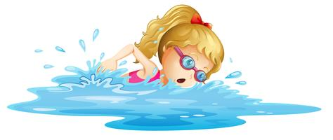 | 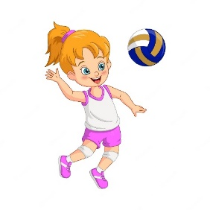 | 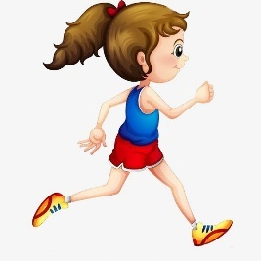
A. | B. | C.

2. Which sport does Mark like?
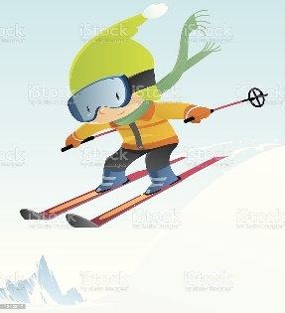 | 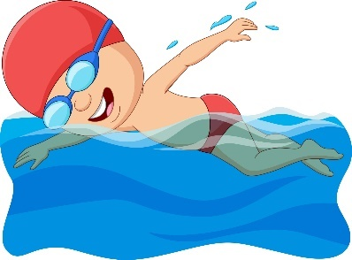 | 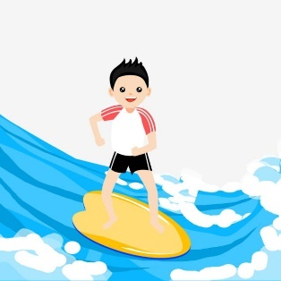
A. | A. | A.

3. Which sports does Tim do every day?
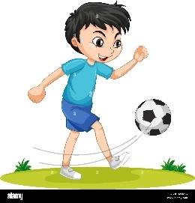 | 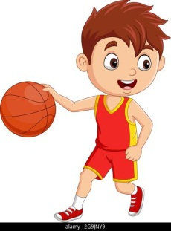 | 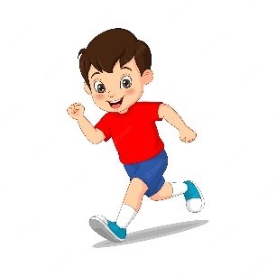
A. | A. | A.

4. Which sports does Mrs. Smith do now?
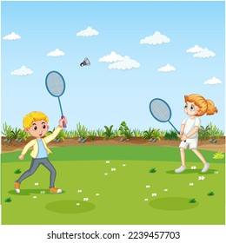 | 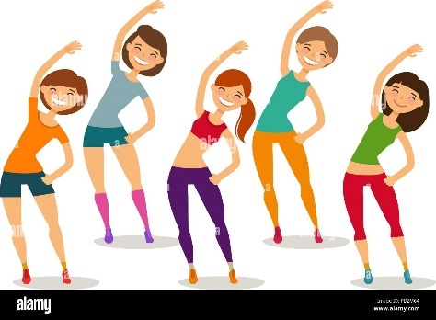 | 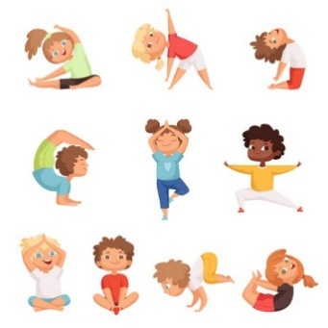
A. | A. | A.
Task 2: People are talking about how to save the environment. Listen carefully then choose the correct answer A, B, C or D for each question below. TRACK 38
5. What is the meaning of reduce?
A. to use again B. to use less C. to make new D. to use more
6. We reduce water by _______________.
A. turning off the water when we brush our teeth
B. playing with water
C. turning on the water when we don’t need it
D. not using water
7. We can reuse things by _______________.
A. using plastic bags B. wasting paper
C. using one side of the paper D. using re-usable shopping bags
8. Creating new materials from the old ones is called _______________.
A. recycle B. reduce C. reuse D. waste
LANGUAGE FOCUS
Mark the letter A, B, C or D to indicate the word that differs from the other three in the position of primary stress in each of the following questions.
9. A. belong B. expense C. future D. effect
10. A. activity B. geography C. biology D. examinee
Mark the letter A, B, C or D to indicate the word whose underlined part differs from the other three in pronunciation in each of the following questions.
11. A. plan B. faster C. part D. plant
12. A. because B. caught C. taught D. laugh
Choose the correct answer to each of the following questions.
13. Robot can cook, ______________ tea or coffee, and clean the house.
A. make B. do C. bake D. build
14. High buildings are also called ______________.
A. tall office B. high house C. skyscrapers D. tall houses
15. Look at those black clouds! It ______________ rain.
A. is going to B. will C. might D. is raining
16. If there is wastepaper bin in each class, the class will be ______________.
A. cleaner B. darker C. dirtier D. lighter
17. We should plant more ______________ to have fresher air.
A. teeth B. trees C. grass D. vegetables
18. Things you throw away because you don’t need them are called ______________.
A. bin B. rubbish C. environment D. papers
19. They will be able to build houses, ______________ and roads.
A. bridges B. sand C. meals D. bricks
20. If I have a terrible headache, I ______________ some medicines.
A. take B. can take C. will take D. would take
21. ______________ is a house on the water.
A. dream house B. mountain C. cottage D. floating house
22. She ______________ the piano since 2000.
A. has played B. will play C. could play D. can play
READING
Read the following text and choose the best answer (A, B, C, or D) for each question.
Rebecca Stevens was the first woman to climb Mount Everest. Before she went up the highest mountain in the world, she was a journalist and lived in a small flat in south London.
In 1993, Rebecca left her job and her family and travelled to Asia with some other climbers. She found that life on Everest is hard. ‘You must carry everything on your back,’ she explained, ‘so you can only take things that you will need. You can’t wash on the mountain, and in the end, 1 didn’t even take a toothbrush. I’m usually a clean person, but there is no water, only snow. Water is very heavy, so you only take enough to drink!’
When Rebecca reached the top of Mount Everest on May 17th 1993, it was the best moment of her life. Suddenly, she became famous.
Now she has written a book about the trip and people often ask her to talk about it. She has a new job too, for a science programme on television.
Rebecca is well-known today, and she has more money, but she still lives in the little flat in south London, among her pictures and books about mountains!
23. Before Rebecca climbed Everest, she worked for _______________.
A. for a bookshop B. for a newspaper C. a TV station D. a travel agency
24. Rebecca didn’t take much luggage because she _______________
A. didn’t have many things. C. had to carry it herself.
B. had a bad back. D. didn’t like it.
25. Rebecca didn’t wash on Everest because _______________
A. it was too cold. B. there was not enough water.
C. she is a dirty person. D. she enjoyed it.
26. Rebecca earned water for _______________.
A. cooking B. cleaning her teeth C. drinking D washing her hair
27. Rebecca became famous when she _______________.
A. got to the highest place in the world.
B. wrote a book about her trip.
C. was on a television programme.
D. was on a newspaper.

Complete the email by choosing the word w hich best fits the blanks.
Hi Mum and Dad.
1 hope you are well. It’s fun here at the summer camp, but the journey from school (28) _______________ a long time. On the way, we went to a (29) _______________ about the history of the area. It was quite interesting. We were tired when we finally got here.
I am (30) _______________ a room with five of my friends. We have to keep our room tidy, which is difficult! The teachers come to check our rooms before we (31) _______________ to bed.
I (32) _______________ you some photos, and I’m sure you’ll like them - they’re really funny.
Love,
Paul
28. A. went B. spent C. had D. took
29. A. museum B. shop C. restaurant D. hospital
30. A. living B. making C. sharing D. staying
31. A. got B. go C. going D. went
32. A. brought B. took C. gave D. emailed
WRITING
Mark the letter A, B, C, or D to indicate the sentence that is closest in meaning to each of the following questions.
33. I can’t drive so we can’t take the car.
A. If I can drive, we can take the car.
B. If I can’t drive, we can take the car.
C. If I can drive, we can’t take the car.
D. If I drive fast, we could take the car.
34. He doesn’t help me, possible because I never ask him for help.
A. If I asked him for help, he will help me.
If I ask him for help, he will help me.
C. If I ask him for help, he would help me.
D. If I asks him for help, he will help me.

Mark the letter A, B, C, or D to indicate the sentence that that is made from the words given.
35. Don’t/ throw/ plastic/ because/ you/ reuse.
A. Not do throw the plastic bags because you can reuse them.
B. Don’t throwing the plastic bags because you can reuse them.
C. Don’t throw the plastic bags because you can reuse them.
D. Don’t throw the plastic bags because you won’t reuse them.
36. There / be / small / pond / front I Lam / house.
A. There is some small ponds in front of Lam’s house.
B. There are some small pond on front of Lam’s house.
C. There are some small ponds to front of house’s Lam.
D. There are some small ponds in front of Lam’s house.
37. My mother/ make/ a big meal/ tonight.
A. My mother will make a big meal tonight.
B. My mother made a big meal tonight.
C. My mother would make a big meal tonight.
D. My mother will making a big meal tonight.
38. They/ cut down/ some trees/ schoolyard.
A. They will cutting down some tree in the schoolyard.
B. They has cut down some trees in the schoolyard.
C. They will cut down some trees in the schoolyard.
D. They cutted down some trees in the schoolyard.
39. It/ only/ small car/ so/ there/ not/ enough room/ all/ us.
A. It is only a small car, so there isn’t room enough for all ot US.
B. It is only a small car, so there isn’t enough room tor all of us.
C. It is only a small car, so there is enough room tor all of us.
D. Is it only a small car, so there is enough room tor all of us.
40. You/ use/ reusable bags/ when/ you/ shopping.
A. You should using reusable bags when you go shopping.
B. You shouldn’t use reusable bags when you go shopping.
C. You should use reusable bags when you going shopping.
D. You should use reusable bags when you go shopping.

B. SPEAKING TEST

Now I’m going to ask you some questions about the TV programme you don’t like. Are you ready?
1. What is the name of the programme?
2. When is it on?
3. What kind of programme is it?
4. Why don’t you like it?

