GRADE 10 – GLOBAL SUCCESS

Unit 1: Family life…………………………………………………………………………2

Unit 2: Humans and the environment………………………………………….11

Unit 3: Music…………………………………………………………………………......22

Unit 4: For a better community……………………………………………………31

Unit 5: Inventions………………………………………………………………………..41

Unit 6: Gender equality……………………………………………………………….50

Unit 7: Viet Nam and international organisations………………………..60

Unit 8: New ways to learn……………………………………………………………71

Unit 9: Protecting the environment……………………………………………..81

1

Unit 10: Ecotourism…………………………………………………………………….90

Unit 1: Family life

Noun

1 |  | Housework | /ˈhaʊswɜːk/ | Việc nhà
2 |  | Housewife | /ˈhaʊswaɪf/ | Bà nội trợ
3 |  | Benefit | /ˈbenɪfɪt/ | Lợi ích
4 |  | Task | /tɑːsk/ | Nhiệm vụ, việc phải làm
5 |  | Bond | /bɒnd/ | Sự gắn kết
6 |  | Value | /ˈvæljuː/ | Giá trị
 |  |  | Verb
1 |  | Divide | /dɪˈvaɪd/ | Phân chia
2 |  | Look after | /lʊk ˈɑːftə(r)/ | Chăm sóc
3 |  | Tidy up | /ˈtaɪdi ʌp/ | Dọn dẹp
4 |  | Strengthen | /ˈstreŋkθn/ | Tăng cường, củng cố
5 |  | Develop | /dɪˈveləp/ | Phát triển
6 |  | Damage | /ˈdæmɪdʒ/ | Phá hủy, làm hỏng
7 |  | Grow up | /ɡrəʊ ʌp/ | Lớn lên
8 |  | Celebrate | /ˈselɪbreɪt/ | Tổ chức, kỉ niệm
 |  |  | Adjective
 |  |  | 2

1 | Traditional | /trəˈdɪʃənl/ | Thuộc về truyền thống
2 | Proud | /praʊd/ | Tự hào
 |  | Phrases
1 | household chores | /ˈhaʊshəʊld tʃɔː(r)z/ | Việc nhà
2 | homemaker | /ˈhəʊmmeɪkə(r)/ | Người nội trợ
3 | breadwinner | /ˈbredwɪnə(r)/ | Trụ cột gia đình
4 | Earn money | /ɜːn ˈmʌni/ | Kiếm tiền
5 | do the heavy lifting | /duː ðə ˈhevi lɪftɪŋ/ | Làm việc nặng
6 | do the laundry | /duː ðə ˈlɔːndri/ | Giặt là
7 | study for exams | /ˈstʌdi fə(r) ɪɡˈzæmz/ | Học ôn thi
8 | Life skill | /laɪf skɪl/ | Kĩ năng sống
9 | Take responsibility | /teɪk rɪspɒnsəˈbɪləti/ | Có trách nhiệm
10 | Take care of | /teɪk keə(r) əv/ | Chăm sóc
11 | routine task | /ruːˈtiːn tɑːsk/ | Công việc hàng ngày
12 | Do the washing-up | /duː ðəˈwɒʃɪŋʌp/ | Rửa chén, bát

Ex I: Find the word which has a different sound in the part underlined.

1. | A. football |  |  |  |  |  |  |  | B. cooking
2. A. afraid |  |  |  |  |  |  |  |  | B. mountain
3. A. prepare |  |  |  |  |  |  |  |  | B. compare
4. | A. housework |  |  |  |  |  |  |  | B. wrong
5. | A. exams |  |  |  |  |  |  |  | B. sisters
6. | A. today |  |  |  |  |  |  |  | B. mother
7. | A. interesting |  |  |  |  |  |  |  | B. mistake
8. | A. cycling |  |  |  |  |  |  |  | B. usually

- good

C. laid

C. careful C. whenever C. cleaners C. money C. divide

- heavy

3

- food D. maid D. family

D. wonderful D. attracts D. brother D. practise D. laundry

9. A. rubbish |  |  |  | B. funny |  |  |  | C. hungry |  |  |  | D. cucumber
10. A. chore |  |  |  | B. children |  |  |  | C. Christmas |  |  |  | D. champion

Ex II: Choose a word that has a different stress pattern from others.

1. | A. equally | B. family | C. important | D. benefit
2. | A. busy | B. routine | C. later | D. English
3. | A. enough | B. market | C. answer | D. visit
4. | A. celebrate | B. national | C. opinion | D. century
5. A. value |  | B. support | C. moment | D. programme
6. | A. special | B. people | C. picnic | D. correct
7. | A. together | B. personal | C. evening | D. favourite
8. | A. complete | B. breakfast | C. second | D. august
9. | A. lesson | B. finger | C. exchange | D. business
10. A. Sunday |  | B. believe | C. modern | D. idol

Ex III: Write the words below in the correct column.

breakfast, crocodile, tractor, brick, ice cream, triangle, brilliant, traveller, brown, control, crazy, trousers, brave, truck, brandnew, crayon, tree, branch, trainer, crown, trumpet, bring, crash, treasure, crab, brush

/br/

/kr/

/tr/

4

Ex IV: Label the picture with a correct phrase given.

 | Lift heavy things |  |  | Do the cooking |  |  |  | Clean the house |  |  | Do the laundry
 | Repair the water |  |  | Put out the |  |  |  | Shop for |  |  | Water the plants
 | pipes |  |  | rubbish |  |  |  | groceries
 | Prepare the |  |  | Arrange flowers |  |  |  | Wash the dishes |  |  | Study for exams
 | meals
1. |  |  |  |  | 2. |  |  |  | 3.
4. |  |  |  |  | 5. |  |  |  | 6.
7. |  |  |  |  | 8. |  |  |  | 9.
10. |  |  |  |  | 11. |  |  |  | 12.
 |  |  |  |  |  | 5

Ex V: Say the words out loud and odd one out.

1. | A. cousin |  |  | B. children |  |  | C. project | D. relative
2. | A. discuss |  |  | B. busy |  |  | C. tiring | D. useful
3. | A. today |  |  | B. century |  |  | C. tomorrow | D. routine
4. | A. develop |  |  | B. important |  |  | C. strengthen | D. divide
5. | A. parent |  |  | B. bond |  |  | C. teenager | D. adult
6. | A. college |  |  | B. university |  |  | C. school | D. supermarket
7. | A. similar |  |  | B. respect |  |  | C. helpful | D. intelligent
8. | A. remember |  |  | B. complete |  |  | C. fantastic | D. understand
9. A. newspaper |  |  |  | B. magazine |  |  | C. novel | D. experience
10. A. prepare |  |  |  | B. ice cream |  |  | C. vegetable | D. hamburger
Ex VI: |  |  | Match.
 |  |  | 1. prepare |  |  |  | a. a lot of money
 |  |  | 2. do |  |  |  | b. responsibility
 |  |  | 3. earn |  |  |  | c. the heavy lifting
 |  |  | 4. clean |  |  |  | d. favorite TV programs
 |  |  | 5. put out |  |  |  | e. the house
 |  |  | 6. answer |  |  |  | f. the laundry
 |  |  | 7. divide |  |  |  | g. birthday
 |  |  | 8. wash |  |  |  | h. the phone
 |  |  | 9. do |  |  |  | i. the household chore equally
 |  |  | 10. watch |  |  |  | j. dinner for the family
 |  |  | 11. take |  |  |  | k. the rubbish
 |  |  | 12. celebrate |  |  |  | l. dirty clothes
 |  |  |  |  |  |  | 6

Ex VII: Circle the best word.

- Jane can’t make/do the cooking because she is studying for her exams at the moment.

- A homemaker is a person who doesn’t go out to work but stays at home to take/look after the family.

- Why don’t many parents make/ask their kids do the housework?

- There are some reasons why/which children should do the housework.

- Your great ideas are really helpful/useful for my project, Susan.

- She is proud that she can run/organize the dishwasher.

- Peter’s father is responsible for making/doing the heavy lifting and repairing the water pipes.

- Family time is when all family members do things together/another.

- What do think about the family value of being true/truthful and honest?

- Children should do their homework by themselves so that they can become dependent/independent.

Ex VIII: Match the words in the box with their meanings.

1. | bond | 5. entertainment
2. | routine | 6. chore
3. | grow up | 7. homemaker
4. | responsibility | 8. benefit

- a task that you do regularly

- to develop into an adult

- the normal order and way in which you regularly do things

- a person, especially a woman who manages a home and takes care of the house and family

- an advantage that something gives you

- films, music,…etc used to entertain people

7

- a duty to take care of somebody or something so that you may be blamed if something goes wrong

- something that forms a connection between people or groups

Ex IX: Put the verbs/phrasal verbs in the correct row.

visit, tidy up, put out, prepare, do, follow, take care of

1. |  | small children
2. |  | the rubbish
3. |  | the household chores
4 |  | the house
5 |  | meals for the family
6. |  | grandparents in the countryside
7 |  | traditional family values

Ex X: Choose the best answer.

1.They ask the children in their family to …………the housework every day.

A. make B. do C. take D. prepare

- They watch their favourite program on TV ………… every Saturday evening.

A. together B. another C. both D. other

- Strong family values can ………….. children to have a happy life later.

A. make B. bring C. prepare D. provide

- I’m …………….I can’t go with you because I’m studying for my exams tomorrow.

A. pity B. sad C. bored D. afraid

- Husbands and wives should ……………….the household chores equally in the family

8

A. divide B. do C. take D. make

- Taking out rubbish is a ……………….task for Jim every afternoon.

A. simple B. easy C. proud D. enormous

- Children can ……………responsible people when doing the housework.

A. turn B. become C. take D. change

- Can she …………..the laundry when I prepare the dinner tonight?

A. wash B. take C. make D. do

- My dad sometimes cooks a good …………… for the whole family.

A. food B. meal C. dish D. plate

- Parents should teach their children to be ……………..and show respect to older people.

A. true |  |  | B. right | C. honest | D. good
 | Ex XI: | Fill in the gap with a suitable word given in the box.
 | skills |  | routines | important | daily |  | encourage
 | stronger |  | strengthen | breadwinner | common |  | necessary

- Although Jack is the ……………… of the family, he still helps his wife with the housework whenever he has time.

- Children who do housework can develop important life…………….that they will need for the rest of their lives.

- Parents should ………………..children to share the housework for their own benefits and the benefits of the whole family.

- Some life skills such as cooking the meals, cleaning the house are really

…………….for the children when they grow up.

- Their family ……..……….help them spend great time together every week.

- Dinners are important for use because we usually share ……………

experiences and talk about the lastest news.

9

- Family members can sit together to discuss ………………issues and make the right decisions or just have casual chats.

- The most ………………..activities family members can do together include playing games outdoor, watching movies or visiting grandparents.

- Today is an important day as it reminds us to express our love to our parents and helps …………….. our family bonds.

- Family time is important as it helps make the bonds between family members ……………….

Ex XII: Complete the sentence with the correct form of the word provided.

- Most people think that house work is boring and it is the ………………… of wives and mothers only. (RESPONSIBLE)

- Studies show that ………………. household chores is good for children. (DO)

- Sharing houswork is a good way to teach children to take

..………………..(RESPONSIBLE)

- Doing housework together helps …………….. family bonds and creates special moments between children and parents. (STRONG)

- ……………….is a quality that makes him different from other students in class.

(HONEST)

- How can parents help their kids achieve great …………… in their study?

(SUCCESSFUL)

- Some ……………… values are still important in our society nowadays.

(TRADITION)

- Being honest and respecting older peple are on top of the list of ………………..

values. (IMPORTANCE)

- The baby cries because her brother doesn’t divide the cake

………………(EQUAL)

- In what ways can parents contribute to the …………………..of their children?

(EDUCATE)

10

Unit 2: Humans and the environment

Noun

1 |  | Aim | /eɪm/ | Mục tiêu
2 |  | Environment | /ɪnˈvaɪrənmənt/ | Môi trường
3 |  | Lifestyle | /ˈlaɪfstaɪl/ | Phong cách sống
4 |  | Ceremony | /ˈserəməni/ | Buổi lễ
5 |  | Issue | /ˈɪʃuː/ | Vấn đề
6 |  | Event | /ɪˈvent/ | Sự kiện
7 |  | Change | /tʃeɪndʒ/ | Sự thay đổi
8 |  | Chemical | /ˈkemɪkl/ | Chất hóa học
9 |  | Material | /məˈtɪəriəl/ | Vật liệu
10 |  | Temperature | /ˈtemprətʃə(r)/ | Nhiệt độ
 |  |  | Verb
1 |  | Attend | /əˈtend/ | Tham dự
2 |  | Set up | /set ʌp/ | Thành lập, thiết lập
3 |  | Improve | /ɪmˈpruːv/ | Cải thiện, nâng cao
4 |  | Encourage | /ɪnˈkʌrɪdʒ/ | Khuyến khích
5 |  | Adopt | /əˈdɒpt/ | Thu nhận
6 |  | Organize | /ˈɔːɡənaɪz/ | Tổ chức
 |  |  | 11

7 | Reduce | /rɪˈdjuːs/ | Giảm
8 | Welcome | /ˈwelkəm/ | Chào đón
9 | Protect | /prəˈtekt/ | Bảo vệ
10 | Achieve | /əˈtʃiːv/ | Đạt được
11 | Remember | /rɪˈmembə(r)/ | Ghi nhớ
12 | Remind | /rɪˈmaɪnd/ | Nhắc nhở
13 | Discuss | /dɪˈskʌs/ | Thảo luận
14 | Prevent | /prɪˈvent/ | Ngăn ngừa
15 | Recycle | /riːˈsaɪkl/ | Tái chế
16 | Damage | /ˈdæmɪdʒ/ | Phá hủy
17 | Pollute | /pəˈluːt/ | Làm ô nhiễm
18 | Increase | /ɪnˈkriːs/ | Gia tăng
 |  | Adjective
1 | Harmful | /ˈhɑːmfl/ | Có hại
2 | Compulsory | /kəmˈpʌlsəri/ | Bắt buộc
3 | Dangerous | /ˈdeɪndʒərəs/ | Nguy hiểm
 |  | Phrases
1 | Raise awareness | /reɪz əˈweənəs/ | Nâng cao nhận thức
2 | Youth Union | /juːθ ˈjuːniən/ | Đoàn Thanh Niên
3 | Pick up the litter | /pɪk ʌp ðə ˈlɪtə(r)/ | Nhặt rác
4 | Make decision | /meɪk dɪˈsɪʒn/ | Quyết định
5 | Green product | /ɡriːn ˈprɒdʌkt/ | Sản phẩm xanh
6 | Electrical appliance | /ɪˈlektrɪkl əˈplaɪəns/ | Thiết bị điện
7 | Plastic waste | /ˈplæstɪk weɪst/ | Chất thải nhựa
 |  | 12

8 | Save energy | /seɪv ˈenədʒi/ | Tiết kiệm năng lượng
9 | Used item | /juːst ˈaɪtəm/ | Vật dụng đã qua sử dụng
10 | Natural resource | /ˈnætʃrəl rɪˈsɔːs/ | Nguồn tài nguyên thiên
 |  |  | nhiên
11 | Rubbish bin | /ˈrʌbɪʃ bɪn/ | Thùng rác
12 | Public place | /ˈpʌblɪk pleɪs/ | Nơi công cộng
13 | Cut down on | /kʌt daʊn ɒn/ | Cắt giảm
Ex I: Find the word which has a different sound in the part underlined.

1. | A. youth |  |  |  |  |  |  |  |  |  | B. together
2. | A. public |  |  |  |  |  |  |  |  |  | B. rubbish
3. | A. pollute |  |  |  |  |  |  |  |  |  | B. struggle
4. | A. helicopter |  |  |  |  |  |  |  |  |  | B. event
5. | A. tough |  |  |  |  |  |  |  |  |  | B. ghost
6. | A. achieve |  |  |  |  |  |  |  |  |  | B. chemical
7. | A. collected |  |  |  |  |  |  |  |  |  | B. finished
8. A. dangerous |  |  |  |  |  |  |  |  |  |  | B. damage
9. | A. decision |  |  |  |  |  |  |  |  |  | B. resource
10. A. cinema |  |  |  |  |  |  |  |  |  |  | B. silence

- thunder C. union C. lucky C. protect C. laugh C. architect C. provided

C. playground C. separate C. celebrate

- thousand D. product D. discuss D. reduce D. cough D. character D. attracted D. energy D. waste D. electrical

Ex II: Choose a word that has a different stress pattern from others.

1. A. issue |  | B. welcome | C. damage | D. increase
2. | A. improve | B. healthy | C. lifestyle | D. billion
3. A. ceremony |  | B. dangerous | C. environment | D. temperature
4. | A. activity | B. interesting | C. literature | D. carefully
5. | A. organize | B. awareness | C. protection | D. tomorrow
6. | A. memory | B. effective | C. oxygen | D. yesterday
 |  |  | 13

7. | A. future | B. carbon | C. practice | D. machine
8. | A. public | B. people | C. provide | D. rubbish
9. A. person |  | B. device | C. compete | D. remind
10. A. tonight |  | B. honest | C. revise | D. believe

Ex III: Write the words below in the correct column.

grandparent, club, produce, airplane, group, practise, player, cloudy, program, please, greeting, predict, classmate, prize, provide, plumber, green, growth, place, prepare, clip, grass, princess, cleaner

/kl/

/pl/

/gr/

/pr/

Ex IV: Circle the best word. Giaoandethitienganh.info

- We are going to set up/attend the first meeting with our new partners tomorrow morning.

- The children will clean up/down the classroom right after the ceremony.

- The leader hopes that the local peole will be able to do more to protect/support the environment.

- They have already done/made an important decision to buy a new house in the big city.

- The teacher told/said the students to put all the rubbish in the bins after the party yesterday.

- It is a choice we make/do to change our daily habits to a greener lifestyle.

- It is one of the easiest way to protect/save the energy and reduce pollution.

14

- It makes/takes many years for plastic waste to break down into smaller pieces.

- Our group is going to pick up/down rubbish in the city center after the lesson.

- I am going to give/do a presentation on climate change next week.

Ex V: Match the verbs/phrasal verbs in column A with suitable nouns or noun phrases in column B.

A |  | B
1. set up |  | a. the classroom
2. adopt |  | b. the rubbish
3. clean up |  | c. Go Green Club
4. make |  | d. the electricity usage
5. raise |  | e. clean-up activities
6. turn off |  | f. a greener lifestyle
7. pick up |  | g. the volunteer program
8. organize |  | i. a big difference
9. cut down on |  | j. electrical appliances
10. take part in |  | k. people’s awareness

Ex VI: Say the words out loud and odd one out.

1. | A. teenager | B. member | C. remind | D. relative
2. | A. important | B. develop | C. harmful | D. dangerous
3. | A. produce | B. damage | C. organize | D. action
4. | A. chemistry | B. compulsory | C. literature | D. geography
5. | A. project | B. attract | C. divide | D. remember
6. | A. event | B. website | C. encourage | D. activity
 |  |  | 15

7. | A. useful | B. local | C. national | D. international
8. | A. information | B. entertainment | C. regular | D. collection
9. | A. become | B. lifestyle | C. prevent | D. adopt
10. A. plastic |  | B cotton | C. wood | D. resource

Ex VII: Match.

1. attend |  | a. the English club
2. join |  | b. energy bills
3. make |  | c. litter in the street
4. pass |  | d. new houses
5. plant |  | e. the school meeting
6. drop |  | f. the right decision
7. use |  | g. organic products
8. build |  | h. a lot of trees
9. reduce |  | i. plastic bags
10. buy |  | j. the final exam

Ex VIII: Complete the word below each picture.
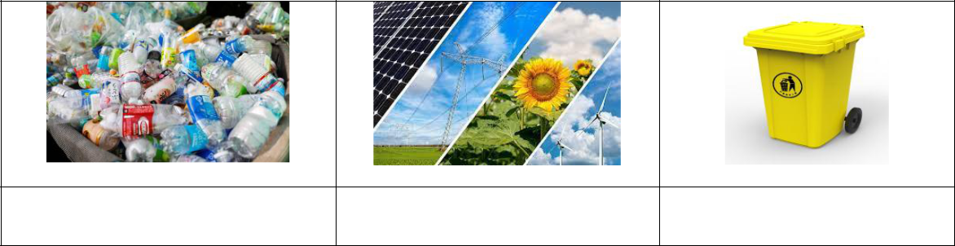

1. p…………. w…………

2. n…………. r…………..

3. r………… b……….

16

4. o………..…. p………..…

5. t………………………

6. e………………….

Ex IX: Match the words and phrases to the meanings.

1. environment |  | a. a supply of something that a country, an
 |  | organization or a person has and can use to increase
 |  | their wealth
2. resource |  | b. causing damage or injury to somebody/something
3. recycle |  | c. the way in which a person lives and works
4. harmful |  | d. the natural world in which people, animals and
 |  | plants live
5. lifestyle |  | e. to treat things that have already been used so that
 |  | they can be used a gain

Ex X: Complete the following sentences with phrases in Ex IX.

- These bottles were being ………………..into a lower-quality product.

- Many people are trying to adopt a healthy…………………nowadays.

- The country does its best to increase the use of renewable ………………….

- The government of countries in the world should do more to protect the

…………………

- Doing physical exercise in polluted air is ……………….to your health.

Ex XI: Choose the best answer.

- We shouldn’t ……… litter in the street because this will make the street dirty.

A. pick B. drop C. throw D. give

17

- If you have to ………………a green activity in your living area, what will you do?

A. increase B. attend C. achieve D. organize

- The teachers encourage students to …………… more trees and flowers in the school garden.

A. plant B. develop C. produce D. provide

- Many modern houses today are built ………….. eco-friendly materials.

A. of B. from C. with D. over

- We are advised to cut ……………on electricity usage to reduce carbon footprint.

A. up B. over C. down D. with

- The children are ………………on how to recycle the used items in their homes.

A. instructed B. asked C. told D. said

- We always try to recycle plastic items instead of throwing them away in the rubbish…………….

A. box B. bin C. basket D. bag

8. The most obvious advantage of living green is that it helps reduce …………...

A. pollute B. polluting C. polluted D. pollution

- Reducing the use of energy can help save money ………….household bills.

A. in B. on C. of D. with

10. Going green can make the air we breathe cleaner and ……………….

A. healthy B. healthier C. healthily D. more healthy

Ex XII: Fill in the gap with a suitable word given in the box.

encourage | recycle | reduce | activities | issues
transport | improve | eco-friendly | energy | safe

- There are many things you can do to become an………………person.

18

- The two countries discussed important environmental ………………….at the meeting last week.

- The aim of the program is to improve the environment and ……………..people to adopt a greener lifestyle.

- We shouldn’t throw away used household items. Instead, we can sort and

……………. them.

- Turning off all electrical appliances when going out is an easy way to save

…………….

- Which of the following ………………..do you think teenagers should do to live green?

- This small action can keep the environment clean and make it …………..for everyone.

- There are some ways the children can do to ……………….the environment in their school.

- Instead of using private vehicles such as car or motorbike, people should use public…………………, walk or cycle as much as possible.

- These simple activities can help……………..carbon footprint and the impact on the environment.

Ex XIII: Complete the sentence with the correct form of the word provided.

- More activities should be organized to raise people’s awareness of

..………………….problems. (ENVIRONMENT)

- Many new car models have attracted great ………………..at the exhibitions.

(ATTEND)

- Turning off all household appliances can prevent …………………situations such as a fire or an explosion. (DANGER)

- Recycling can protect natural resources and prevent ………………….. (POLLUTE)

- They are …………… to put more rubbish bins in public places such as parks or bus stations. (ASK)

19

- The activities can keep our environment clean, ……………..and safe for every citizen. (BEAUTY)

- I totally agree that our small actions can make a big……………….(DIFFERENT)

- Too many vehicles on the roads can lead to …………….global temperatures and air pollution. (INCREASE)

- Our teacher is very ……………of the results of our final test done last week.

(PRIDE)

- Carbon footprint is the amount of carbon dioxide ………………by the activities of a person or an organization. (PRODUCE)

Ex XIV: Complete the crossword using the prompts.

8

M

 |  | R
1 | R | E

2 | H

 | 3
4 | P
5 | L
P

E

C | R
S
C | 6

7 | N

9 | 10

E

L

Y

20

ACROSS:

- to treat things that have already been used so that they can be used again

- causing damage or injury to somebody or something

- to give somebody support, courage or hope

- to make sure somebody or something is not not damaged, injured

- the way in which a person lives and works

- a light strong material that is produced by chemical processes and can be formed into shape when heated

- existing in nature, not made by humans

DOWN:

- a substance that things can be made from

- the strength, effort required for physical or mental activity

- to make something smaller in size, quantity, price

21

Unit 3: Music

Noun

1 | Idol | /ˈaɪdl/ | Thần tượng
2 | Fan | /fæn/ | Người hâm mộ
3 | Award | /əˈwɔːd/ | Giải thưởng
4 | Trumpet | /ˈtrʌmpɪt/ | Cái kèn
5 | Comment | /ˈkɒment/ | Sự bình luận
6 | Artist | /ˈɑːtɪst/ | Nghệ sĩ
7 | Audience | /ˈɔːdiəns/ | Khán giả
8 | Competition | /kɒmpəˈtɪʃn/ | Sự cạnh tranh
9 | Judge | /dʒʌdʒ/ | Ban giám khảo
10 | Performance | /pəˈfɔːməns/ | Màn trình diễn
11 | Career | /kəˈrɪə(r)/ | Sự nghiệp
12 | Participant | /pɑːˈtɪsɪpənt/ | Người tham dự
 |  | 22

13 | Event | /ɪˈvent/ | Sự kiện
14 | Atmosphere | /ˈætməsfɪə(r)/ | Không khí
15 | Experience | /ɪkˈspɪəriəns/ | Trải nghiệm
16 | Stage | /steɪdʒ/ | Sân khấu
17 | Stadium | /ˈsteɪdiəm/ | Sân vận động
18 | Costume | /ˈkɒstjuːm/ | Trang phục
19 | Festival | /ˈfestɪvl/ | Lễ hội
20 | Composer | /kəmˈpəʊzə(r)/ | Nhà soạn nhạc
21 | Contest | /ˈkɒntest/ | Cuộc thi
22 | Viewer | /ˈvjuːə(r)/ | Người xem
23 | Works | /wɜːks/ | Tác phẩm
 |  | Verb
1 | Receive | /rɪˈsiːv/ | Nhận được
2 | Perform | /pəˈfɔːm/ | Biểu diễn
3 | Upload | /ʌpˈləʊd/ | Tải lên
4 | Reach | /riːtʃ/ | Đạt tới
5 | Decide | /dɪˈsaɪd/ | Quyết định
6 | Participate (in) | /pɑːˈtɪsɪpeɪt/ | Tham gia
7 | Relax | /rɪˈlæks/ | Xả hơi, nghỉ ngơi
 |  | Adjective
1 | Talented | /ˈtæləntɪd/ | Tài năng
2 | Latest | /ˈleɪtɪst/ | Mới nhất, gần nhất
3 | Well-known | /wel ˈnəʊn/ | Nổi tiếng
 |  | Phrases
 |  | 23

1 | Social media | /ˈsəʊʃl ˈmiːdiə/ | Mạng xã hội
2 | Take place | /teɪk pleɪs/ | Diễn ra, xảy ra
3 | Art exhibition | /ɑːteksɪˈbɪʃn/ | Triển lãm nghệ thuật
4 | Musical | /ˈmjuːzɪkl | Nhạc cụ
 | instrument | ˈɪnstrəmənt/
5 | Family gathering | /ˈfæməli ˈɡæðərɪŋ/ | Buổi tụ họp gia đình
6 | Look forward to | /lʊk ˈfɔːwəd tə/ | Trông mong, chờ đợi
Ex I: Find the word which has a different sound in the part underlined.

1. | A. gather |  |  |  |  |  |  |  |  |  | B. than |  |  |  |  |  |  |  |  |  | C. South
2. | A. look |  |  |  |  |  |  |  |  |  | B. cook |  |  |  |  |  |  |  |  |  | C. foot
3. | A. singer |  |  |  |  |  |  |  |  |  | B. stage |  |  |  |  |  |  |  |  |  | C. judge
4. | A. stadium |  |  |  |  |  |  |  |  |  | B. dancing |  |  |  |  |  |  |  |  |  | C. today
5. | A. family |  |  |  |  |  |  |  |  |  | B. really |  |  |  |  |  |  |  |  |  | C. identify
6. | A. recorded |  |  |  |  |  |  |  |  |  | B. stayed |  |  |  |  |  |  |  |  |  | C. provided
7. | A. tickets |  |  |  |  |  |  |  |  |  | B. questions |  |  |  |  |  |  |  |  |  | C. seasons
8. | A. charity |  |  |  |  |  |  |  |  |  | B. chemist’s |  |  |  |  |  |  |  |  |  | C. chosen
9. | A. popular |  |  |  |  |  |  |  |  |  | B. music |  |  |  |  |  |  |  |  |  | C. furious
10. A. event |  |  |  |  |  |  |  |  |  |  | B. receive |  |  |  |  |  |  |  |  |  | D. festival

- weather D. boots D. exchange D. famous D. bicycle D. collected D. scores D. chocolate D. funny D. media

Ex II: Choose a word that has a different stress pattern from others.

1. | A. happen | B. result | C. single | D. follow
2. | A. interest | B. Saturday | C. attractive | D. favourite
3. | A. hobby | B. invite | C. program | D. movie
4. | A. delay | B. concert | C. message | D. statement
5. A. exam |  | B. present | C. number | D. colour
6. | A. whether | B. friendship | C. listen | D. surprise
 |  |  | 24

7. | A. audience | B. beautiful | C. important | D. different
8. | A. competition | B. exhibition | C. entertainment | D. participant
9. | A. website | B. receive | C. winner | D. country
10. A. island |  | B. greatest | C. prefer | D. nation

Ex III: Say the words out loud and odd one out.

1. A. guitar |  | B. drum | C. trumpet | D. famous
2. | A. concert | B. participant | C. judge | D. artist
3. | A. audience | B. perform | C. prefer | D. compete
4. A. receive |  | B. comment | C. decide | D. produce
5. | A. different | B. popular | C. composer | D. ordinary
6. | A. prize | B. award | C. champion | D. punish
7. | A. cover | B. relax | C. upload | D. record
8. | A. attract | B. contest | C. exam | D. competition
9. | A. artist | B. friend | C. musician | D. receive
10. A. social |  | B. talented | C. viewer | D. exciting

Ex IV: Match the words with their meanings.

1. audience |  | a. a person in a court who has the authority to decide how
 |  | criminals should be punished or to make legal actions
2. composer |  | b. a competition in which people try to win something
3. idol |  | c. a person or thing that is loved and admired very much
4. contest |  | d. a group of people who have gathered to watch or listen
 |  | to something
5. talent |  | e. a person who writes music especially classical music
6. judge |  | f. a natural ability to do something well

Ex V: Complete the sentences using words in Ex IV.

25

- Michael Jackson has been my …………..since I was a little boy.

- His uncle was a great …………………..of operas.

- The …………………..has made the final decision to choose the winner of the game.

- We encourage ………………..participation during the game show.

- He said he enjoyed the …………………with his competitor for the champion.

- Mr. Bean displayed his ………………for comedy at the event.

Ex VI: Put the words in the correct columns.

receive, asleep, concert, program, perform, famous, singer, invite, music, talent, award, trumpet, theatre, upload, friendship, revise, attract, birthday,
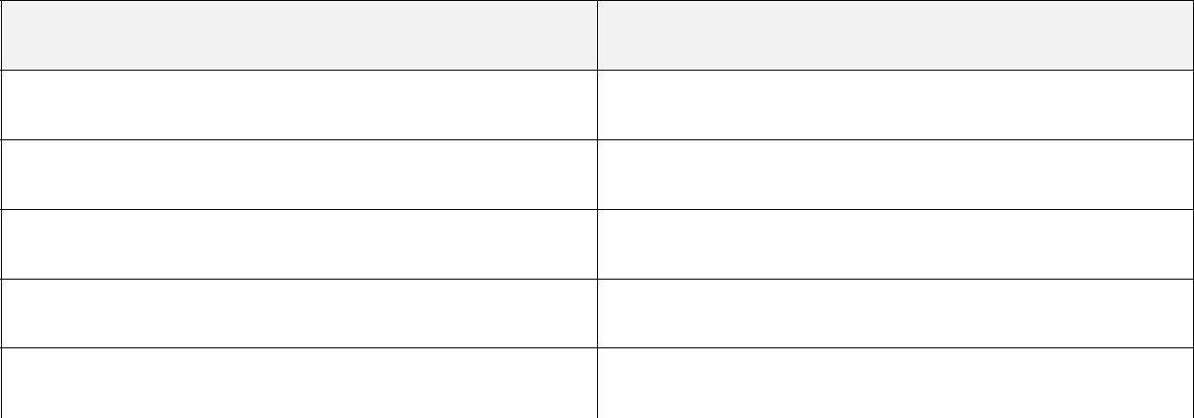

0o

o0

Ex VII: Match.

1. play |  | a. many awards
2. write |  | b. tickets online
3. receive |  | c. the school performance
4. share |  | d. musical instruments
5. book |  | e. an audio record
6. attend |  | f. an interesting show on TV
 | 26

7. watch |  | g. music
8. make |  | i. information and videos

Ex VIII: Choose the best answer.

1.Jim learnt to play …………piano, drums, guitar and trumpet by himself.

A. a B. C. the D. an

- As the concert did not ……………place, we had to stay at home.

A. take B. make C. organize D. perform

- …………. three players with the highest scores can remain on the show.

A. Even B. Only C. Among D. Between 4. They are using eco-friendly materials to …………. their houses. A. design B. develop C. upload D. build

- Teenagers all over the world seem to have the same …………. in music.

A. taste B. level C. favour D. ear

- His father taught hime how to play the guitar at the ………. of 12.

A. grade B. age C. old D. year

- The man has written many works about heroes and the fight …………. the enemies.

A. over B. with C. for D. against

- Celine Dion is my idol. I am one of her biggest …………..

A. lovers B. partners C. fans D. audiences

- The new album released by the boy band has sold at least two million……………

A. copies B. versions C. songs D. hits

10. The song was ……………for two Grammy awards in the previous season.

A. composed B. called C. performed D. voted

27

Ex IX: Circle the best word.

- She is a popular teen/teenager idol all over the world now.

- We are making/doing a research on traditional music in Vietnam and some other Asian countries.

- The performance was so boring that it made all of us fall/feel asleep.

- The singer has to practise so hard/hardly for the show tonight.

- He is one of the country’s most/ famous singer/singers but he didn’t release many albums.

- My close friend has participated in many talent/talented competitions.

- We encourage our daughter to sing at family gatherings and she has become/turned more confident.

- My favorite artist is Mr. Carol because he is one of the judges on a popular TA talent show/performance.

- How did the boy feel when going/attending the event yesterday morning?

- The children have passed the final exam and they all feel relaxed/relaxing now.

Ex X: Complete the word below each picture.

1.m……………. i…………… | 2. a………………………. | 3. a………………………
4. a…………. e…………….. | 5. c……………………… | 6. c…………………………
 | 28

Ex XI: Fill in the gap with a suitable word given in the box.

awards | festival | atmosphere | popular | participants
experiences | musical | star | stadium | favourite

- The latest video has made her an online ………… within a couple of months.

- My friends and I prefer writing blogs about ………………..at a music festival.

- The singer has received many important …………. for her beautiful voice and lovely songs.

- Alex can’t go to the music ……………….next Sunday because he has an English test on that day.

- People don’t need to buy tickets at the …………… ticket office because they can book them online nowadays.

- They watch the show not only to see the ……………. sing but also to hear the comments of the judges.

- We could make new friends and enjoyed the exciting ……………at the festival.

- Viewers can vote online for their …………….. singers by sending text messages.

- He is invited to join the band because he can play some

……………….instruments.

- Some new videos can quickly become …………… all over the word within a short period of time.

Ex XII: Complete the sentence with the correct form of the word provided.

- The organizers have finished ……………… for the festival. (PREPARE)

- The man is a talented artist who can write music and play many ……………….

instruments. (MUSIC)

- Their ……………… opinions and interesting arguments make the show really exciting. (DIFFERENCE)

29

Giaoandethitienganh.info

- The singing contest includes short performances to choose …………………...., semi-finals and finals. (PARTICIPATE)

- The ……………. of this show in different seasons have become famous singers in Vietnam. (WIN)

- So many ………………are going to perform on the stage in this music festival.

(ART)

- It is a form of traditional ………..……….art and it was recognized as part of

Vietnamese national culture. (PERFORM)

- Collecting rainwater wil allow people to save …………………resources and improve the environment. (NATURE)

- Watching music videos online is now more popular than …………….to the radio. (LISTEN)

- The winners of the contest have to base themselves on ……………… of the coaches and votes from the audience. (DECIDE)

30

Unit 4: For a better community

Noun

1 | Community | /kəˈmjuːnəti/ | Cộng đồng
2 | Volunteer | /vɒlənˈtɪə(r)/ | Tình nguyện viên
3 | Development | /dɪˈveləpmənt/ | Sự phát triển
4 | Advertisement | /ədˈvɜːtɪsmənt/ | Tình nguyện
5 | Service | /ˈsɜːvɪs/ | Dịch vụ
6 | Confidence | /ˈkɒnfɪdəns/ | Sự tự tin
7 | Opportunity | /ɒpəˈtjuːnəti/ | Cơ hội
8 | Orphanage | /ˈɔːfənɪdʒ/ | Trại trẻ mồ côi
9 | Charity | /ˈtʃærəti/ | Từ thiện
10 | Experience | /ɪkˈspɪəriəns/ | Kinh nghiệm
11 | Purpose | /ˈpɜːpəs/ | Mục đích
12 | Aim | /eɪm/ | Mục tiêu
13 | Career | kəˈrɪə(r)/ | Sự nghiệp
 |  | 31

Verb

1 |  | apply (for a job) | /əˈplaɪ/ | Xin việc
2 |  | Benefit | /ˈbenɪfɪt/ | Làm lợi
3 |  | Organize | /ˈɔːɡənaɪz/ | Tổ chức
4 |  | Boost | /buːst/ | Tăng cường, nâng cao
5 |  | Donate | /dəʊˈneɪt/ | Quyên góp
6 |  | Deliver | /dɪˈlɪvə(r)/ | Giao hàng
7 |  | Gain | /ɡeɪn/ | Thu được
8 |  | Improve | /ɪmˈpruːv/ | Cải thiện
9 |  | Support | /səˈpɔːt/ | Hỗ trợ
10 |  | Train | /treɪn/ | Huấn luyện, đào tạo
11 |  | Create | /kriˈeɪt/ | Tạo ra
 |  |  | Adjective
1 |  | Regular | /ˈreɡjələ(r)/ | Đều đặn
2 |  | Generous | /ˈdʒenərəs/ | Hào phóng
3 |  | Remote | /rɪˈməʊt/ | Xa xôi, hẻo lánh
4 |  | Homeless | /ˈhəʊmləs/ | Vô gia cư
5 |  | Essential | /ɪˈsenʃl/ | Cần thiết, quan trọng
6 |  | Available | /əˈveɪləbl/ | Có sẵn
7 |  | Cheerful | /ˈtʃɪəfl/ | Vui vẻ
8 |  | Confused | /kənˈfjuːzd/ | Nhầm lẫn
9 |  | Disappointed | /dɪsəˈpɔɪntɪd/ | Thất vọng
10 |  | Grateful | /ˈɡreɪtfl/ | Biết ơn
Phrases

32

1 | Get involved | /ɡet ɪnˈvɒlvd/ | Tham gia
2 | Local business | /ˈləʊkl ˈbɪznəs/ | Doanh nghiệp địa phương
3 | Raise money | /reɪz ˈmʌni/ | Quyên tiền
4 | Communication | /kəˌmjuːnɪˈkeɪʃn skɪl/ | Kĩ năng giao tiếp
 | skill
5 | Time management | /taɪm ˈmænɪdʒmənt/ | Quản lí thời gian
6 | non-profit | /nɒn ˈprɒfɪt | Tổ chức phi lợi nhuận
 | organization | /ɔːɡənaɪˈzeɪʃn/

Ex I: Find the word which has a different sound in the part underlined.

1. | A. orphanage |  |  |  |  |  |  |  |  |  |  |  | B. grateful |  |  |  |  |  |  |  |  |  |  |  | C. organize |  |  |  |  |  |  |  |  |  |  |  | D. giving
2. | A. disappointed B. exchanged |  |  |  |  |  |  |  |  |  |  |  |  |  |  |  |  |  |  |  |  |  |  |  | C. provided |  |  |  |  |  |  |  |  |  |  |  | D. collected
3. | A. therefore |  |  |  |  |  |  |  |  |  |  |  | B. neither |  |  |  |  |  |  |  |  |  |  |  | C. toothache |  |  |  |  |  |  |  |  |  |  |  | D. weather
4. | A. systems |  |  |  |  |  |  |  |  |  |  |  | B. profits |  |  |  |  |  |  |  |  |  |  |  | C. benefits |  |  |  |  |  |  |  |  |  |  |  | D. thanks
5. A. climb |  |  |  |  |  |  |  |  |  |  |  |  | B. bomb |  |  |  |  |  |  |  |  |  |  |  | C. dumb |  |  |  |  |  |  |  |  |  |  |  | D. build
6. | A. dozen |  |  |  |  |  |  |  |  |  |  |  | B. discover |  |  |  |  |  |  |  |  |  |  |  | C. confused |  |  |  |  |  |  |  |  |  |  |  | D. government
7. | A. houses |  |  |  |  |  |  |  |  |  |  |  | B. arranges |  |  |  |  |  |  |  |  |  |  |  | C. series |  |  |  |  |  |  |  |  |  |  |  | D. finishes
8. | A. school |  |  |  |  |  |  |  |  |  |  |  | B. chance |  |  |  |  |  |  |  |  |  |  |  | C. champion |  |  |  |  |  |  |  |  |  |  |  | D. charity
9. | A. homeless |  |  |  |  |  |  |  |  |  |  |  | B. honour |  |  |  |  |  |  |  |  |  |  |  | C. hamburger |  |  |  |  |  |  |  |  |  |  |  | D. hospital
10. A. remote |  |  |  |  |  |  |  |  |  |  |  |  | B. essential |  |  |  |  |  |  |  |  |  |  |  | C. deliver |  |  |  |  |  |  |  |  |  |  |  | D. enter

Ex II: Choose a word that has a different stress pattern from others.

1. | A. regular | B. advertise | C. discussion | D. orphanage
2. | A. career | B. local | C. useful | D. email
3. A. helpful |  | B. mountain | C. market | D. become
4. A. summer |  | B. apply | C. contact | D. answer
5. | A. enjoy | B. brother | C. lady | D. ticket
 |  |  | 33

6. | A. primary | B. successful | C. interest | D. charity
7. | A. mistake | B. protect | C. gather | D. research
8. | A. reply | B. money | C. playground | D. action
9. A. receive |  | B. member | C. beside | D. donate
10. A. project |  | B. purpose | C. homeless | D. prepare

Ex III: Label the picture

 | Collecting |  |  | Planting trees |  |  | Teaching small |  | Donating old
 | garbage |  |  |  |  |  | children |  | books
 | Cleaning the |  |  | Watering plants |  |  | Donating blood |  | Repairing water
 | streets |  |  |  |  |  |  |  | pipes
 | Cooking free |  |  | Helping the |  |  | Sewing clothes |  | Building houses
 | meals |  |  | elderly
1. |  |  | 2. |  |  |  | 3. |  | 4.
5. |  |  | 6. |  |  |  | 7. |  | 8.
9. |  |  | 10. |  |  |  | 11. |  | 12.
 |  |  |  |  | 34

Ex IV: Say the words out loud and odd one out.

1. | A. question |  |  | B. audience |  |  | C. volunteer | D. scientist
2. | A. discuss |  |  | B. article |  |  | C. organize | D. improve
3. | A. arrive |  |  | B. childhood |  |  | C. teenager | D. adult
4. | A. offer |  |  | B. increase |  |  | C. elderly | D. boost
5. | A. condition |  |  | B. article |  |  | C. protect | D. system
6. | A. local |  |  | B. homeless |  |  | C. useful | D. donation
7. | A. generous |  |  | B. increase |  |  | C. local | D. cheerful
8. | A. regular |  |  | B. prevent |  |  | C. deliver | D. improve
9. | A. opportunity |  |  | B. entertainment |  |  | C. grateful | D. development
10. A. career |  |  |  | B. support |  |  | C. apply | D. create
Ex V: |  | Match.
 |  |  | 1. join |  |  | a. the house prices
 |  |  | 2. visit |  |  | b. money for charity
 |  |  | 3. increase |  |  | c. a local environmental group
 |  |  | 4. donate |  |  | d. houses for the old people
 |  |  | 5. sell |  |  | e. money and food
 |  |  | 6. raise |  |  | f. common interests and values
 |  |  | 7. deliver |  |  | f. the city centre
 |  |  | 8. gain |  |  | g. hand-made items
 |  |  | 9. build |  |  | h. life experiences
 |  |  | 10. share |  |  | i. free meals

Ex VI: Circle the best word.

35

- My uncle is working as/like a volunteer at a local organization for community development.

- Our class find community work very interesting/interested.

- My friends and I are so exciting/excited about volunteering at a remote village.

- How can Jane apply with/for volunteer work at this centre?

- During our presentation, the audience confused/raised a lot interesting questions for the topic.

- Both Jim and Michael are talking about/on the plan for new activities.

- Susan was talking with some children when/while she was waiting for her mother.

- We need to join hands/legs to help improve the community and reduce pollution.

- Doing volunteering work takes/gives me opportunities to meet other teenagers with similar interests.

- The money collected/collecting from selling hand-made itesm is used to build houses for homeless people.

Pham Thu Tra - 0989552182

Ex VII: Choose the best answer.

- The father came to pick the little boy ………….. after school yesterday

A. on B. up C. with D. in

- They decided to help ………….. a community centre for young people in some poor villages.

A. make B. design C. visit D. build

- The group has ……………. a program to help poor children in many remoted areas.

A. joined B. benefited C. applied D. raised

36

- Our class …………… around five million VND to help people in flooded areas last year.

A. exchanged B. raised C. collected D. took

- The Club has organized many volunteering ………………….for all students to participate.

A. act B. actions C. activities D. acted

- …………. of our club members help cook free meals for poor families in the city.

A. Some B. Any C. Each D. Among

- If you ……….. a member of the Volunteer Club, what could you do to help?

A. are B. become C. were D. joined

8. We …………… the Volunteer Club when we started secondary school.

A. attended B. applied C. joined D. participated

- At the end of each school year, we ………….old textbooks and send them to poor students in remote areas.

A. sell B. collect C. exchange D. desing

10. They need more volunteers to …………..at the food bank this weekend.

A. work B. join C. participate D. organize

Ex VIII: Match the words with their definitions.

a. | volunteer | e. homeless
b. | orphanage | f. apply
c. | community | g. advertisement
d. | remote | h. benefit

- a home for children whose parents are dead

- far away from places where other people live

37

- to make a formal request usually in writing for a job

- an advantage that something gives you

- a notice, picture or film telling people about a product, job or service

- all the people living in a particular area, country

- a person does a job without being paid for it

- having no home, and therefore living on the streets

Ex IX: Find the following words in the word search.

service | generous | charity | experience
donation | opportunity | communication | orphanage

C | G | X | U | I |  | O | P | Q | W | Z | V | M | M
H | O | R | P | H |  | A | N | A | G | E | M | Y | Y
A | D | M | N | H |  | P | I | O | E | D | W | T | X
R | Y | K | M | X |  | X | V | F | C | B | R | I | E
I | H | K | F |  | U | U | O | Z | C | F | S | N | K
T | D | P | V | G |  | N | S | W | Q | E | I | U | D
Y | E | X | P |  | E | R | I | E | N | C | E | T | O
U | I | O | O | N |  | V | N | C | M | H | L | R | N
E | I | O | P |  | E | R | I | C | A | Z | V | O | A
M | N | B | H | R |  | I | O | Y | I | T | O | P | T
E | E | R | O | O |  | W | F | J | V | N | I | P | I
P | I | R | D | U |  | V | H | W | Y | O | I | O | O
Q | X | Y | W | S |  | E | R | V | I | C | E | D | N
 |  |  |  |  |  |  | 38

Ex X: Fill in the gap with a suitable word given in the box.

poor | neighbourhood | activities | local | charity
essential | opportunities | experience | community | organize

- There are many …………………... for the children to get involved in this community project.

- The government has tried to help …………….. businesses to export their products to Europe.

- Our group …………… some after-school activities to help poor children in the village.

- Jack was watching a news program about the………….conditions of a local school in the mountainous areas.

- There are some ………..…… for volunteers such as reading books to the elderly people, teaching children Vietnamese.

- Nowadays more and more teenagers and young people are getting involved in ………………….activities.

- They set up a volunteer club at their school and developed plans to help people in their ………………...

- Doing community work can help improve…………… life skills for secondary students.

- Peter is a very generous man because he is willing to give a lot of money to

………………

- The club was set up five years ago to help teenagers gain some work

………………

Ex XI: Complete the sentence with the correct form of the word provided.

- Community service can boost our …………………and help us learn many useful skill. (CONFIDENT)

39

- What are regular ……………….organized by this local centre? (ACT)

- We join a local ……………………..group to clean up the street twice a week.

(ENVIRONMENT)

- The teacher wants to increase students’ interest in …………….. at the community centre. (VOLUNTEER)

- The company decided to help build a new school in the …………………areas.

(MOUNTAIN)

- Cleaning up the environment and ………………old books, clothes are two of our regular activities. (DONATE)

- He has just found a job advertisement from a non-governmental …………………

(ORGANISE)

- I have already filled in the online …………………form and sent it to the company. (APPLY)

- One area that the organization particularly focuses on is ……………..

(EDUCATE)

- Our school has organised different training courses to help teacher improve their …………………skills. (TEACH)

40

Unit 5: Inventions

Noun

1 | App | /æp/ | Ứng dụng
2 | Smartphone | /ˈsmɑːtfəʊn/ | Điện thoại thông minh
3 | Device | /dɪˈvaɪs/ | Thiết bị
4 | Distance | /ˈdɪstəns/ | Khoảng cách
5 | Emotion | /ɪˈməʊʃn/ | Cảm xúc
6 | Result | /rɪˈzʌlt/ | Kết quả
7 | Experiment | /ɪkˈsperɪmənt/ | Cuộc thí nghiệm
8 | Discovery | /dɪˈskʌvəri/ | Sự khám phá
9 | technology | /tekˈnɒlədʒi/ | Công nghệ
10 | Laboratory | /ləˈbɒrətri/ | Phòng thí nghiệm
11 | Function | /ˈfʌŋkʃn/ | Chức năng
12 | Tool | /tuːl/ | Công cụ
13 | Tablet | /ˈtæblət/ | Máy tính bảng
 |  | 41

14 | Model | /ˈmɒdl/ | Kiểu mẫu
 |  | Verb
1 | Invent | /ɪnˈvent/ | Phát minh
2 | Improve | /ɪmˈpruːv/ | Cải thiện, nâng cao
3 | Allow | /əˈlaʊ/ | Cho phép
4 | Communicate | /kəˈmjuːnɪkeɪt/ | Giao tiếp
5 | Change | /tʃeɪndʒ/ | Thay đổi
6 | Create | /kriˈeɪt/ | Tạo ra
7 | Control | /kənˈtrəʊl/ | Kiểm soát
8 | Store | /stɔː(r)/ | Lưu trữ
9 | Research | /rɪˈsɜːtʃ/ | Nghiên cứu
10 | Recommend | /rekəˈmend/ | Gợi ý, đề xuất
 |  | Adjective
1 | Suitable | /ˈsuːtəbl/ | Phù hợp
2 | Convenient | /kənˈviːniənt/ | Thuận tiện
3 | Educational | /edʒuˈkeɪʃənl/ | Thuộc về giáo dục
4 | Valuable | /ˈvæljuəbl/ | Có giá trị
5 | Useful | /ˈjuːsfl/ | Hữu ích
6 | Modern | /ˈmɒdn/ | Hiện đại
 |  | Phrases
1 | Press the button | /pres ðə ˈbʌtn/ | ấn nút
2 | Charge the battery | /tʃɑːdʒ ðə ˈbætri/ | Sạc pin

Ex I: Find the word which has a different sound in the part underlined.

1. A. technology B. geography C. grapefruit D. language

42

2. | A. charge |  |  |  |  |  |  |  |  |  |  | B. research |  |  |  |  |  |  |  |  |  |  |  | C. match
3. | A. distance |  |  |  |  |  |  |  |  |  |  | B. collect |  |  |  |  |  |  |  |  |  |  |  | C. discover
4. | A. allow |  |  |  |  |  |  |  |  |  |  | B. crown |  |  |  |  |  |  |  |  |  |  |  | C. brown
5. | A. think |  |  |  |  |  |  |  |  |  |  | B. thirsty |  |  |  |  |  |  |  |  |  |  |  | C. either
6. | A. invented |  |  |  |  |  |  |  |  |  |  | B. worked |  |  |  |  |  |  |  |  |  |  |  | C. finished
7. | A. telephones |  |  |  |  |  |  |  |  |  |  | B. classmates |  |  |  |  |  |  |  |  |  |  |  | C. improves
8. A. kneel |  |  |  |  |  |  |  |  |  |  |  | B. knowledge |  |  |  |  |  |  |  |  |  |  |  | C. kangaroo
9. | A. effective |  |  |  |  |  |  |  |  |  |  | B. convenient |  |  |  |  |  |  |  |  |  |  |  | C. expect
10. A. apply |  |  |  |  |  |  |  |  |  |  |  | B. really |  |  |  |  |  |  |  |  |  |  |  | C. century

Ex II: Put the words in the correct column.

- machine D. create D. grow D. Thursday D. laughed D. decides D. knock D. develop D. daily

engineer, invention, develop, difficult, Internet, Japanese, vegetable, architect, finally, entertain, example, understand, December, Saturday, computer, equipment, pollution, usually, performance, souvenir

0oo

o0o

oo0

Ex III: Choose a word that has a different stress pattern from others.

1. A. invention |  | B. advantage | C. computer | D. memory
2. | A. valuable | B. recommend | C. suitable | D. battery
3. | A. control | B. model | C. distance | D. function
4. | A. actually | B. following | C. discover | D. educate
 |  |  | 43

5. | A. smartphone | B. result | C. button | D. tablet
6. | A. research | B. modern | C. useful | D. transport
7. A. however |  | B. example | C. emotion | D. customer
8. | A. learner | B. device | C. neither | D. quickly
9. | A. complete | B. question | C. traffic | D. robot
10. A. sentence |  | B. monthly | C. connect | D. listen

Ex IV: Complete the word below each picture.
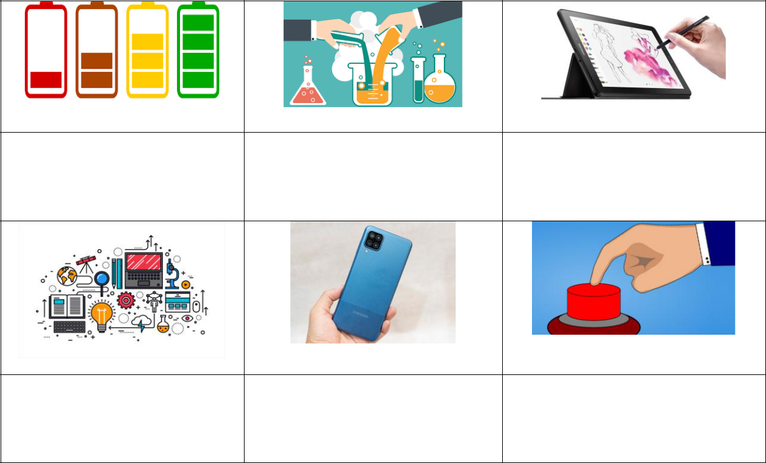

1.c…………the b…………

2. e……………………………… 3. t……………………..

- t………………………….. 5. s………….. p………………. 6. p…………..the b………….

Ex V: Circle the best word.

- Robots are one example of Artificial Intelligent/Intelligence known as AI.

- The internet can help us to communicate over/on long distances.

- All you have to do is to push/press the button to start the device.

- I need to charge the mobile phone because the battery is quite high/low.

- You need to study the information carefully before choosing the best/highest computer.

44

- It is a modern device that allows/agrees us to store a lot of information.

- Scientists have searched/researched for years into the new ways of curing cancer patients.

- Mobilephone is widely/largely used nowadays as it brings humans a lot of advantages.

- It is quite impossible to imagine/examine the Internet without personal computers.

- Many youngsters use computers to play games rather than study or wait/look for information.

Ex VI: Say the words out loud and odd one out.

1. | A. benefit | B. language | C. communicate | D. invention
2. | A. robot | B. cleaner | C. engineer | D. scientist
3. | A. explain | B. certain | C. design | D. refuse
4. | A. second | B. fifth | C. valuable | D. third
5. | A. problem | B. decide | C. solution | D. reason
6. A. software |  | B. keyboard | C. hardware | D. equipment
7. | A. important | B. processor | C. modern | D. suitable
8. | A. amount | B. display | C. store | D. exchange
9. | A. screen | B. battery | C. function | D. mouse
10. A. benefit |  | B. disadvantage | C. advantage | D. strength

Ex VII: Match.

1. save |  | a. the battery
2. press |  | b. the window
3. charge |  | c. a new language
4. start |  | d. a lot of money
 | 45

5. learn |  | e. laptop to school
6. close |  | f. many large programs
7. solve |  | g. the button
8. store |  | h. the puzzle
9. run |  | i. the device
10. bring |  | j. a lot of important information
Ex VIII: Choose the best answer.

- Why do you think it will be ……….. useful invention?

- Modern devices have changed the ……………we communicate with each other.

A. sort B. kind C. way D. type

- When you are …………….to do something, you will do things without being forced to do.

A. ready B. voluntary C. free D. compulsory

4. What are the types of community service and the benefits of …………..?

A. volunteer B. volunteered C. to volunteer D. volunteering

- The company has just introduced a new kind of smartphone which

……………fantastic.

A. looks B. sees C. watches D. views

6. I can carry my laptop around because it is very …………..and light.

A. heavy C. useful C. small D. big

- Some driverless cars in still …………… development in many countries.

A. in B. on C. over D. about

- Many people may become …………… in the future due to the development of technology.

46

A. employed B. unemployed C. employment D. unemployment

- Mr. Smith has just told me ……………to use this new device.

A. whether B. which C. how D. what

- The equipment has a touchscreen and it can be ……….. on smartphones, laptops or even tablets.

A. used B. taken C. started D. transferred

Ex IX: Match the phrases in column A with those in column B.

A |  | B
1. take a look at |  | a. the house
2. turn off |  | b. the fan on hot summer days
3. break into |  | c. new words in the dictionary
4. turn on |  | d. meeting our grandparents
5. look up |  | e. a beautiful poster
6. look forward to |  | f. electrical appliances when going out

Ex X: Complete the sentence with the correct form of the word provided.

- What ………………..are your friends talking about? They are telephone and computer. (INVENT)

- Feel free to ask me if you need further ………………. about the project.

(INFORM)

- The …………………of something is not always the result of careful experiments.

(DISCOVER)

- We can exchange information……………… thanks to the invention of email.

(CONVENIENT)

- Latest inventions have ……………… changed our lives in the last 10 years.

(COMPLETE)

47

- AI is one of the most important ………………. of the 21st century. (INVENT)

- ……………….can design machines that can think and act like humans.

(SCIENCE)

- AI can help drivers find the most ………………..route. (SUIT)

- Some special robots can do difficult or ………………….tasks effectively.

(DANGER)

- A robot vacuum cleaner can make our housework less…………… (TIRED)

Ex XI: Find the words.

 | Device |  |  |  |  | Invention |  |  |  | Popular |  |  |  |  | Technology |  |  |  | Modern
Computer |  |  |  |  |  | Benefit |  |  | Communicate |  |  |  |  |  | Control |  |  |  |  | Store
D |  | M |  | E |  | I | N |  | G |  | B |  | F |  | I | O |  | P |  | Q |  | Z
C |  | O |  | M |  | P | U |  | T |  | E |  | R |  | J | K |  | L |  | R |  | D
O |  | D |  | Y |  | Q | E |  | Z |  | N |  | V |  | L | H |  | T |  | I |  | O
M |  | E |  | F |  | I | F |  | D |  | E |  | V |  | I | C |  | E |  | B |  | N
M |  | R |  | X |  | N | D |  | H |  | F |  | X |  | Z | Y |  | C |  | I |  | L
U |  | N |  | F |  | V | S |  | W |  | I |  | Q |  | A | Z |  | H |  | M | B
N |  | F |  | L |  | E | U |  | E |  | T |  | U |  | P | S |  | N |  | W | Q
I |  | Z |  | X |  | N | V |  | B |  | N |  | K |  | U | U |  | O |  | O |  | D
C |  | O |  | N |  | T | R |  | O |  | L |  | E |  | I | U |  | L |  | P |  | L
A |  | E |  | R |  | I | C |  | B |  | V |  | B |  | S | T |  | O |  | R |  | E
T |  | W |  | P |  | O | P |  | U |  | L |  | A |  | R | R |  | G |  | E | W
E |  | A |  | Z |  | N | X |  | X |  | V |  | B |  | N | K |  | Y |  | K |  | Y

Ex XII: Fill in the gap with a suitable word given in the box.

48

communicate | programs | modern | emotions | camera
useful | allows | destinations | computers | language

- It is interesting to know that the robot can show different ……………….when

talking to human beings.

- Using laptops ………….. human beings to study better and work faster.

- We like the new apps because they allow us to ………..……. and study at the same time.

- This new robot can communicate with people using human ………………and

expressing emotions.

- Some …………… devices can measure the room size and recognize the furniture.

- Some computer ……………… can help customers plan their holidays, book flights and hotels.

- The men have just installed some interesting software on the school …………..

- With a smartphone, users now can surf the web and use maps to look for their ……………………..

- With a digital ………….., my father can quickly view and delete photos and transfer them to his computer.

- This device has a lot of …………….. features that other new models do not have.

49

Unit 6: Gender equality
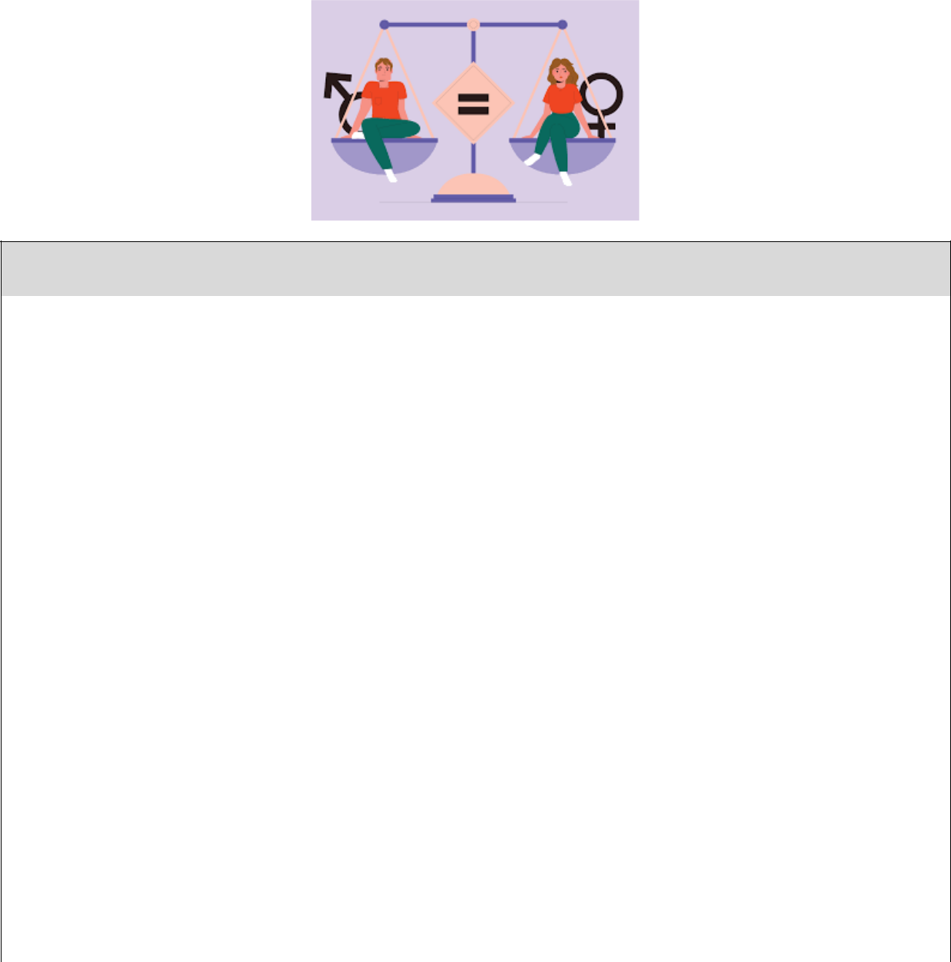

Noun

1 | Kindergarten | /ˈkɪndəɡɑːtn/ | Mẫu giáo
2 | Surgeon | /ˈsɜːdʒən/ | Bác sĩ phẫu thuật
3 | Opportunity | /ɒpəˈtjuːnəti/ | Cơ hội
4 | Gender | /ˈdʒendə(r)/ | Giới
5 | Change | /tʃeɪndʒ/ | Sự thay đổi
6 | Society | /səˈsaɪəti/ | Xã hội
7 | Education | /edʒuˈkeɪʃn/ | Sự giáo dục
8 | Income | /ˈɪnkʌm/ | Thu nhập
9 | Challenge | /ˈtʃælɪndʒ/ | Thử thách
10 | Victim | /ˈvɪktɪm/ | Nạn nhân
11 | Salary | /ˈsæləri/ | lương
12 | Marriage | /ˈmærɪdʒ/ | Sự kết hôn
 |  | 50

13 | Behaviour | /bɪˈheɪvjə(r)/ | Hành vi
14 | Status | /ˈsteɪtəs/ | Vị thế
 |  | Verb
1 | Focus on | /ˈfəʊkəs ɒn/ | Tập trung vào
2 | Allow | /əˈlaʊ/ | Cho phép
3 | Encourage | /ɪnˈkʌrɪdʒ/ | Khuyến khích
4 | Treat | /triːt/ | Đối xử
5 | Influence | /ˈɪnfluəns/ | ảnh hưởng
6 | Promote | /prəˈməʊt/ | Nâng cao
7 | Complete | /kəmˈpliːt/ | Hoàn thành
8 | Provide | /prəˈvaɪd/ | Cung cấp
9 | Improve | /ɪmˈpruːv/ | Cải thiện
10 | Face | /feɪs/ | Đối mặt
11 | Continue | /kənˈtɪnjuː/ | Tiếp tục
12 | Develop | /dɪˈveləp/ | Phát triển
13 | Behave | /bɪˈheɪv/ | Cư xử
14 | Protect | /prəˈtekt/ | Bảo vệ
15 | Punish | /ˈpʌnɪʃ/ | Phạt
16 | Appear | /əˈpɪə(r)/ | Xuất hiện
17 | Admit | /ədˈmɪt/ | Thừa nhận, công nhận
18 | Exist | /ɪɡˈzɪst/ | Tồn tại
19 | Force | /fɔːs/ | Ép buộc
 |  | Adjective
1 | Adorable | /əˈdɔːrəbl/ | Dễ thương
 |  | 51

2 | Equal | /ˈiːkwəl/ | Bình đẳng, ngang bằng
3 | Physical | /ˈfɪzɪkl/ | Thuộc về thể chất
4 | Mental | /ˈmentl/ | Thuộc về tinh thần
 |  | Phrases
1 | Career choice | /Career tʃɔɪs/ | Lựa chọn nghề nghiệp
2 | Domestic violence | /dəˈmestɪk ˈvaɪələns/ | Bạo lực gia đình
3 | Persuasion skill | /pəˈsweɪʒn skɪl/ | Kĩ năng thuyết phục
4 | Social skill | /ˈsəʊʃl skɪl/ | Kĩ năng xã hội
5 | Get married | /ɡet ˈmærid/ | Kết hôn
6 | Labour market | /ˈleɪbə(r) ˈmɑːkɪt/ | Thị trường lao động

Ex I: Find the word which has a different sound in the part underlined.

1. | A. assistants |  |  |  |  |  |  |  |  |  |  |  |  |  | B. teachers |  |  |  |  |  |  |  |  |  |  | C. nowadays |  |  |  |  |  |  |  |  |  |  | D. always
2. | A. women |  |  |  |  |  |  |  |  |  |  |  |  |  | B. written |  |  |  |  |  |  |  |  |  |  | C. wanted |  |  |  |  |  |  |  |  |  |  | D. weekend
3. | A. advantages |  |  |  |  |  |  |  |  |  |  |  |  |  | B. experiences |  |  |  |  |  |  |  |  |  |  | C. fisnishes |  |  |  |  |  |  |  |  |  |  | D. provides
4. | A. some |  |  |  |  |  |  |  |  |  |  |  |  |  | B. another |  |  |  |  |  |  |  |  |  |  | C. adorable |  |  |  |  |  |  |  |  |  |  | D. brother
5. | A. future |  |  |  |  |  |  |  |  |  |  |  |  |  | B. mustn’t |  |  |  |  |  |  |  |  |  |  | C. humour |  |  |  |  |  |  |  |  |  |  | D. tutor
6. | A. excersise |  |  |  |  |  |  |  |  |  |  |  |  |  | B. behave |  |  |  |  |  |  |  |  |  |  | C. female |  |  |  |  |  |  |  |  |  |  | D. prepare
7. | A. physics |  |  |  |  |  |  |  |  |  |  |  |  |  | B. society |  |  |  |  |  |  |  |  |  |  | C. dry |  |  |  |  |  |  |  |  |  |  | D. carefully
8. | A. improve |  |  |  |  |  |  |  |  |  |  |  |  |  | B. sister |  |  |  |  |  |  |  |  |  |  | C. invite |  |  |  |  |  |  |  |  |  |  | D. pilot
9. | A. maths |  |  |  |  |  |  |  |  |  |  |  |  |  | B. feather |  |  |  |  |  |  |  |  |  |  | C. strength |  |  |  |  |  |  |  |  |  |  | D. north
10. A. treated |  |  |  |  |  |  |  |  |  |  |  |  |  |  | B. performed |  |  |  |  |  |  |  |  |  |  | C. married |  |  |  |  |  |  |  |  |  |  | D. offered

Ex II: Choose a word that has a different stress pattern from others.

1. | A. encourage | B. influence | C. business | D. government
2. | A. equally | B. physical | C. engineer | D. educate
 |  |  | 52

Giaoandethitienganh.info

3. | A. access | B. provide | C. mental | D. social
4. | A. rural | B. gender | C. labour | D. promote
5. | A. intelligent | B. education | C. population | D. entertainment
6. | A. culture | B. challenge | C. market | D. around
7. | A. continue | B. salary | C. secondly | D. violence
8. | A. parents | B. circle | C. career | D. punish
9. | A. marriage | B. complete | C. behave | D. receive
10. A. admit |  | B. protect | C. enjoy | D. status

Ex III: Match.

1. give |  | a. important decisions
2. perform |  | b. the air force
3. develop |  | c. higher salary
4. create |  | d. the same job opportunities
5. improve |  | e. social skills
6. receive |  | f. an important operation
7. earn |  | g. gender equality
8. achieve |  | h. actions
9. join |  | i. customers
10. serve |  | j. a better education
11. make |  | k. education in rural areas
12. take |  | l. jobs for women

Ex IV: Say the words out loud and odd one out.

1. | A. develop | B. educate | C. violence | D. protect
2. | A. equal | B. receive | C. behave | D. punish
 |  |  | 53

3. | A. mental | B. physical | C. marriage | D. pratical
4. | A. income | B. opportunity | C. salary | D. payment
5. | A. secretary | B. architect | C. nurse | D. society
6. | A. achieve | B. continue | C. necessary | D. improve
7. | A. intend | B. career | C. earn | D. exist
8. | A. gentle | B. caring | C. honest | D. pressure
9. | A. traditional | B. communication C. invention |  | D. collection
10. A. official |  | B. employment | C. harmful | D. dangerous

Ex V: Put the following verbs and adjectives in the correct columns.

difficult, continue, medical, different, violence, educate, popular, assistant, discover, instruction, satisfy, exhausted, decision, collection, national, fantastic, physical, equally, November, certainly, however, yesterday
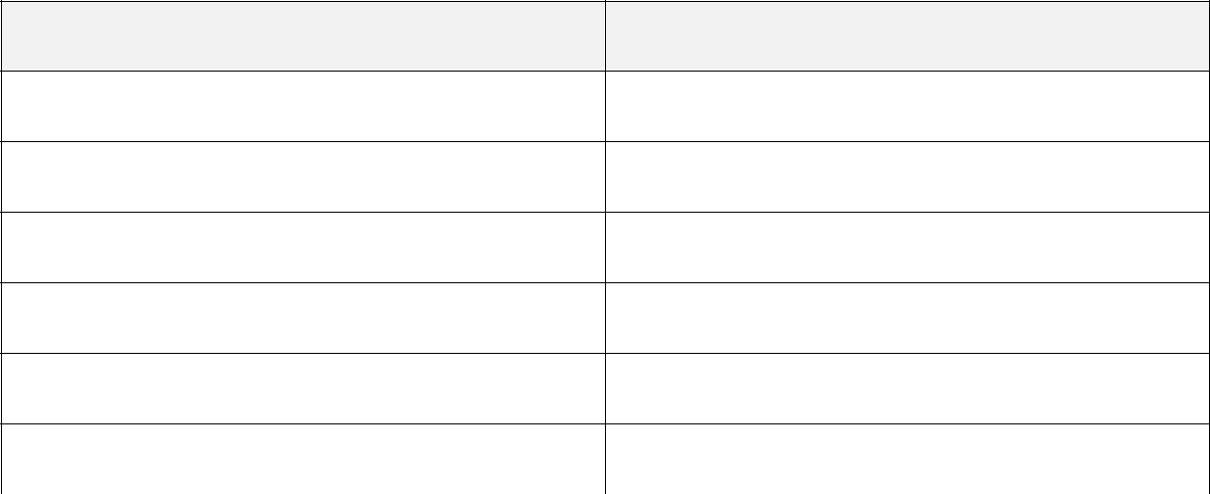

0oo

o0o

Ex VI: Complete the word below each picture.

54

1. s……………………… | 2. m…………………………. | 3. e………………………
4. g………………………… | 5. e………………………… | 6. p…………………………

Ex VII: Match the words with their meanings.

1. equality |  | a. the money that employees receive for doing their
 |  | job
2. opportunity |  | b. the way that someone behaves towards other
 |  | people
3. violence |  | c. a process of teaching, learning and training in
 |  | schools, colleges or universities
4. career |  | d. the fact of being equal in rights, status or
 |  | advantages
5. education |  | e. violent behaviour that is intended to hurt or kill
 |  | somebody
6. behaviour |  | f. the legal relationship between two people
7. marriage |  | g. a series of jobs that a person has in a particular area
 |  | of work
8. salary |  | h. a time when a particular situation makes it possible
 |  | to do or achieve something

Ex VIII: Circle the best word.

- A good surgeon must have physical and mental strong/strength.

- The aim of this project is to develop children’s social/society skills.

55

- Unfortunately, in many parts of the world men and women have an equal/unequal status.

- In some places, women have to work long/longer to earn the same amount of money as men.

- Girls can face serious health/healthy risks if they get married young.

- What can education/educated girls do for their children and families?

- My father can work well above/under pressure and he doesn’t mind working long hours.

- Doctors usually make important decision about patients’ health and safe/safety.

- What qualities/qualify do employers need for this job?

- Can men and women be given equal opportunity/opportunities in the workplace?

Ex IX: Choose the best answer.

1. Women can …………in many parts of the army and police forces nowadays.

A. do B. serve C. work D. join

- Mary can’t work long hours because she has to ………… care of her small children.

A. look B. make C. put D. take

- Employers ……………. treat male and female workers unfairly.

A. shouldn’t B. should C. must D. mustn’t

- …………… girls than boys go to school or stay long at school.

A. Few B. Fewer C. Little D. Less

- They have better job skills and can earn ……….. salaries than others in the company.

A. low B. lower C. high D. higher

- It was the …………..official international football match for women.

56

A. first B. one C. once D. twice

7. Should all people be …………..with equal access to information?

A. provide B. to provide C. provided D. providing

- We must …………… actions to stop domestic violence immediately.

A. do B. create C. design D. take

- In some rural areas, girls are ………………….to do hard work at home and in the fields.

A. force B. to force C. forced D. forcing

- In many classes, girls can ……………..much better than boys.

A. perform B. represent C. treat D. appear Pham Thu Tra - 0989552182

Ex X: Do the crossword.
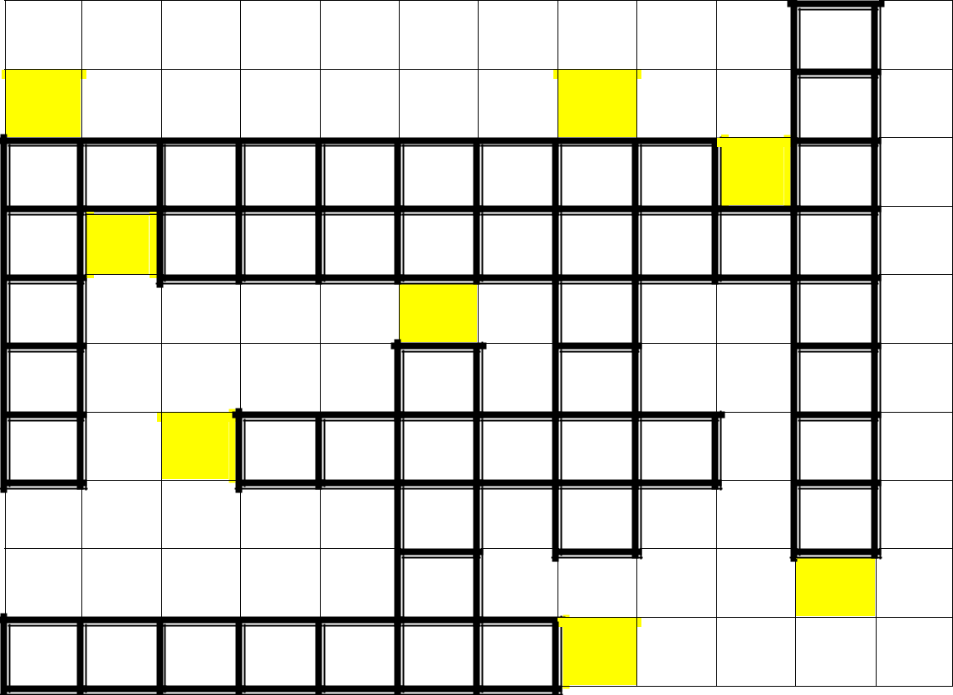

5 | 7
 | 1
 | 2
 | 6
 | 3
 | 8

4

ACROSS:

57

- My parents always ……………………me in my choice of career.

- The greatest ………………..facing the country is air pollution.

- My uncle had a successful ………………. in television journalism.

- The children have grown up to become useful members of ……………….

DOWN:

- There is an ………………..number of boys and girls in our class.

- They ……………….. all candidates equally in this contest.

- The government is working ways to improve …………….equality in employment.

- There is a growing problem of ……………… violence in rural areas nowadays.

Ex XI: Fill in the gap with a suitable word given in the box.

challenges | skills | knowledge | education | because
differences | project | violence | treatment | Gender

- Girls who get married at an early age might become victims of domestic

………………

- ……………. can give girls the opportunity to have a better life in the future.

- Women working in jobs traditionally done by men still have to face big

…………………

- Some women can earn high salaries because they don’t have good job

……………

- Women have to face daily violence and and unequal ……………… both at home and at work.

- …………… equality has been greatly improved all over the world.

- Men and women have the same abilities to learn and apply medical …………...

- Our group worked on the ………… called gender equality in the modern society last week.

58

9. Gender discrimination sometimes starts at home …………. parents treat

boys and girls differently.

- The research shows that gender ……………. can not prevent a person from pursuing a job.

Ex XII: Complete the sentence with the correct form of the word provided.

- Is the job ……………………done by men or women, Jim? (TRADITION)

- Both men and women have the same abilities to learn and apply medical

……………….. (KNOW)

- Education is really important in fighting for ……………. between the genders.

(EQUAL)

- Governments, ………………….. and individuals must work together to achieve gender equality all over the world. (ORGANISE)

- Girls and women should be provided equal access to education and

……………… (EMPLOY)

- Girls should not be forced to get ……………….. before the age of eighteen.

(MARRY)

- Domestic ………………… against girls and women must be stopped. (VIOLENT)

- They have to meet requirements of physical ………………., mental strength and intelligence. (FIT)

- Catherine and Susan are talented and ……………….. doctors in our hospital.

(SUCCESS)

- In this country, girls are …………….. to become wives and mothers before the age of fifteen. (FORCE)

59

Unit 7: Viet Nam and international organisations

Noun

1 | Organisation | /ɔːɡənaɪˈzeɪʃn/ | Tổ chức
2 | Goal | /ɡəʊl/ | Mục tiêu
3 | Poverty | /ˈpɒvəti/ | Sự nghèo đói
4 | Expert | /ˈekspɜːt/ | Chuyên gia
5 | Investor | /ɪnˈvestə(r)/ | Nhà đầu tư
6 | Responsibility | /rɪspɒnsəˈbɪləti/ | Trách nhiệm
7 | Custom | /ˈkʌstəm/ | Phong tục, tập quán
8 | Value | /ˈvæljuː/ | Giá trị
9 | Agreement | /əˈɡriːmənt/ | Hiệp định
10 | Quality | /ˈkwɒləti/ | Chất lượng
11 | Goods | /ɡʊdz/ | Hàng hóa
 |  | 60

11 | Service | /ˈsɜːvɪs/ | Dịch vụ
12 | Trade | /treɪd/ | Thương mại
13 | Destination | /destɪˈneɪʃn/ | Điểm đến
14 | Region | /ˈriːdʒən/ | Khu vực
15 | Relation | /rɪˈleɪʃn/ | Mối quan hệ
16 | Benefit | /ˈbenɪfɪt/ | Lợi ích
17 | Culture | /ˈkʌltʃə(r)/ | Văn hóa
 |  | Verb
1 | Reduce | /rɪˈdjuːs/ | Giảm bớt
2 | Improve | /ɪmˈpruːv/ | Cải thiện, nâng cao
3 | Participate (in) | /pɑːˈtɪsɪpeɪt/ | Tham gia
4 | Form | /fɔːm/ | Thành lập, tạo ra
5 | Protect | /prəˈtekt/ | Bảo vệ
6 | Support | /səˈpɔːt/ | Hỗ trợ
7 | Commit | /kəˈmɪt/ | Cam kết
8 | Welcome | /ˈwelkəm/ | Chào đón
9 | Respect | /rɪˈspekt/ | Tôn trọng
10 | Focus (on) | /ˈfəʊkəs/ | Tập trung vào
11 | Select | /sɪˈlekt/ | Chọn lựa
12 | Gain | /ɡeɪn/ | Thu được
13 | Accept | /əkˈsept/ | Chấp nhận
 |  | Adjective
1 | International | /ɪntəˈnæʃnəl/ | Quốc tế
2 | Active | /ˈæktɪv/ | Tích cực, năng động
 |  | 61

3 | Disadvantaged | /dɪsədˈvɑːntɪdʒd/ | Bất lợi, khó khăn
4 | Economic | /iːkəˈnɒmɪk/ | Thuộc về kinh tế
5 | Foreign | /ˈfɒrən/ | Nước ngoài
6 | Various | /ˈveəriəs/ | Đa dạng
7 | Essential | /ɪˈsenʃl/ | Thiết yếu, quan trọng
8 | Competitive | /kəmˈpetətɪv/ | Cạnh tranh, ganh đua
9 | Attractive | /əˈtræktɪv/ | Cuốn hút, hấp dẫn
10 | Financial | /faɪˈnænʃl/ | Thuộc về tài chính
11 | Peacekeeping | /ˈpiːskiːpɪŋ/ | Gìn giữ hòa bình
 |  | Phrases
1 | World peace | /wɜːld piːs/ | Hòa bình thế giới
2 | Drop out of | /drɒp aʊt əv/ | Từ bỏ
3 | Technical support | /ˈteknɪkl səˈpɔːt/ | Hỗ trợ kĩ thuật
4 | Detailed plan | /ˈdiːteɪld plæn/ | Kế hoạch chi tiết
5 | Southest Asia | /saʊθ ˈiːst ˈeɪʒə/ | Đông Nam Á
6 | Get access to | /ɡet ˈækses tə/ | Tiếp cận

Ex I: Find the word which has a different sound in the part underlined.

1. A. welcome |  |  |  |  |  |  |  | B. commit
2. | A. gain |  |  |  |  |  |  | B. maintain
3. | A. clothes |  |  |  |  |  |  | B. services
4. | A. choice |  |  |  |  |  |  | B. schooling
5. | A. improved |  |  |  |  |  |  | B. attracted
6. | A. parking |  |  |  |  |  |  | B. army
7. | A. lower |  |  |  |  |  |  | B. folder

C. social |  |  |  |  |  |  |  | D. promote
C. rainy |  |  |  |  |  |  |  | D. fountain
C. countries |  |  |  |  |  |  |  | D. lives
C. charity |  |  |  |  |  |  |  | D. achieve
C. exported |  |  |  |  |  |  |  | D. provided
C. various |  |  |  |  |  |  |  | D. darkness
C. growth |  |  |  |  |  |  |  | D. foreign
62

8. | A. should |  |  |  |  | B. about |  |  |  |  | C. loudly |  |  |  |  |  | D. founder
9. | A. healthy |  |  |  |  | B. together |  |  |  |  | C. thousand |  |  |  |  |  | D. monthly
10. A. studied |  |  |  |  |  | B. hundred |  |  |  |  | C. number |  |  |  |  |  | D. further

Ex II: Choose a word that has a different stress pattern from others.

1. | A. available | B. disadvantaged | C. participant | D. competitive
2. | A. benefit | B. business | C. company | D. volunteer
3. | A. different | B. foreigner | C. united | D. visitor
4. | A. standard | B. export | C. tourist | D. travel
5. | A. predict | B. peaceful | C. office | D. service
6. | A. economic | B. opportunity | C. international | D. organisation
7. | A. really | B. soldier | C. support | D. global
8. | A. charity | B. video | C. serious | D. important
9. | A. quality | B. condition | C. cultural | D. sociable
10. A. exhibition |  | B. activity | C. community | D. investment

Ex III: Put the words in correct columns.

certificate, education, economic, communicate, voluntary, participate, activity, participant, beautifully, competitive, responsible, environment, comfortable, economy, politician, architecture, equality, community, traditional, disadvantaged, ordinary, military, development, security

0ooo

o0oo

oo0o

63

Ex IV: Circle the best word.

- As a member of the organisation, we have to follow/break the strict rules.

- Some imported goods are much cheaper than our locally/local produced goods.

- Viet Nam is one of many countries that is willing to participate/join the peacekeeping activities in the region.

- Ha Noi has become one of the the most attracting/attractive destinations for foreign visitors.

- By joining more international organisations, our country has become a member of a wider/higher community.

- Many young people nowadays prefer to work/working in a more competitive working environment.

- Variety/Various job opportunities are now available to young people in the province.

- We all welcome foreign/foreigner businesses who want to invest in the economy.

- In the past, the country was not as active on/in the interational stage as it it today.

Ex V: Match.

1. join |  | a. disadvantaged children
2. reduce |  | b. more markets
3. enter |  | c. an important project
4. welcome |  | d. relations with neighbours
5. support |  | e. an agreement
 | 64

6. sign |  | f. job trainning and career advice
7. use |  | g. a living
8. find |  | h. poverty
9. run |  | i. foreign businesses
10. offer |  | j. donations effectively
11. form |  | j. an international organisation
12. earn |  | k. a good job
Ex VI: Say the words out loud and odd one out. Giaoandethitienganh.info

1. | A. design | B. trade | C. economy | D. politics
2. | A. cheap | B. attractive | C. expensive | D. package
3. A. become |  | B. customer | C. select | D. commit
4. | A. popular | B. financial | C. attraction | D. natural
5. A. product |  | B. import | C. focus | D. welcome
6. | A. college | B. reduce | C. university | D. school
7. | A. local | B. international | C. responsible | D. national
8. | A. peace | B. war | C. country | D. practical
9. | A. recognise | B. foreign | C. improve | D. invest
10. A. goal |  | B. aim | C. dream | D. member

Ex VII: Match the words with their meanings.

Pham Thu Tra - 0989552182

1. organisation |  | a. an open area where people buy and sell goods
2. custom |  | b. to make something/somebody better than
 |  | before
3. market |  | c. a group of people who form a business, club
 |  | together
 | 65

4. support |  | d. not having education, money that people need to
 |  | succeed in life
5. disadvantaged |  | e. things that are produced to be sold
6. government |  | f. an accepted way of behaving or of doing things in
 |  | a society or a community
7. improve |  | g. a group of people who are responsible for
 |  | controlling a country
8. goods |  | h. help or encourage somebody/something

Ex VIII: Choose the best answer.

- The organisation …………… many opportunities for all children to attend school and study.

A. supports B. promotes C. provides D. strengthens

- Teenagers should learn some necessary skills for the job …………before they finish school.

A. market B. place C. area D. region

- …………. does the organisation particularly aim to do for the children in our country?

A. When B. What C. Where D. Which

4. Do you think it will be the most useful program ………… our local community?

A. with B. of C. for D. in

- Which project will certainly ………….more benefits to people in our village?

A. bring B. commit C. improve D. support

- Many teenagers nowadays drop…………. of school and start working to earn their living.

A. down B. out C. front D. up

- The country is willing to ………….friendly relations with other nations.

66

A. respect B. accept C. welcome D. develop

- Various cultural exchanges help ………….visitors know more about our country.

A. foreign B. local C. national D. valuable

- Vietnamese students are now ………….to get educational opportunities abroad than before.

A. easiest B. easier C. easy D. easily

- Many Vietnamese universities and colleges also accept ……………..students.

A. local B. national C. cultural D. international

Ex IX: Complete the word below each picture.

1. g………………………….. | 2. c…………………………… | 3. re……………………………..
4. in………………………….. | 5. co…………………………… | 6. c……………………………..
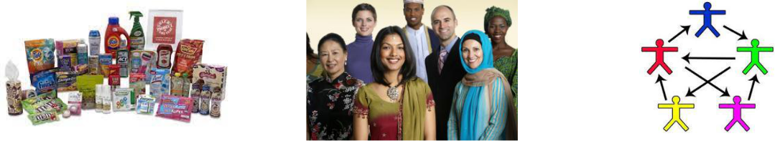

Ex X: Fill in the gap with a suitable word given in the box.

electricity | peace | festivals | advantages | destinations
knowledge | country | cultural | opportunities | career

- The government has tried its best to attract more foreign investors to the

………………...

67

- Viet Nam has become one of the most popular ………………. for foreign tourists in the world.

- People in some developing countries lack basic services such as gas, water and ………………..

- The organisation aims to help countries all over the world promote their history, traditions, buildings and places of ……………importance.

- Some countries in the region have helped achieve …………. in the global community.

- There are numerous ……….…… of Viet Nam as a member of many international organisations.

- Organising different ………………..helps the country promote its local customs and cultural values.

- We can help them continue their education by offering them job training and ……………..advice.

- When teenagers finish school, they should have some necessary skills and

…………….. to work in a fast-changing world.

- I believe that the project brings local people more ……………..to improve their living standards.

Ex XI: Complete the crossword.
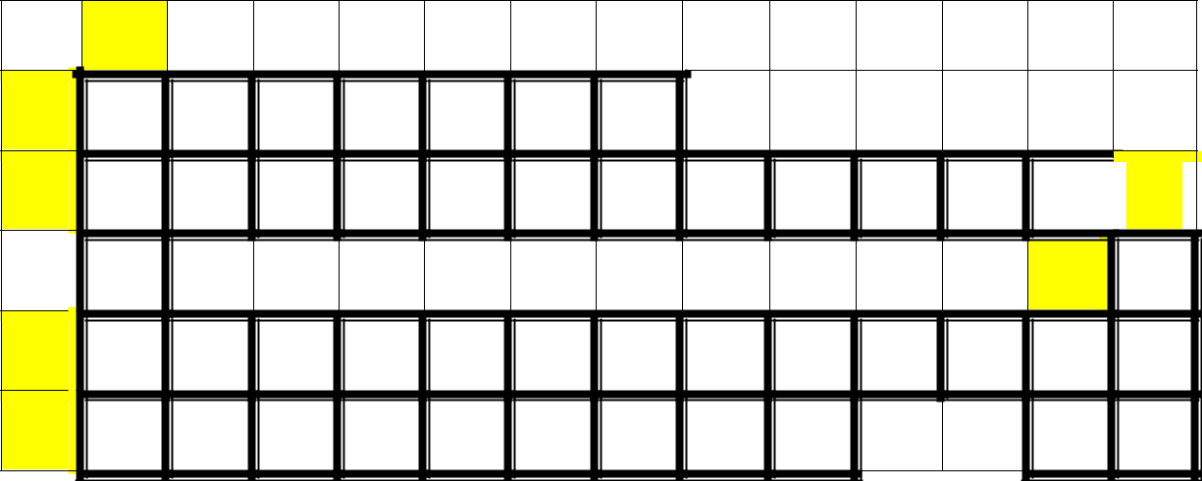

 | 7
1 | P
2 | O
3 | E
4 | R
 | 68

10

9 | G
A

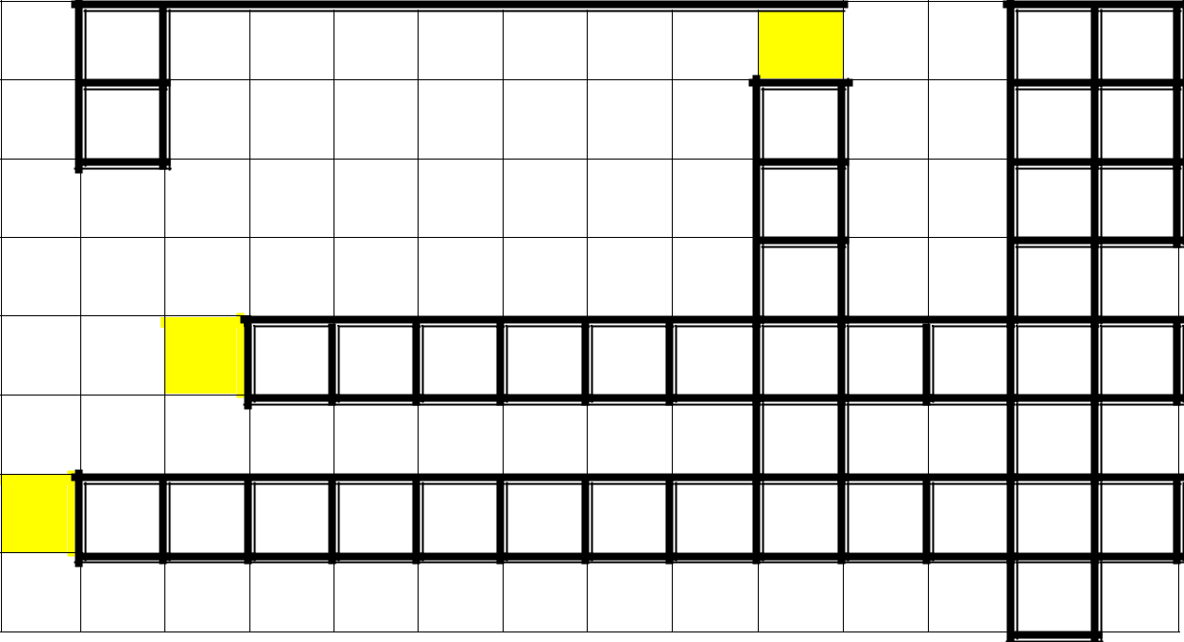

5

8

C

G

6 | D

ACROSS:

- This trade fair will help businesses from Viet Nam to p………………. their products.

- The o……………………. provides housing and support services for homeless young people in the countryside.

- Efforts to reduce waste are strongly supported by e………………………groups.

- We seek to improve r………………..between our two countries.

- Different g…………………. in the world should join hands to reduce global warming and air pollution

- The organisation was set up to support the most d……………………children all over the world.

DOWN:

- The government in this developing country is aiming to reduce child p……………. in the near future.

- They c……………. to provide our country with technical support and expert advice.

- The new club provides a wide range of a…………………. including football, tennis and swimming.

69

- There is a g……………….net work of 64 national, regional and international organisations.

Ex XII: Complete the sentence with the correct form of the word provided.

- Being a member of international organisations can create more …………………

opportunities for both Vietnamese and foreign students. (EDUCATION)

- Viet Nam has become a more active ………………..in both regional and global activitties. (PARTICIPATE)

- The program has created a lot of opportunities for ……………. teenagers to continue their education. (ADVANTAGE)

- The primary aim of the new policy is to reduce ………………. and improve life of people in rural areas. (POOR)

- The program helps promote equal participation in society and a ……………… in which people respect each other. (CULTURAL)

- The country has joined some ………………..educational programs to improve children’s learning results. (REGION)

- It has been selected as the first traning centre for international

peacekeeping………………….in Southest Asian. (ACTION)

- ……………….. foreign relations has helped the country gain many financial benefits. (DEVELOP)

- Being a member of many international ……………….. has created more educational opportunities for both Vietnamese and foreign students. (ORGANISE)

- My sister is now working in an international company and she has improved her ………………….. and language skills a lot. (COMMUNICATE)

70

Unit 8: New ways to learn

 |  | Noun
1 | Information | /ɪnfəˈmeɪʃn/ | Thông tin
2 | Material | /məˈtɪəriəl/ | Tài liệu
3 | Control | /kənˈtrəʊl/ | Sự kiểm soát
4 | Method | /ˈmeθəd/ | Phương pháp
5 | Tip | /tɪp/ | Mẹo vặt
6 | Website | /ˈwebsaɪt/ | Trang web
7 | Outline | /ˈaʊtlaɪn/ | Dàn ý
8 | Presentation | /preznˈteɪʃn/ | Sự thuyết trình
 |  | 71

9 | Strategy | /ˈstrætədʒi/ | Chiến lược
10 | Workshop | /ˈwɜːkʃɒp/ | Hội thảo
11 | Idea | /aɪˈdɪə/ | Ý tưởng
11 | Individual | /ɪndɪˈvɪdʒuəl/ | Cá nhân
12 | Purpose | /ˈpɜːpəs/ | Mục đích
 |  | Verb
1 | Upload | /ʌpˈləʊd/ | Tải lên
2 | Search | /sɜːtʃ/ | Tìm kiếm
3 | Discuss | /dɪˈskʌs/ | Thảo luận
4 | Encourage | /ɪnˈkʌrɪdʒ/ | Khuyến khích, khích lệ
5 | Exchange | /ɪksˈtʃeɪndʒ/ | Trao đổi
6 | Conversation | /kɒnvəˈseɪʃn/ | Hội thoại
7 | Knowledge | /ˈnɒlɪdʒ/ | Kiến thức
8 | Harm | /hɑːm/ | Gây hại
9 | Review | /rɪˈvjuː/ | Ôn tập
10 | Enable | /ɪˈneɪbl/ | Cho phép
11 | Install | /ɪnˈstɔːl/ | Lắp đặt, cài đặt
 |  | Adjective
1 | Original | /əˈrɪdʒənl/ | Ban đầu, nguyên thủy
2 | Traditional | /trəˈdɪʃənl/ | Truyền thống
3 | Face-to-face | /feɪs tə ˈfeɪs/ | Mặt đối mặt, trực tiếp
4 | Specific | /spəˈsɪfɪk/ | Cụ thể
5 | Immediate | /ɪˈmiːdiət/ | Ngay lập tức
6 | Direct | /dəˈrekt/ | Trực tiếp
 |  | 72

7 | Instruction book | /ɪnˈstrʌkʃn/ | Sách hướng dẫn
8 | Impressive | /ɪmˈpresɪv/ | ấn tượng
9 | Familiar (with) | /fəˈmɪliə(r)/ | Quen thuộc với
10 | Suitable | /ˈsuːtəbl/ | Phù hợp
11 | Confident | /ˈkɒnfɪdənt/ | Tự tin
12 | Responsible | /rɪˈspɒnsəbl/ | Trách nhiệm
13 | Digital | /ˈdɪdʒɪtl/ | Kỹ thuật số
14 | Personal | /ˈpɜːsənl/ | Cá nhân
 |  | Phrases
1 | Take notes | /teɪk nəʊts/ | Ghi chép
2 | Online learning | /ˌɒnˈlaɪn ˈlɜːnɪŋ/ | Học trực tuyến
3 | Blended learning | /blendɪd ˈlɜːnɪŋ/ | Học hỗn hợp
4 | Internet | /ˈɪntənet kəˈnekʃn/ | Kết nối Internet
 | connection
5 | Technical problem | /ˈteknɪkl ˈprɒbləm/ | Vấn đề kĩ thuật
6 | Pay attention to | /peɪ əˈtenʃn tu/ | Chú ý tới
7 | Have access to | /hæv ˈækses tu/ | Tiếp cận với
8 | Study schedule | /ˈstʌdi /ˈʃedjuːl/ | Lịch học
9 | Short-sightedness | /ʃɔːt ˈsaɪtɪdnəs/ | Cận thị
10 | Research result | /rɪˈsɜːtʃ rɪˈzʌlt/ | Kết quả nghiên cứu
11 | Teamwork skill | /ˈtiːmwɜːk skɪl/ | Kĩ năng làm việc nhóm
11 | Play the role (of) | /pleɪ ðə rəʊl/ | Đóng vai trò
12 | Real-life | /riːəl ˈlaɪf | Kinh nghiệm thực tế cuộc sống
 | experience | ɪkˈspɪəriəns/
13 | Make friends | /meɪk frendz/ | Kết bạn
 |  | 73

Giaoandethitienganh.info

 | (with)
14 | Field trip | /fiːld trɪp/ | Chuyến đi thực tế
15 | Electronic device | /ɪlekˈtrɒnɪk dɪˈvaɪs/ | Thiết bị điện tử
16 | Social interaction | /ˈsəʊʃl ɪntərˈækʃn/ | Tương tác xã hội

Ex I: Find the word which has a different sound in the part underlined.

1. | A. schedule |  |  |  |  |  |  |  |  |  |  |  | B. research
2. | A. discuss |  |  |  |  |  |  |  |  |  |  |  | B. purpose
3. | A. harmful |  |  |  |  |  |  |  |  |  |  |  | B. horrable
4. | A. original |  |  |  |  |  |  |  |  |  |  |  | B. strategy
5. | A. review |  |  |  |  |  |  |  |  |  |  |  | B. elephant
6. | A. specific |  |  |  |  |  |  |  |  |  |  |  | B. electronic
7. | A. blended |  |  |  |  |  |  |  |  |  |  |  | B. improved
8. | A. online |  |  |  |  |  |  |  |  |  |  |  | B. outline
9. A. method |  |  |  |  |  |  |  |  |  |  |  |  | B. brother
10. A. famous |  |  |  |  |  |  |  |  |  |  |  |  | B. society

- charming C. upload C. honour C. advantage C. device C. social

C. sighted C. website C. Northern C. workshop

- exchange D. understand D. hamster D. gorilla

D. enable D. classroom D. visited D. invention D. whether D. scientist

Ex II: Choose a word that has a different stress pattern from others.

1. | A. technical | B. encourage | C. personal | D. confident
2. | A. connection | B. internet | C. suitable | D. digital
3. | A. improve | B. design | C. result | D. email
4. | A. experience | B. interaction | C. responsible | D. familiar
5. | A. computer | B. attention | C. impressive | D. honesty
6. | A. immediate | B. traditional | C. conversation | D. material
7. | A. interesting | B. instruction | C. yesterday | D. benefit
8. A. review |  | B. problem | C. focus | D. knowledge
 |  |  | 74

9. A. activity

10. A. recorder

B. geography B. relative

C. communicate C. advantage

D. information D. discussion

Ex III: Say the words out loud and odd one out.

1. | A. sometimes | B. quickly | C. always | D. usually
2. A. comment |  | B. idea | C. project | D. exchange
3. | A. digital | B. tool | C. device | D. equipment
4. | A. classmate | B. relative | C. customs | D. neighbour
5. | A. reply | B. answer | C. response | D. question
6. A. tablet |  | B. motorbike | C. computer | D. smartphone
7. A. laptop |  | B. newpaper | C. novel | D. magazine
8. | A. social | B. discussion | C. entertainment | D. interaction
9. A. exchange |  | B. improve | C. valuable | D. promote
10. A. phrase |  | B. identify | C. word | D. sentence

Ex IV: Complete the word below each picture.

1. k…………………………… |  |  | 2. c…………………………… | 3. w…………………………..
4. i…………………………. |  |  | 5. l ………….. m…………… | 6. p……………………………
 | Ex V: | Match.
 |  |  | 75

1. watch |  | a. materials before going to class
2. find |  | b. a lot of projects
3. take |  | c. more information about the topic
4. prepare |  | d. all the lessons
5. do |  | e. new learning activities
6. understand |  | f. videos
7. try |  | g. long distances
8. save |  | h. careful notes
9. travel |  | i. the lessons well
10. attend |  | j. a lot of time

Ex VI: Choose the best answer.

- He asks me to watch the video and find more information …………….the given topic.

A. in B. about C. with D. of

- We prefer working in groups because it gives us a chance to discuss ……….

our classmates.

A. with B. about C. in D. to

- Our class has to ………………learning materials at home and discuss the topic in class tomorrow.

A. support B. upload C. strengthen D. prepare

- Our group is ………..a lot projects that help us understand the lessons much better.

A. making B. doing C. taking D. organising

- I don’t like the traditional methods. Therefore, I wish to ………………the new learning activities.

76

A. review B. exchange C. try D. encourage

- Jacks gets a lot of useful tips on this website and he has ………….. an outline for his presentation.

A. made B. done C. taken D. read

- When students have problems, they can ask ……………answers or help immediately.

A. on B. for C. with D. about

- The boy doesn’t know how to ………….. the new app on his smartphone.

A. open B. create C. install D. set up

- The computer I often ………….to learn English is a birthday present from my father.

A. use B. make C. design D. start

- Smartphones can store audio books because they have a lot of storage

…………...

A. place |  |  | B. area |  | C. space | D. room
 | Ex VII: | Match the words with their definitions.
1. digital |  |  |  | a.a piece of work involving careful study of a subject
 |  |  |  | over a period of time
2. instruction |  |  |  | b. using a system of receiving or sending information
 |  |  |  | as a series of the numbers, showing an electronic
 |  |  |  | signal is there or is not there
3. blended |  |  |  | c. a small computer that is easy to carry, with a large
 |  |  |  | touchscreen and usually without a keyboard
4. project |  |  |  | d. facts or details about somebody or something
5. internet |  |  |  | e. a particular way of doing something
6. information |  |  |  | f. detailed information on how to do or use
 |  |  |  | something
 |  |  |  |  | 77

7. tablet |  | g. an international computer network connecting
 |  | other networks and computers that allows people to
 |  | share information all over the world
8. method |  | h. to mix two or more things together
Ex VIII: Circle the best word.

- Face-to-face learning allows us to communicate with teachers immediately and directly/indirectly.

- Learning in a traditional classroom also has few/fewer distractions than learning online.

- She thinks that one learning has more/less advantages than disadvantages.

- Siting in front of a computer is not healthy with/for our eyes and back.

- What/Which do you think is more effective: blended or traditional learning?

- Have you all finished the project given/taken by our English teacher, Susan?

- Technology has provided/brought new experiences to both language learners and teachers.

- One benefit of face-to-face learning is that students can connect with others and help solve problems more quicker/quickly.

- Students can be easily distracted by online entertain/entertainment programs when they study online.

- Many schools put/place computer skills into their programs to prepare students for their future career.

Ex IX: Find the following words in the word search.

 |  | discussion |  |  |  |  |  | project |  |  |  |  | access |  |  |  |  |  |  | direct |  |  |  | traditional
 |  | attention |  |  |  |  | presentation |  |  |  |  |  | material |  |  |  |  |  | internet |  |  |  |  |  | method
 |  | M | A |  |  | T |  | E |  |  | R |  | I |  |  | A |  | L |  |  | Y | U |  |  | O | L
 |  | V | T |  |  | Z |  | A |  |  | Q |  | D |  |  | K |  | L |  |  | Y | D |  |  | I | O
 |  |  |  |  |  |  |  |  |  |  |  |  |  | 78

P | R | E | S | E | N | T | A | T | I | O | N
R | A | S | Z | X | C | B | N | M | S | E | Y
O | D | I | U | I | O | P | L | J | C | G | H
J | I | D | U | N | X | Z | V | Q | U | W | M
E | T | I | S | T | A | C | C | E | S | S | E
C | I | R | Q | E | E | S | W | Z | S | X | T
T | O | E | H | R | D | F | I | U | I | Y | H
Q | N | C | W | N | X | S | F | J | O | N | O
V | A | T | T | E | N | T | I | O | N | D | D
W | L | Q | L | T | O | P | X | B | V | C | K
Ex X: Fill in the gap with a suitable word given in the box.

discussion | challenge | traditional | develop | materials
effective | search | materials | connection | suitalbe

- Blended learning is a way of learning that combines online materials with

………………..classroom methods.

- One disadvantage of online learning is that we really need a fast internet………………

- An online ………….. abroad gives us a chance to exchange comments and ideas about our projects with our classmates.

- I usually go to the school library, read newspaper artices or …………… the

Internet to find useful information.

- Online learning is not …………… for students who have no internet connection or computers.

79

- Teachers encourage and ……………. learners to become responsible and confident individuals.

- When attending school camps, students can make friends with other students and ……………….life skills in unfamiliar situations.

- Textbooks, lectures and other traditional ………………..make make learners of English feel bored.

- Learners can check their answers right after they ………………..the online exercises or tests.

- Learning online is much more …………… because it allows us to learn at our own pace.

Ex XI: Complete the sentence with the correct form of the word provided.

- With online learning, we can learn anytime and anywhere with an internet

……………… (CONNECT)

- Blended learning can help students develop ………………… and teamwork skills. (COMMUNICATE)

- Some modern schools are particularly designed to help each student to be

………………… (SUCCESS)

- Students are expected to participate in …………………….and express their personal opinions in the lessons. (DISCUSS)

- The field trips are designed to give students real-world ………………..

(EXPERIENCE)

- Both Jim and Mary are looking for some information for their ……………….

Tommorrow. (PRESENT)

- Sport can be used as a ……………….tool to improve gender roles and build a healthy lifestyle. (POWER)

- Mr. Smith has ……………… changed his traditional classrooms into a modern learning environment. (SUCCESS)

- Technology makes it easier for learners to find information quickly and

……………..( ACCURATE)

80

- We love ……………….in discussions as it hellps us share our ideas and learn from other classmates. (PARTICIPATE)

Unit 9: Protecting the environment

 |  | Noun
1 | Issue | /ˈɪʃuː/ | Vấn đề
2 | Deforestation | /diːˌfɒrɪˈsteɪʃn/ | Nạn phá rừng
3 | Solution | /səˈluːʃn/ | Giải pháp
4 | Effort | /ˈefət/ | Nỗ lực
5 | Biodiversity | /baɪəʊdaɪˈvɜːsəti/ | Đa dạng sinh học
 |  | 81

6 | Habitat | /ˈhæbɪtæt/ | Môi trường sống
7 | Ecosystem | /ˈiːkəʊsɪstəm/ | Hệ sinh thái
8 | Wildlife | /ˈwaɪldlaɪf/ | Động vật hoang dã
9 | Effect | /ɪˈfekt/ | Sự tác động
10 | Balance | /ˈbæləns/ | Sự cân bằng
11 | Impact | /ˈɪmpækt/ | Sự tác động
11 | Atmosphere | /ˈætməsfɪə(r)/ | Không khí
12 | Consequence | /ˈkɒnsɪkwəns/ | Hậu quả
13 | Substance | /ˈsʌbstəns/ | Chất
14 | Cause | /kɔːz/ | Nguyên nhân
15 | Awareness | /əˈweənəs/ | Nhận thức
 |  | Verb
1 | Identify | /aɪˈdentɪfaɪ/ | Xác định
2 | Organise | /ˈɔːɡənaɪz/ | Tổ chức
3 | Explain | /ɪkˈspleɪn/ | Giải thích
4 | Focus (on) | /ˈfəʊkəs/ | Tập trung vào
5 | Suggest | /səˈdʒest/ | Giải thích
6 | Succeed | /səkˈsiːd/ | Thành công
7 | Advise | /ədˈvaɪz/ | Khuyên nhủ
8 | Prevent | /prɪˈvent/ | Ngăn chặn
9 | Depend (on) | /dɪˈpend/ | Lệ thuộc vào
10 | Survive | /səˈvaɪv/ | Tồn tại
11 | Involve | /ɪnˈvɒlv/ | Liên quan
12 | Deal (with) | /diːl/ | Giải quyết, đối mặt
 |  | 82

13 | Destroy | /dɪˈstrɔɪ/ | Phá hủy, hủy hoại
14 | Damage | /ˈdæmɪdʒ/ | Phá hủy, hủy hoại
15 | Increase | /ɪnˈkriːs/ | Gia tăng
16 | Disappear | /dɪsəˈpɪə(r)/ | Biến mất
17 | Believe | /bɪˈliːv/ | Tin tưởng
18 | Ban | /bæn/ | Cấm
19 | Threaten | /ˈθretn/ | Đe dọa
20 | Punish | /ˈpʌnɪʃ/ | Phạt
 |  | Adjective
1 | Practical | /ˈpræktɪkl/ | Thực tế
2 | Global | /ˈɡləʊbl/ | Thuộc về toàn cầu
3 | Serious | /ˈsɪəriəs/ | Nghiêm trọng
4 | Respiratory | /rəˈspɪrətri dɪˈziːz/ | Bệnh về đường hô hấp
 | disease
5 | Illegal | /ɪˈliːɡl/ | Bất hợp pháp
6 | Strict | /strɪkt/ | Nghiêm khắc
7 | Avoid | /əˈvɔɪd/ | Né tránh
 |  | Phrases
1 | Come up with | /kʌm ʌp wɪð/ | Nghĩ ra
2 | Global warming | /ˈɡləʊbl ˈwɔːmɪŋ/ | Sự nóng lên toàn cầu
3 | Endangered | /ɪnˈdeɪndʒəd | Động vật có nguy cơ tiệt chủng
 | animal | ˈænɪml/
4 | Climate change | /ˈklaɪmət tʃeɪndʒ/ | Biến đổi khí hậu
5 | Cut down | /kʌt daʊn/ | Đốn, chặt
6 | Alarming rate | /əˈlɑːmɪŋ reɪt/ | Mức độ đáng báo động
 |  | 83

Ex I: Find the word which has a different sound in the part underlined.

1. | A. Southern |  |  |  |  |  |  |  |  |  |  |  | B. gather |  |  |  |  |  |  |  |  |  |  |  | C. threaten |  |  |  |  |  |  |  |  |  | D. farther
2. | A. effort |  |  |  |  |  |  |  |  |  |  |  | B. focus |  |  |  |  |  |  |  |  |  |  |  | C. global |  |  |  |  |  |  |  |  |  | D. moment
3. | A. balance |  |  |  |  |  |  |  |  |  |  |  | B. impact |  |  |  |  |  |  |  |  |  |  |  | C. practical |  |  |  |  |  |  |  |  |  | D. awareness
4. | A. substance |  |  |  |  |  |  |  |  |  |  |  | B. purpose |  |  |  |  |  |  |  |  |  |  |  | C. punish |  |  |  |  |  |  |  |  |  | D. discussion
5. | A. correctly |  |  |  |  |  |  |  |  |  |  |  | B. physical |  |  |  |  |  |  |  |  |  |  |  | C. identify |  |  |  |  |  |  |  |  |  | D. country
6. | A. organise |  |  |  |  |  |  |  |  |  |  |  | B. suggest |  |  |  |  |  |  |  |  |  |  |  | C. damage |  |  |  |  |  |  |  |  |  | D. exchange
7. | A. explain |  |  |  |  |  |  |  |  |  |  |  | B. fountain |  |  |  |  |  |  |  |  |  |  |  | C. rainy |  |  |  |  |  |  |  |  |  | D. chain
8. | A. prevent |  |  |  |  |  |  |  |  |  |  |  | B. depend |  |  |  |  |  |  |  |  |  |  |  | C. destroy |  |  |  |  |  |  |  |  |  | D. cinema
9. | A. survived |  |  |  |  |  |  |  |  |  |  |  | B. participated |  |  |  |  |  |  |  |  |  |  |  | C. endangered |  |  |  |  |  |  |  |  |  | D. allowed
10. A. increase |  |  |  |  |  |  |  |  |  |  |  |  | B. cheating |  |  |  |  |  |  |  |  |  |  |  | C. breast |  |  |  |  |  |  |  |  |  | D. heat

Ex II: Choose a word that has a different stress pattern from others.

1. | A. solution | B. habitat | C. consequence | D. atmosphere
2. | A. wildlife | B. effect | C. workshop | D. villager
3. | A. system | B. climate | C. punish | D. succeed
4. | A. volunteer | B. important | C. awareness | D. discover
5. | A. attend | B. involve | C. begin | D. movie
6. | A. previous | B. animal | C. disappear | D. following
7. | A. avoid | B. danger | C. survive | D. believe
8. | A. increase | B. illegal | C. alarming | D. serious
9. | A. disease | B. finish | C. countryside | D. station
10. A. cultural |  | B. assignment | C. benefit | D. government

Ex III: Say the words out loud and odd one out.

1. A. alarming B. diversity C. serious D. natural

84

2. | A. remote | B. habitat | C. animal | D. plants
3. | A. protect | B. hunt | C. survive | D. problem
4. A. damage |  | B. destroy | C. improve | D. threaten
5. | A. temperature | B. atmosphere | C. activity | D. dangerous
5. | A. prevent | B. global | C. international | D. national
6. | A. continue | B. observe | C. focus | D. advantage
7. | A. weather | B. benefit | C. climate | D. warming
8. | A. classical | B. yesterday | C. tomorrow | D. future
9. | A. borrow | B. punish | C. effort | D. increase
10. A. solution |  | B. problem | C. policy | D. suggest

Ex IV: Circle the best word.

- The government should introduce strict laws to prevent people with/from illegal hunting.

- We should take/do different actions to protect endangered animals.

- Some sea animals disappeared due to serious/seriously polluted water in the ocean.

- My friends and I are doing an important project on different environment/environmental organisations.

- What environmental projects are they working on/with at the moment?

- The environment we live in is solving/facing many serious problems like air pollution, global warming.

- The lost of forest can destroy the natural soil and bring/lead to climate change.

- Air pollution is mainly caused by fumes that come/go out of vehicles, machines or factories.

- Many endangered species appear/disappear because of pollution and climate change.

85

- The government should introduce strict laws to stop illegal/illegally hunting and killing of animals.

Ex V: Complete the phrase for each picture.

1. g…………..w…………… | 2. c…………… c……………. | 3. w………..l…………
4. e………………s……………. | 5. d………………………….. | 6. a……………p………………
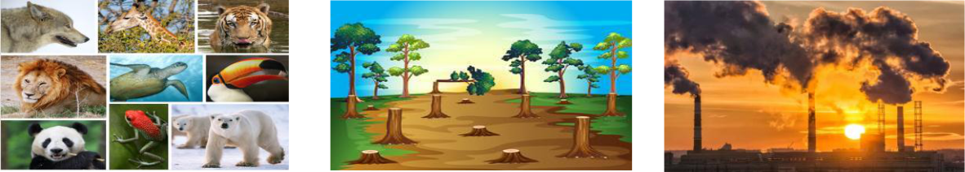
Ex VI: Match the words with their meanings.

1. ecosystem |  | a. the action of cutting down or burning trees in an
 |  | area
2. balance |  | b. not allowed by the law
3. illegal |  | c. causing damage or injury to somebody or
 |  | something
4. endangered |  | d. the process of making air, water, soil dirty
5. deforestation |  | e. all the plants and living creatures in a particular
 |  | area considered in relation to their physical
 |  | environment
6. pollution |  | f. at risk of no longer existing
7. habitat |  | g. a situation in which different things exist in equal,
 |  | correct amounts
 | 86

8. harmful

h.the place where a particular type of animal and plant is normally found

Ex VII: Choose the best answer.

- The children are not ……………… to pick flowers from the school garden now.

A. allow B. to allow C. allowed D. allowing

- He can’t ………….the school meeting tomorrow because he has to revise for the final exam.

A. attend B. go C. travel D. participate

3. The group is finding ways to ………….. endangered animals.

A. exist B. survive C. improve D. save

- The students can get a lot of useful information ……….. endangered animals on this website.

A. at B. about C. with D. of

- Some ………….. gases in the air can lead to global warming and climate change.

A. harmful B. useful C. serious D. practical

6. The number of endangered species…………..increasing due to illegal hunting.

A. are B. were C. is D. was

- Global warming can ……….. extreme weather conditions such as floods or heatwaves.

A. lead B. affect C. bring D. cause

8. Another ……………. is to stop burning leaves, rubbish and other materials.

A. problem B. solution C. issue D. impact

- Can you choose an environmental problem and ……….. a presentation on the solutions to it?

A. do B. work C. make D. take

87

10. What is happening ………..the animals in this picture, George?

A. to |  |  | B. with |  | C. of | D. about
Ex VIII: |  | Match.
 | 1. do |  |  | a. parents’ advice
 | 2. prepare |  |  | b. habitats
 | 3. follow |  |  | c. the environment
 | 4. protect |  |  | d. the traffic rules
 | 5. drop |  |  | e. some research
 | 6. lose |  |  | f. endangered animals
 | 7. raise |  |  | g. litter in the streets
 | 8. break |  |  | i. a presentation about environmental protection
 | 9. save |  |  | j. photos of beautiful animals
 | 10. take |  |  | k. public awareness
Ex IX: Fill in the gap with a suitable word given in the box.

atmosphere | natural | variety | vehicles | pollution
problems | habitat | nature | balance | environment

- Biodiversity refers to all the ………….. of plants and animals in a particular area.

- Human beings should rescue surviving animals and provide a protected

…………….. for them.

- Global warming is the rise in the average temperature of the earth’s

…………………..

- Cutting down natural forests can have a negative effect on the ……………….

- Loss of trees can damage the …………… habitats of many animals and put the wildlife in danger.

88

- If the natural…………..of ecosystems is affected, it will be harmful to all living and non-living things.

- One way to prevent air ………….. is to use electric vehicles or public transport and plant more trees.

- Using public transport will reduce gas emissions from private …………… and make the air much cleaner.

- James is going to talk about some solutions to one of the most serious

…………….. in our city.

- The World Wide Fund aims to stop the process of destroying the planet’s natural environment and to build a future in which humans respect the

…………...

Ex X: Complete the sentence with the correct form of the word provided.

- Many ……………..animals are threatened due to habitat loss and illegal hunting of human beings. (DANGER)

- Illegal trade in animal body parts can lead to the ………………….of many animals. (APPEAR)

- Air……………. is a serious problem because it can damage people’s health.

(POLLUTE)

- The program aims to improve public …………….. through school talks, regular public events and social media. (AWARE)

- The animal lives in deep, wild forests which are not ……………… by human activities. (DAMAGE)

- Strict ……………… should also be applied to illegal hunting of endangered species so that rare and beautiful animals can survive. (PUNISH)

- It is an endangered animal which needs to be ……………….to survive.

(PROTECT)

- Some scientists work with local governments so that they can have greater

……………… support. (POLITICS)

- Global warming can have serious consequences such as ……………sea levels and extreme weather. (RISE)

89

- …………….gases in the atmosphere is a major cause of some respiratory diseases or even lung cancer. (POISON)

Unit 10: Ecotourism

Noun

1 | Stalactite | /ˈstæləktaɪt/ | Thạch nhũ
2 | Field trip | /ˈfiːld trɪp/ | Chuyến đi thực tế
3 | Experience | /ɪkˈspɪəriəns/ | Trải nghiệm
4 | Profit | /ˈprɒfɪt/ | Lợi nhuận
5 | Craft | /krɑːft/ | Đồ thủ công
 |  | 90

6 | Duty | /ˈdjuːti/ | Nhiệm vụ
7 | Ecotourism | /ˈiːkəʊtʊərɪzəm/ | Du lịch sinh thái
8 | Tradition | /trəˈdɪʃn/ | Truyền thống
9 | Emission | /ɪˈmɪʃ | Sự thải (khí)
10 | Trail | /treɪl/ | Đường mòn
11 | Souvenir | /suːvəˈnɪə(r)/ | Đồ lưu niệm
 |  | Verb
1 | Add | /æd/ | Thêm vào
2 | Form | /fɔːm/ | Hình thành
3 | Touch | /tʌtʃ/ | Chạm, sờ
4 | Promise | /ˈprɒmɪs/ | Hứa hẹn
5 | Damage | /ˈdæmɪdʒ/ | Hủy hoại
6 | Explore | /ɪkˈsplɔː(r)/ | Khám phá
7 | Recommend | /rekəˈmend/ | Gợi ý, đề xuất
8 | Attract | /əˈtrækt/ | Thu hút
9 | Respect | /rɪˈspekt/ | Tôn trọng
10 | Require | /rɪˈkwaɪə(r)/ | Yêu cầu, đòi hỏi
11 | Interact (with) | /ɪntərˈækt/ | Tương tác với
 |  | Adjective
1 | Eco-friendly | /iːkəʊ ˈfrendli/ | Thân thiện với hệ sinh thái
2 | Aware (of) | /əˈweə(r)/ | Nhận thức
3 | Responsible | /rɪˈspɒnsəbl/ | Có trách nhiệm
4 | Positive | /ˈpɒzətɪv/ | Tích cực
5 | Negative | /ˈneɡətɪv/ | Tiêu cực
 |  | 91

6 | Well-known | /wel ˈnəʊn/ | Nổi tiếng
7 | Special | /ˈspeʃl/ | Đặc biệt
8 | Sustainable | /səˈsteɪnəbl/ | Bền vững
9 | Active | /ˈæktɪv/ | Chủ động, năng động
10 | Specific | /spəˈsɪfɪk/ | Cụ thể
11 | Disappointed | /dɪsəˈpɔɪntɪd/ | Thất vọng
12 | Comfortable | /ˈkʌmftəbl/ | Thoải mái
 |  | Phrases
1 | Tourist attraction | /əˈtrækʃn/ | Điểm thu hút khách du lịch
2 | Give up | /ɡɪv /ɡɪv | Từ bỏ
3 | Coral reef | /ˈkɒrəl riːf/ | Rặng san hô
4 | Handmade | /hændˈmeɪd | Sản phẩm thủ công
 | product | ˈprɒdʌkt/
5 | Cost of living | /kɒst əv ˈlɪvɪŋ/ | Chi phí sinh hoạt
6 | Go hiking | /ɡəʊ ˈhaɪkɪŋ/ | Đi bộ đường dài
Ex I: Find the word which has a different sound in the part underlined.

1. | A. Thursday |  |  |  |  |  |  |  |  |  |  |  |  |  | B. thickness |  |  |  |  |  |  |  |  |  |  | C. thunder |  |  |  |  |  |  |  |  |  |  |  |  | D. there
2. | A. seventy |  |  |  |  |  |  |  |  |  |  |  |  |  | B. become |  |  |  |  |  |  |  |  |  |  | C. respect |  |  |  |  |  |  |  |  |  |  |  |  | D. emission
3. A. known |  |  |  |  |  |  |  |  |  |  |  |  |  |  | B. knowledge |  |  |  |  |  |  |  |  |  |  | C. knives |  |  |  |  |  |  |  |  |  |  |  |  | D. kingdom
4. | A. sunbathed |  |  |  |  |  |  |  |  |  |  |  |  |  | B. enjoyed |  |  |  |  |  |  |  |  |  |  | C. disappointed |  |  |  |  |  |  |  |  |  |  |  |  | D. tired
5. | A. protect |  |  |  |  |  |  |  |  |  |  |  |  |  | B. special |  |  |  |  |  |  |  |  |  |  | C. local |  |  |  |  |  |  |  |  |  |  |  |  | D. respect
6. | A. active |  |  |  |  |  |  |  |  |  |  |  |  |  | B. handmade |  |  |  |  |  |  |  |  |  |  | C. thousand |  |  |  |  |  |  |  |  |  |  |  |  | D. travel
7. | A. include |  |  |  |  |  |  |  |  |  |  |  |  |  | B. culture |  |  |  |  |  |  |  |  |  |  | C. product |  |  |  |  |  |  |  |  |  |  |  |  | D. lucky
8. | A. enough |  |  |  |  |  |  |  |  |  |  |  |  |  | B. physical |  |  |  |  |  |  |  |  |  |  | C. tough |  |  |  |  |  |  |  |  |  |  |  |  | D. although
9. A. damages |  |  |  |  |  |  |  |  |  |  |  |  |  |  | B. reduces |  |  |  |  |  |  |  |  |  |  | C. promotes |  |  |  |  |  |  |  |  |  |  |  |  | D. exchanges
 |  |  |  |  |  |  |  |  |  |  |  |  |  |  |  |  |  |  |  |  |  |  |  |  |  | 92

10. A. beach B. character C. achieve D. challenge

Ex II: Choose a word that has a different stress pattern from others.

1. | A. require | B. damage | C. leisure | D. punish
2. | A. favourite | B. negative | C. beautiful | D. tradition
3. | A. souvenir | B. interact | C. energy | D. recommend
4. | A. promise | B. instead | C. rubbish | D. balance
5. | A. responsible | B. environment | C. sustainable | D. comfortable
6. | A. positive | B. attraction | C. animal | D. cultural
7. | A. generous | B. resources | C. specific | D. extremely
8. | A. profit | B. follow | C. enjoy | D. famous
9. | A. tomorrow | B. uniform | C. condition | D. delicious
10. A. villager |  | B. meaningful | C. popular | D. addition

Ex III: Write the correct phrase below each picture.

Waste water |  | Litter on the |  |  | Hunt wild | Buy some
 |  | beach |  |  | animals | souvenirs
Feed the animals |  | Follow the |  |  | Go hiking | Take photos
 |  | walking paths
Explore the coral |  | Eat seafood |  |  | Buy arts and | Work on a local
reef |  |  |  |  | crafts | farm
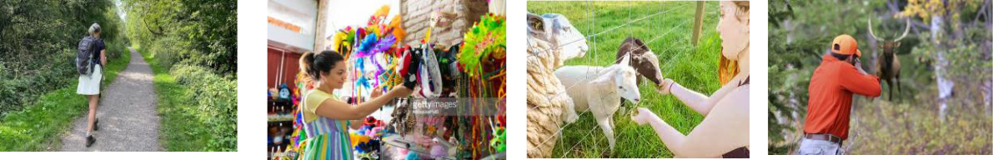
93

1. | 2. | 3. | 4.
5. | 6. | 7. | 8.
9. | 10. | 11. | 12.

Ex IV: Say the words out loud and odd one out.

1. | A. customer | B. dangerous | C. tourist | D. servant
2. | A. device | B. tourism | C. economy | D. politics
3. | A. education | B. industry | C. culture | D. nature
4. | A. pagoda | B. legal | C. honest | D. hard-working
5. | A. effect | B. impact | C. destroy | D. influence
6. | A. upset | B. understand | C. cheerful | D. excited
7. | A. grandfather | B. guest | C. cousin | D. birthday
8. | A. promise | B. birthday | C. anniversary | D. wedding
9. | A. scholarship | B. apply | C. sponsorship | D. allowance
10. A. project |  | B. environment | C. encourage | D. diversity

Ex V: Match the words with their meanings.

- ecotourisma. a journey made by a group of people to study something in its natural environment

2. impact | b. physical harm caused to something which makes it

94

 |  | less attractive, useful or valuable
3. damage |  | c. not harmful to the environment
4. field trip |  | d. organised holidays that are designed so that tourists
 |  | damage the environment as little as possible
5. eco-friendly |  | e. to travel to an area or a country to learn about it
6. explore |  | f. the powerful effect that something has on somebody
 |  | or something
7. handmade |  | g. a belief, custom or way of doing things that has
 |  | existed for a long time among a group of people
8. tradition |  | h.made by a person using their hands rather than by
 |  | machines

Ex VI: Circle the best word.

- Responsible tourists will be aware from/of the environment when they travel.

- Did they know the possible danger that they might cause/lead to the environment?

- There are both positive and negative effects that ecotourism has/leaves on the local people.

- Travelling by car or by plane can decrease/increase carbon dioxide emissions in the atmosphere.

- Handmade products from their village are well-known around/over the country.

- One advantage/disadvantage of ecotourism is that it can create more jobs for local people.

- A high percentage of the world’s forests has been lost because people cut down trees to take/make room for farms.

- What/Which of the following sentences is not mentioned in the text as a cause of deforestation?

95

- We discuss with them about the negative and positive affects/effects of tourism on the environment.

- If I live in the countryside, I will grow/make a lot of vegetables.

Ex VII: Match.

1. make |  | a. the environment
2. buy |  | b. local tourists
3. earn |  | c. traditional arts and crafts
4. protect |  | d. the national park
5. use |  | e. a lot of profits
6. grow |  | f. culture to more people
7. reduce |  | g. local services
8. introduce |  | h. some money
9. help |  | i. a lot of vegetables
10. explore |  | j. the carbon footprint

Ex VIII: Choose the best answer.

- Ecotourists can learn a lot ……………the customs and traditions of the places they visit.

A. from B. on C. with D. about

2. The negative impact of ecotourism on the local environment is ……………

A. huge B. large C. high D. low

- Forest help produce clean water and air and they provide people

…………jobs.

A. about B. with C. to D. of

- Trees are cut down and used to make paper and some wood –

…………..products.

96

A. relate B. relating C. related D. relates

- The children are getting ready………… the fieldtrip to the wildlife park tomorrow morning.

A. with B. for C. of D. about

- We don’t want to leave the rubbish …………. because it is not good for the environment.

A. behind B. below B. beneath D. before

- Our group had a three-day walk ……………. the mountains in the north of Viet

Nam.

A. over B. above C. through D. across

- ………….. his trip, he stayed with local people and leant about their culture and enjoyed local food.

A. In B. During C. With D. Over

9. They learn ………….. to help save wild animals in the local research centre.

A. which B. where C. how D. who

- One thing every citizen should do is to ………… littering on the beach or the street.

A. increase |  |  | B. punish | C. promise |  | D. avoid
 | Ex IX: | Fill in the gap with a suitable word given in the box.
 | ecotourism |  | popular | ecotour |  | environment |  | weather
 | reduce |  | resources | local |  | products |  | traditions

- Tourists should not hunt animals to protect the …………… environment.

- By travelling by plane, tourists can reduce the negative impact of their travelling on the ……………….

- It is possible to …………… the negative impact on environment is by travelling in a more eco-friendly way.

97

- The local people may benefit from ……………….. as it increases the cost of living in their area.

- Mass tourism is the most ………..….. form of tourism as it is often the cheapest way to go on holiday.

- Local community can be seriously affected if tourists do not respect local customs and ………………...

- Extreme ……………. conditions like floods and forest fires can destroy much of the world’s forests every year.

- We plan an ……………… to the mountain because it is beautiful at this time of the year.

- We must take steps to save natural ………….. otherwise our planet will be in danger.

- We help local people earn some money by using local services and buying their local …………...

Pham Thu Tra - 0989552182

Ex X: Complete the sentence with the correct form of the word provided.

- Local people are very ………………..and welcoming to the foreign visitors. (FRIEND)

- Forests play an important role in reducing climate change and soil ……………... (ERODE)

- In fact, ……………… has put forests in many parts of the world at risk.

(FOREST)

- My family watched the most …………….and friendly animals on earth from our high-speed boats. (BEAUTY)

- The tour offers some ……………….videos about the local environment.

(EDUCATE)

- Ecotourism provides …………….. with many opportunities to explore the nature. (TOUR)

98

- Sustainable tourism involves not only environmental ……………… but also cultural respect. (PROTECT)

- It stresses the active role of visitors in ………………the environment. (SAVE)

- Can you design an ecotour to a local ……………… and give a presentation about it? (ATTRACT)

- The reading is about the ………………. of forests and the problem of deforestation. (IMPORTANT)

Giaoandethitienganh.info chuyên
1. Cung cấp tài liệu tiếng anh file word các cấp phong phú, chất lượng.
2. Tải tài liệu không giới hạn số lần tải, không giới hạn tài liệu tải.
3. Tài liệu tiếng anh rất đa dạng, file word chỉnh sửa được.
4. Phí đăng ký chỉ 100k/năm. Vĩnh viễn chỉ 300k/ thành viên cũ; 350k/thành viên mới.
Hân hạnh mời bạn ghé thăm!

