 | ISS GRADE 4 TESTS - THEME 5  Time allotted: 60 | Mã đề: E4-5

PART 1 | Listening (6 questions)
1. Listen and draw lines. There is one example. (2 questions)
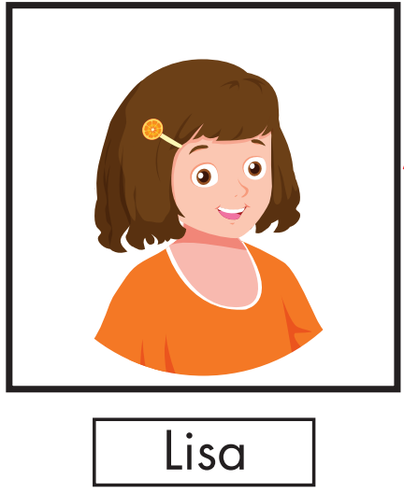 | 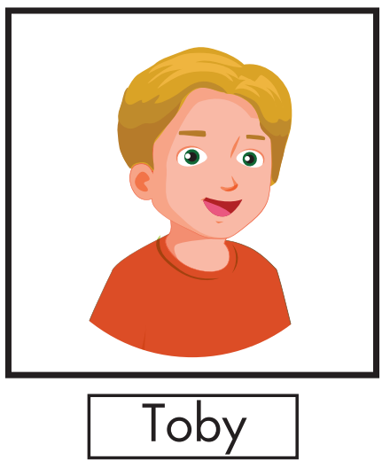 | 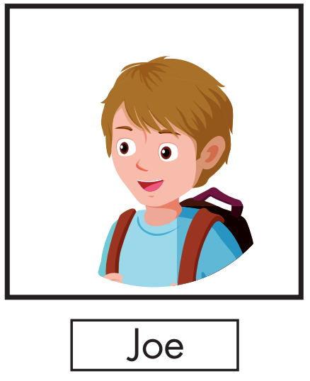
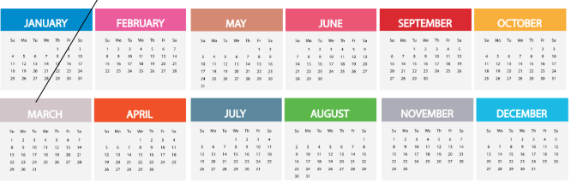
Read the question. Listen and write a number. There are two examples. (2 questions)
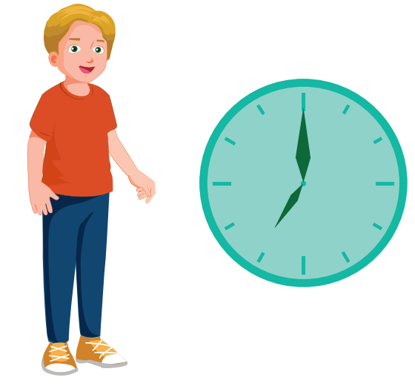
What time does Toby get up? 7:00
What time does Toby eat breakfast? 7:30
What time does Toby have lunch? (3)___________
What time does Toby go to bed? (4)___________
Listen and choose the answer. There is one example. (2 questions)
Examples:
What does Joe want to do in the morning?
 |  | 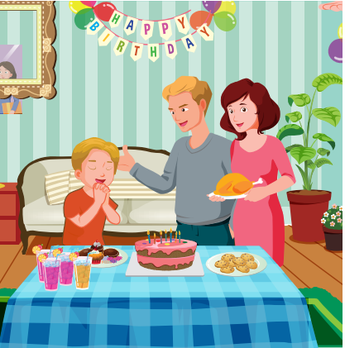
A. ☐ | B. ☑ | C. ☐
Questions:
5. What does Toby want to do in the morning?
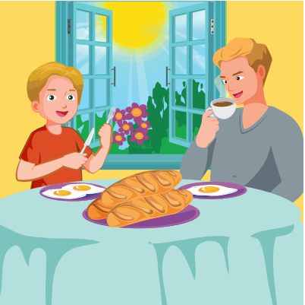
A. ☐ | B. ☐ | C. ☐
6. What time does Toby go to bed?
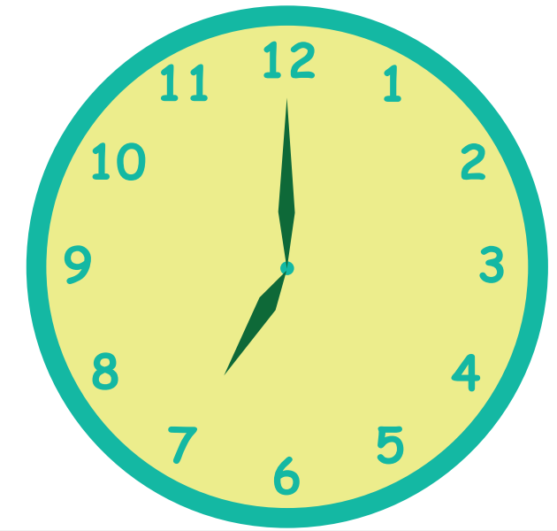 | 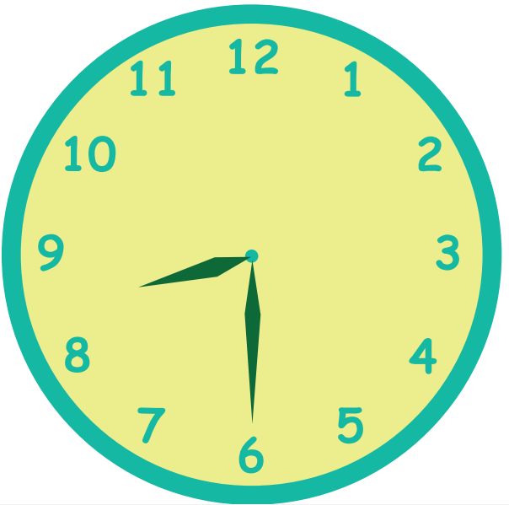 | 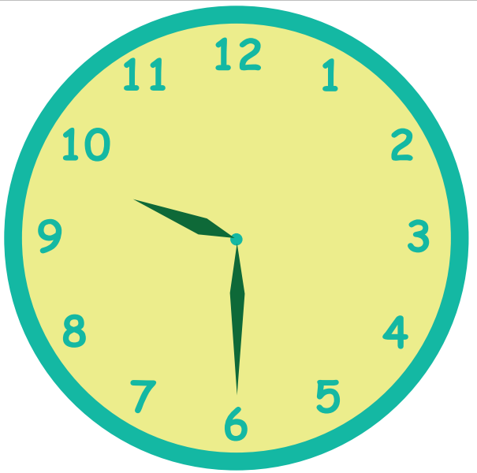
A. ☐ | B. ☐ | C. ☐

PART 2 | Reading and Writing (11 questions)
Look read and choose the True or False. There are 2 examples. (2 questions)
Examples:
 |  | I get up in the morning. | ☑ True ☐ False
 | 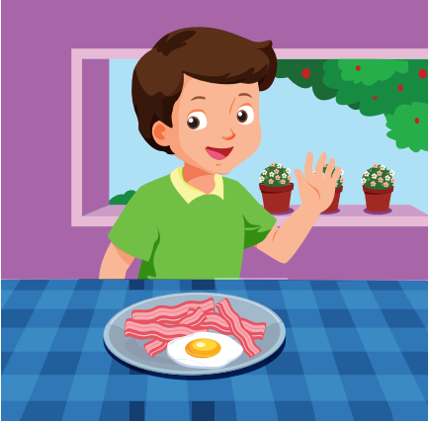 | I do my homework. | ☐ True ☑ False
Questions:
7. |  | I go to bed. | ☐ True ☐ False
8. |  | I have dinner. | ☐ True ☐ False
Look and read. Choose True or False. (2 questions)
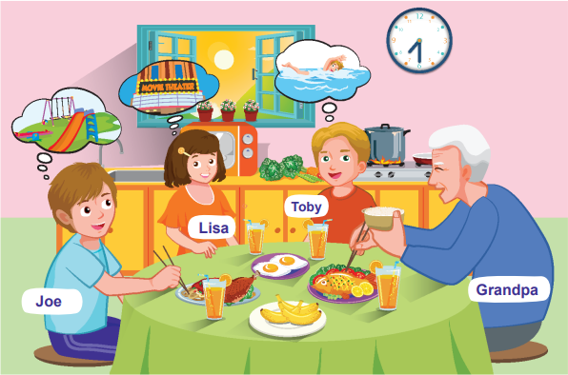
Examples:
Breakfast is at 8:30. | ☐ True ☑ False
Toby wants to go swimming in the morning. | ☑ True ☐ False
Questions:
9. Joe wants to go to the playground. | ☐ True ☐ False
10. Lisa wants to eat lunch. | ☐ True ☐ False
Look at the pictures. Look at the letters. Rearrange the words. (2 questions)
Examples:

Keywords: u/A/g/s/t/u
→ A u g u s t
Questions:

11. | 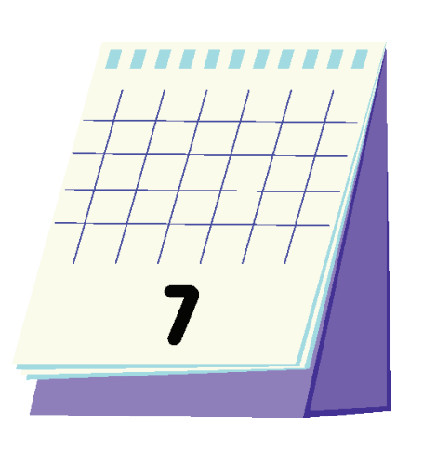 | Keywords: y/u/J/l  → .......................................

12. |  | Keywords: n/e/u/J  → .......................................
Read this. Choose a word from the box. Write the correct word. There is one example. (2 questions)
Fun with Grandpa
Grandpa wants to do many things when he visits us! He wants to go to the playground in the morning.He wants to go (13)___________ in the afternoon. We have a swimming pool at our house. He wants to go to a (14)___________ in the evening. It's for my uncle's birthday and we can eat cake!
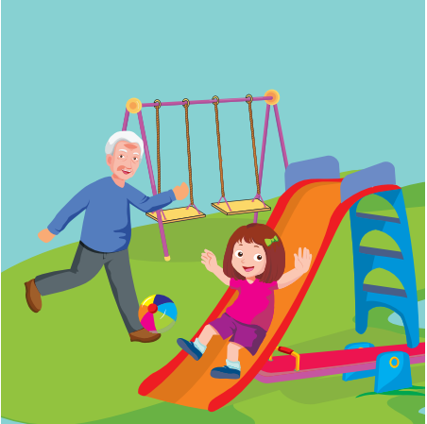  playground | movies
swimming | 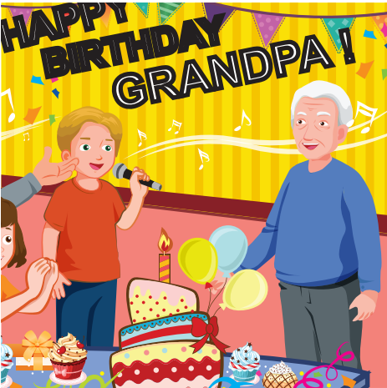  party
Look at the pictures and read the questions. Write one-word answers.
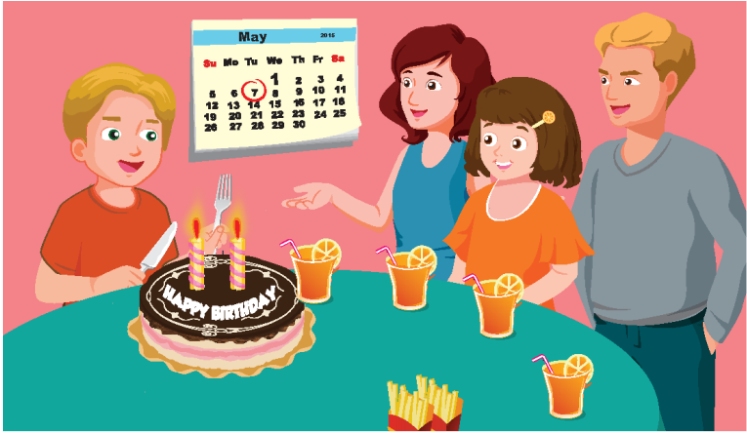
When is Toby's birthday?
It's in May .
What is he going to do?
He's going to (15)___________ the cake.
Look at the pictures and read the questions. Write one-word answers (2 questions)
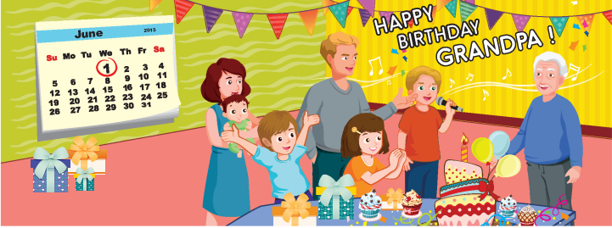
When is Grandpa's birthday?
It's in (16)___________
What is Toby going to do?
He's going to (17)___________ a song.
---THE END---

