 | ISS GRADE 4 TESTS - THEME 4  Time allotted: 60 | Mã đề: E4-4

PART 1 | Listening (6 questions)
1. Listen and draw lines. There is one example. (2 questions)
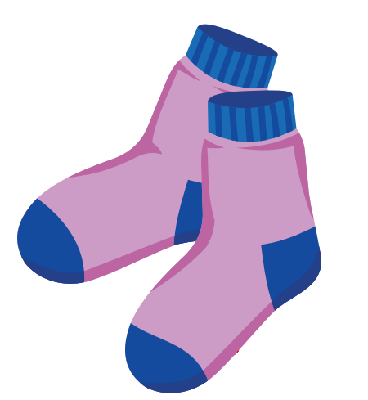 | 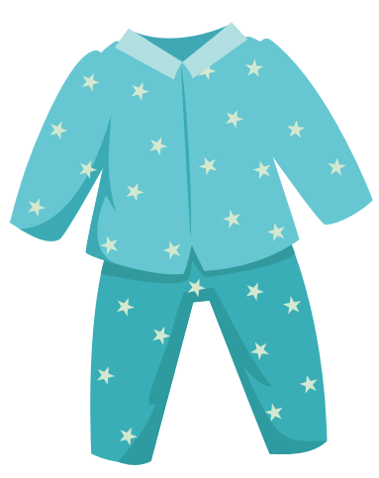
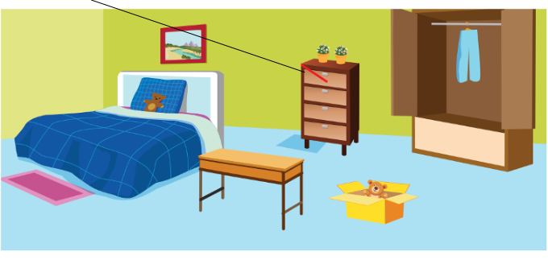
Read the question. Listen and write a name or a number. There are two examples. (2 questions)
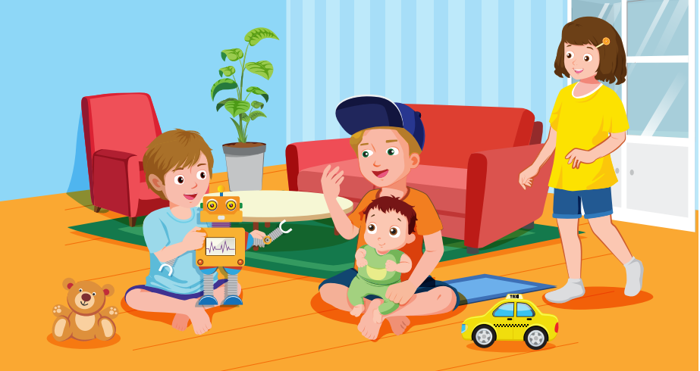
Who is wearing the cap? Toby
What is the girl's name? Lisa
What is the boy's name? (3)___________
What is the baby's name? (4)___________
Listen and choose the answer. There is one example. (2 questions)
Examples:
What is Lisa wearing?
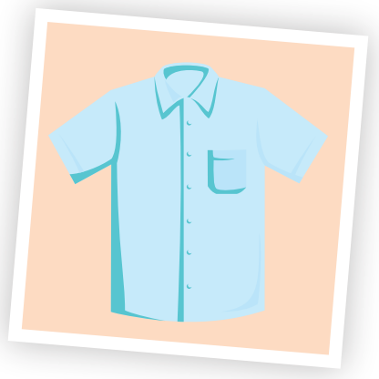 | 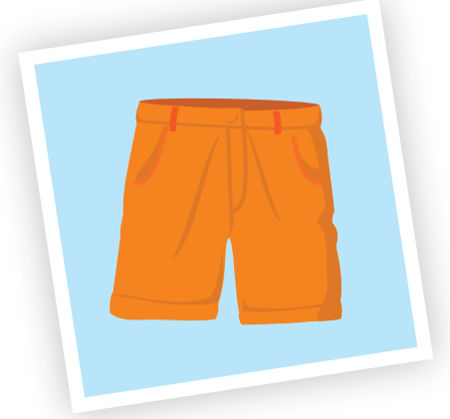 | 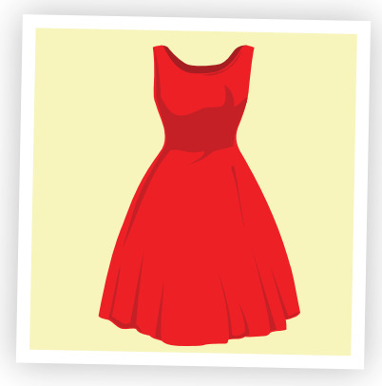
A. ☐ | B. ☑ | C. ☐
Questions:
5. What is mom wearing?
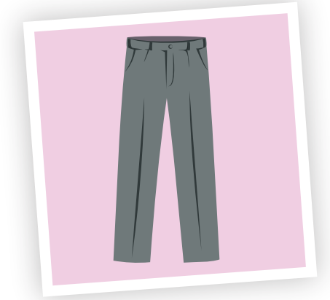 | 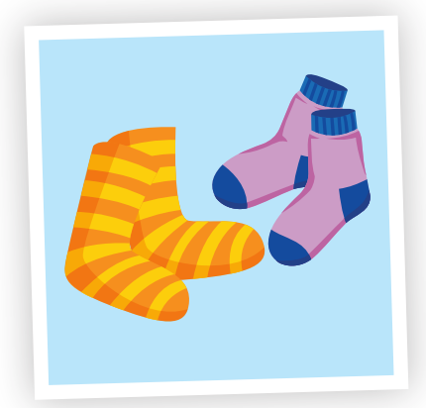 | 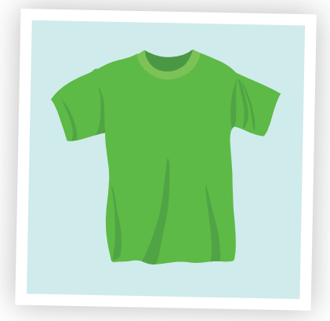
A. ☐ | B. ☐ | C. ☐
6. What is Toby wearing?
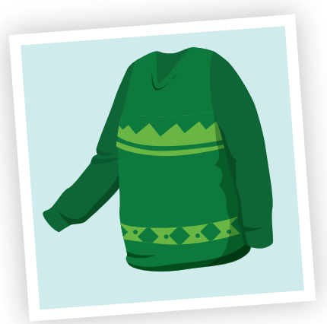 | 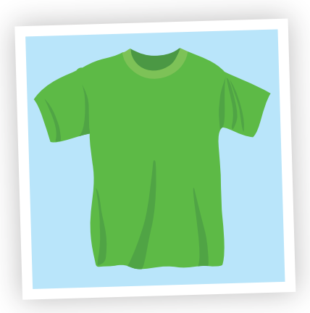 | 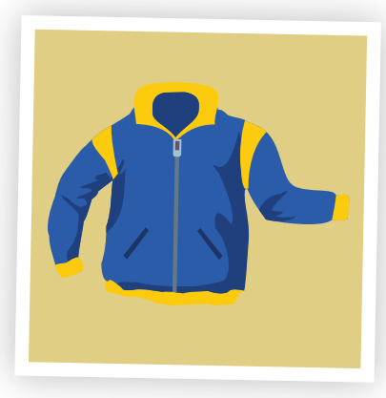
A. ☐ | B. ☐ | C. ☐

PART 2 | Reading and Writing (12 questions)
Look and read. Choose the True or False. There are two examples. (2 questions)
Examples:
 | 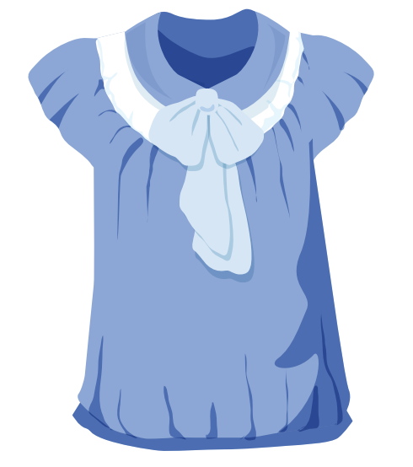 | This is a blouse. | ☑ True ☐ False
 | 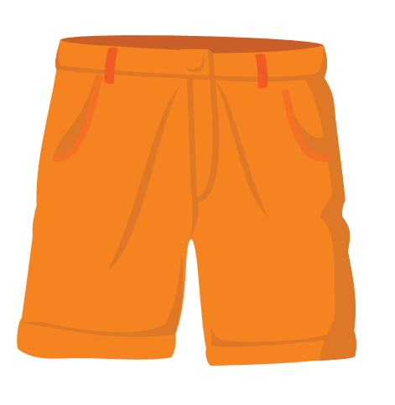 | They are socks. | ☐ True ☑ False
Questions:
7. | 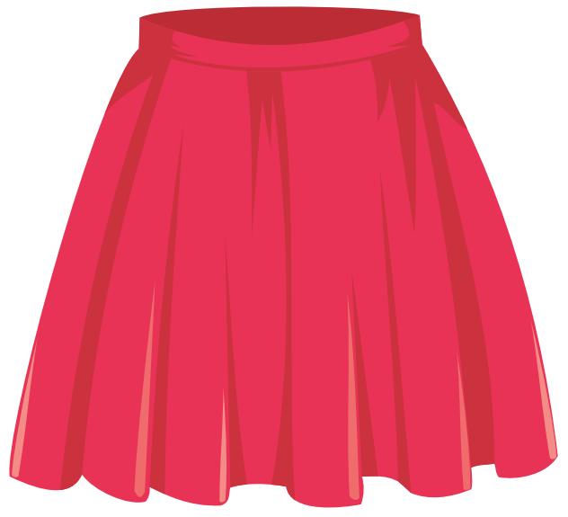 | This is a dress. | ☐ True ☐ False
8. | 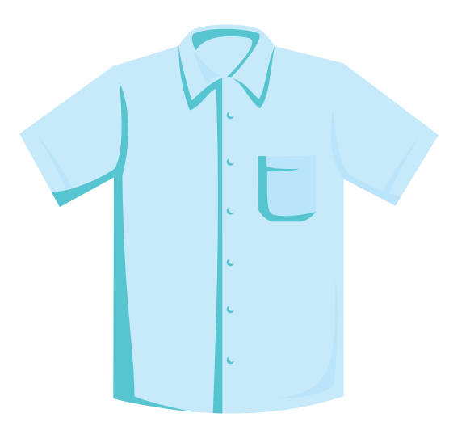 | This is a shirt. | ☐ True ☐ False
Look and read. Choose the True or False
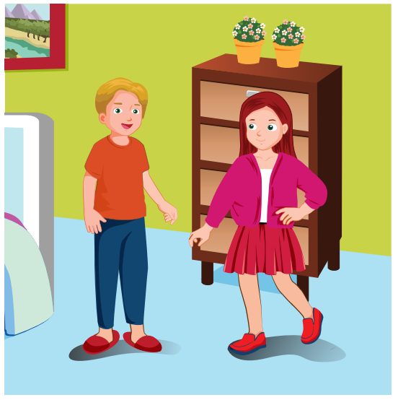
Examples:
She's wearing a skirt. | ☑ True ☐ False
Questions:
9. He's wearing pajamas. | ☐ True ☐ False
Look and read. Choose the True or False (2 questions)
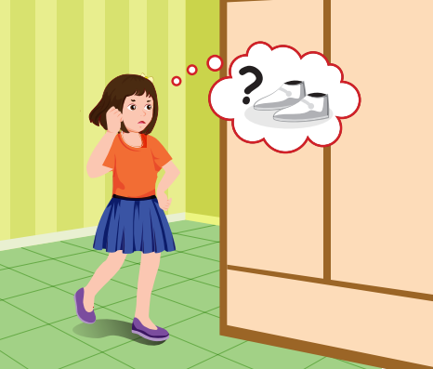
Questions:
10. She's wearing a blue dress. | ☐ True ☐ False
11. She's wearing white sneakers. | ☐ True ☐ False
Look at the pictures. Look at the letters. Rearrange the words. (2 questions)
Examples:

 | 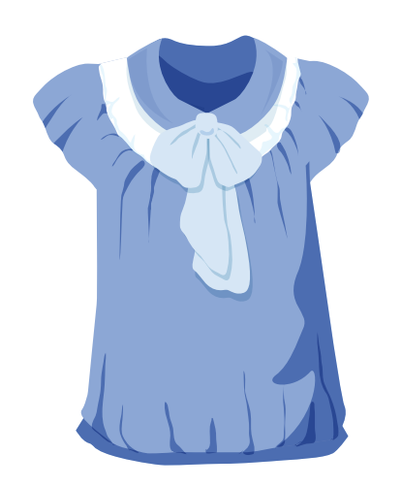 | Keywords: l/u/b/e/o/s  → b l o u s e
Questions:

12. | 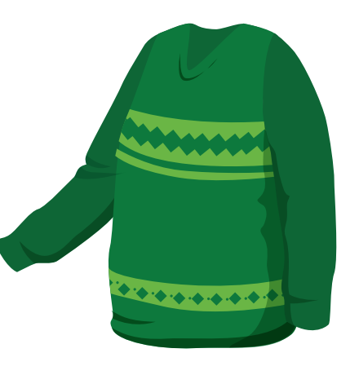 | Keywords: a/r/e/t/e/s/w  → .......................................

13. | 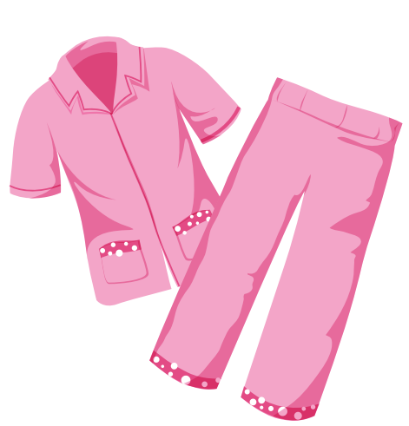 | Keywords: s/a/m/j/a/p/a  → .......................................
Read this. Choose a word from the box. Write the correct word. There is one example (2 questions)
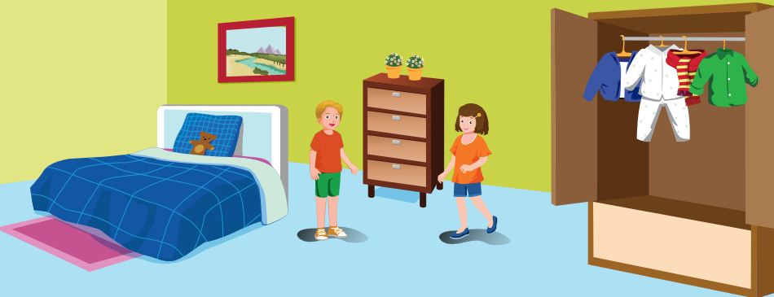
What are they wearing?
Lisa and Toby are packing clothes. Toby is wearing green shorts. Lisa is wearing blue (14)___________ on her feet. Her pajamas are (15)___________ .The kids are ready to go!
green | 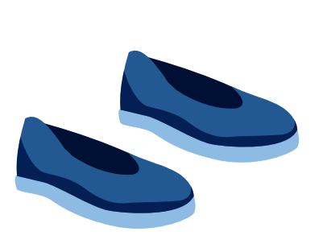  shoes
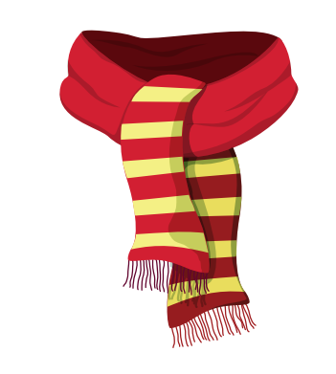  scarf | white
Look at the pictures and read the questions. Write the answers.
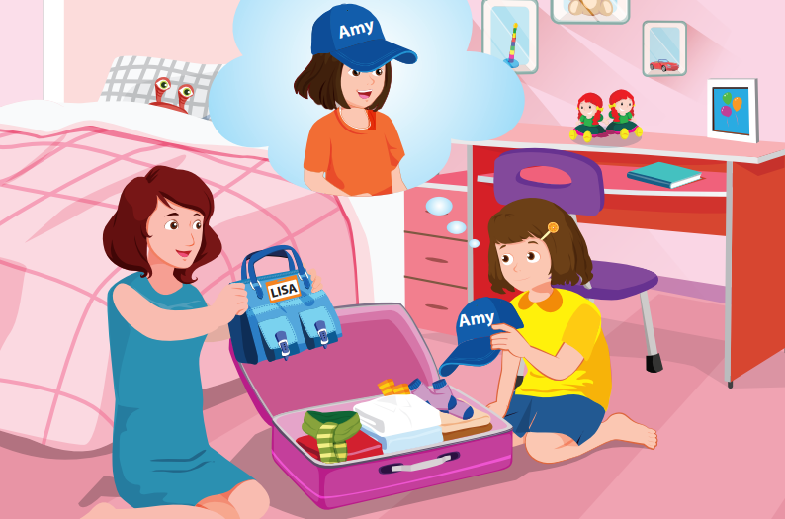
Is it Lisa's handbag?
Yes, it is .
Is it Lisa's cap?
(16)___________ .
Look at the pictures and read the questions. Write the answers. (2 questions)
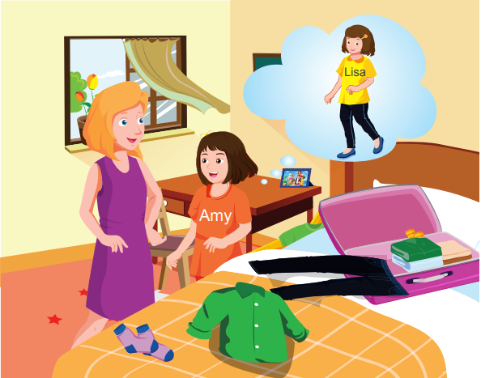
Are they Amy's socks?
Yes, (17)___________ .
Are they Amy's jeans?
No, (18)___________.
---THE END---

