 | ISS GRADE 4 TESTS - THEME 3  Time allotted: 60 | Mã đề: E4-3

PART 1 | Listening (6 questions)
1. Listen and draw lines. There is one example. (2 questions)
Example | 1 | 2
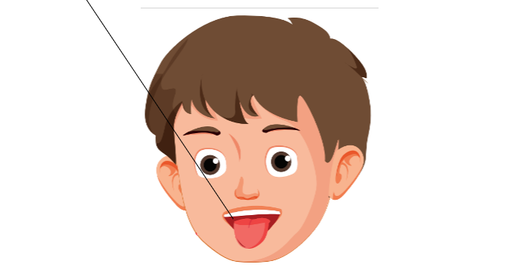
Read the questions. Listen and write a name or a number. There are two examples (2 questions)
How many boys are in the photo? 3
Who is taller than Amy? Toby
Who is shorter than Amy? (3)___________
Who is thinner than Joe? (4)___________
Listen and choose the answer There is one example. (2 questions)
Examples:
What is the teacher touching?
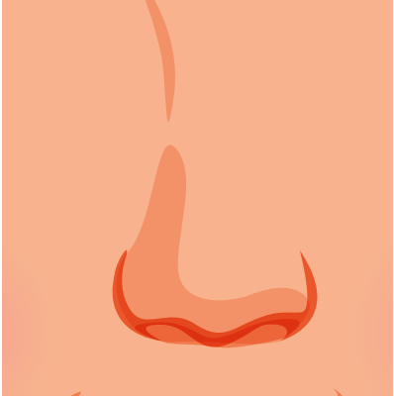 | 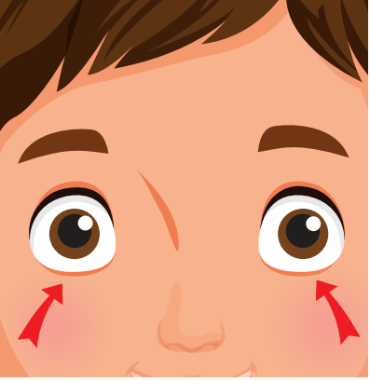 | 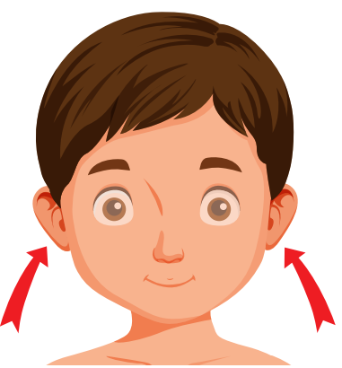
A. ☐ | B. ☐ | C. ☑
Questions:
5. What is the teacher touching?
 | 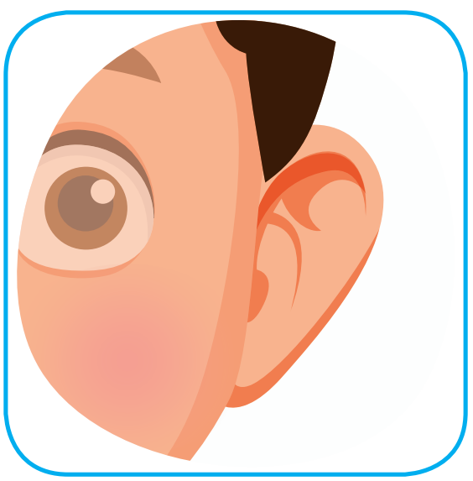
A. ☐ | B. ☐ | C. ☐
6. What is the teacher pointing to?
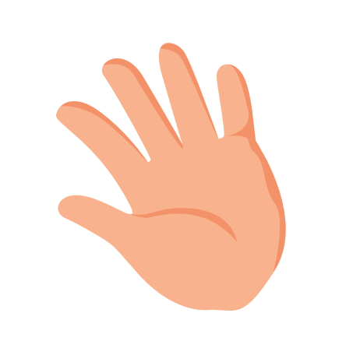 | 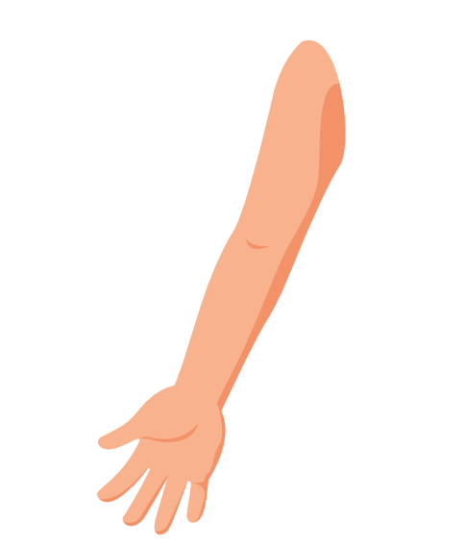 | 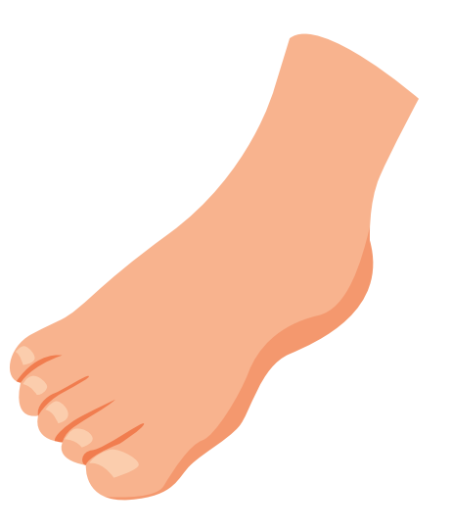
A. ☐ | B. ☐ | C. ☐

PART 2 | Reading and Writing (11 questions)
Look and read. Choose the True or False. There are two examples. (2 questions)
Examples:
 |  | This is a head. | ☑ True ☐ False
 | 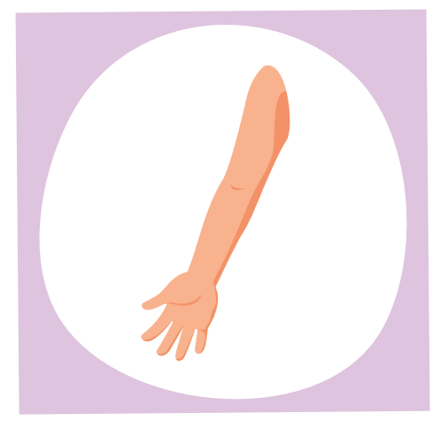 | This is a leg. | ☐ True ☑ False
Questions:
7. |  | This is a hand. | ☐ True ☐ False
8. | 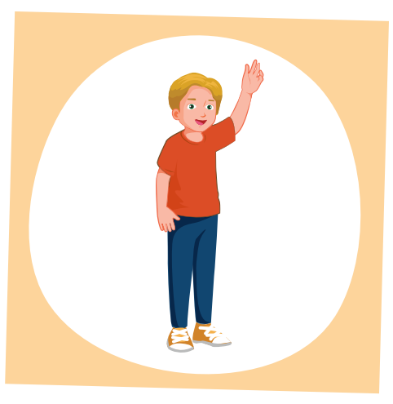 | This is a foot. | ☐ True ☐ False
Look and read. Choose the True or False (2 questions)
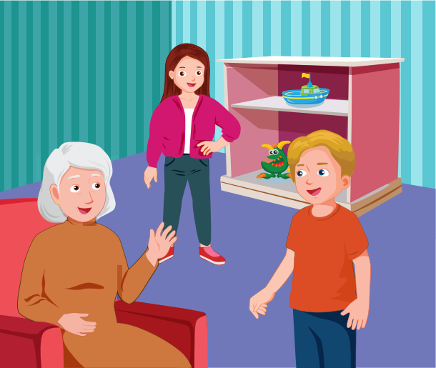
Examples:
Toby's grandfather is sitting down. | ☐ True ☑ False
There are three people in the picture. | ☑ True ☐ False
Questions:
9. The girl has long hair. | ☐ True ☐ False
10. The boy is old. | ☐ True ☐ False
Look at the pictures. Look at the letters. Rearrange the words. (2 questions)
Examples:

Keywords: c/a/f/e
→ f a c e
Questions:

11. | 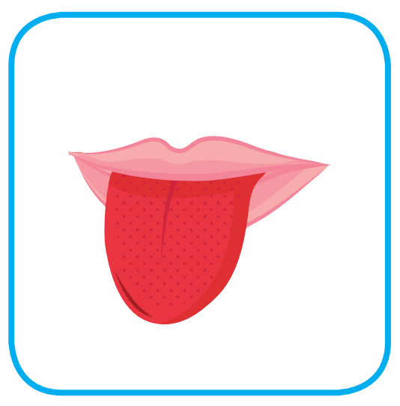 | Keywords: g/o/n/t/u/e  → .......................................

12. | 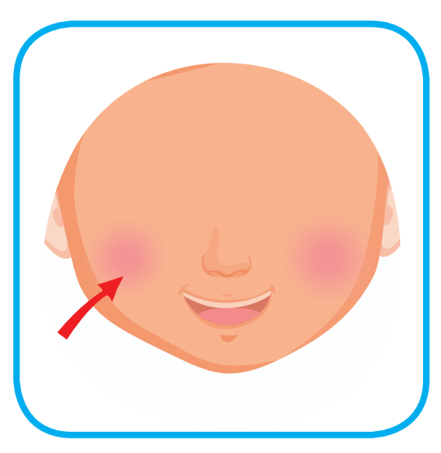 | Keywords: h/e/c/k/e/s  → .......................................
Read this. Choose a word from the box. Write the correct word. There is one example. (2 questions)
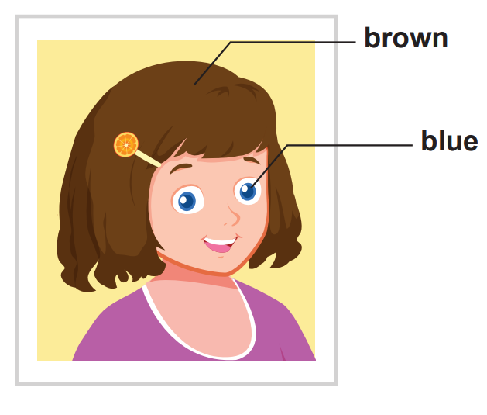
My best friend
Lisa’s my best friend . She’s very pretty. She has brown hair and blue (13)___________. She’s (14)___________ than me.
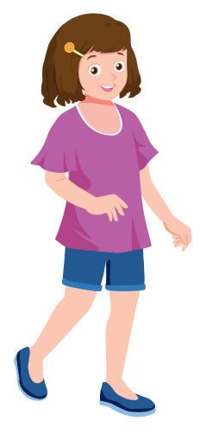  friend | 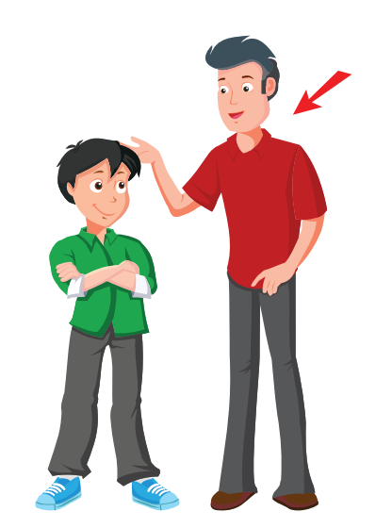  taller
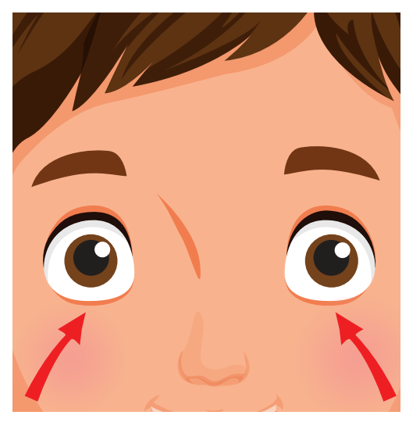  eyes | 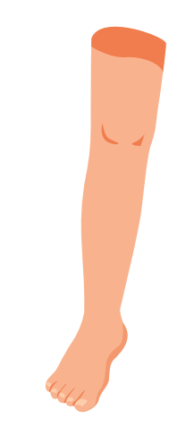  leg
Look at the pictures and read the questions. Write one-word answers
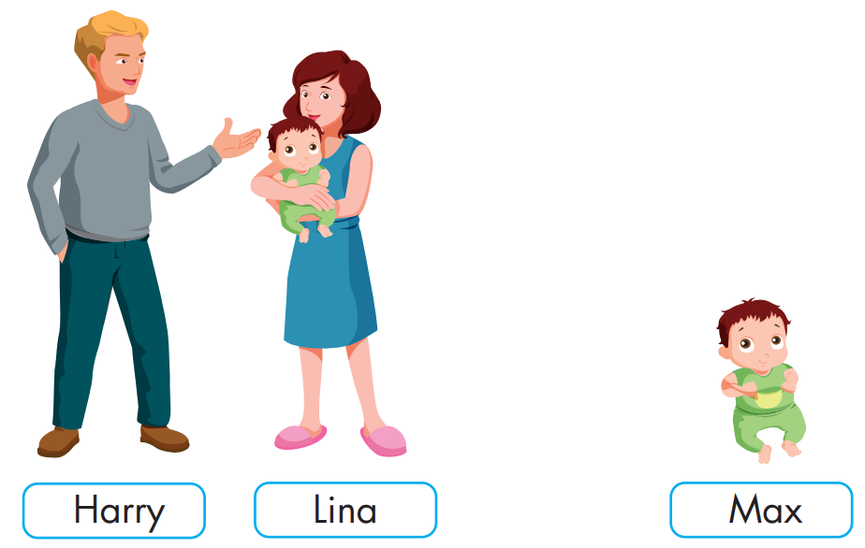
Who is younger than Lina? Max
Who is taller than than Lina? (15)___________
Look at the pictures and read the questions. Write one-word answers (2 questions)
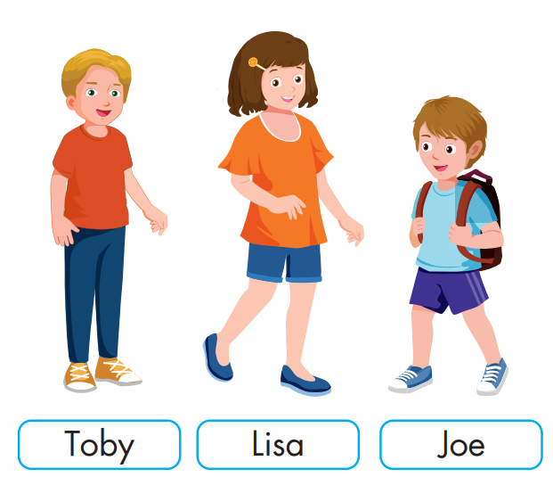
Who is shorter than Toby? (16)___________
Who is taller than Toby? (17)___________
---THE END---

