 | ISS GRADE 4 TESTS - THEME 2  Time allotted: 60 | Mã đề: E4-2

PART 1 | Listening (7 questions)
1. Listen and draw lines. There is one example. (2 questions)
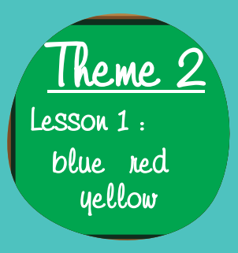 | 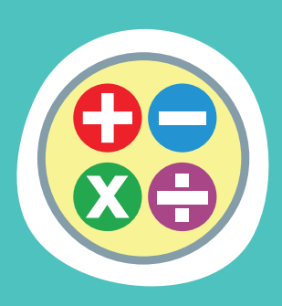 | 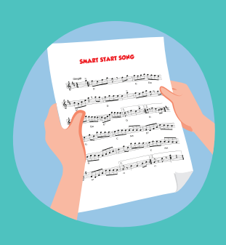
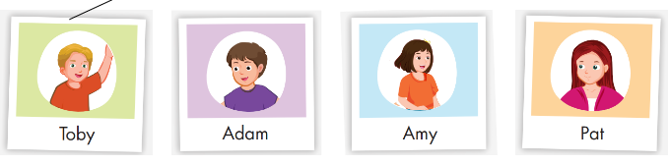
Read the question. Listen and write an object or a number. There are two examples. (2 questions)
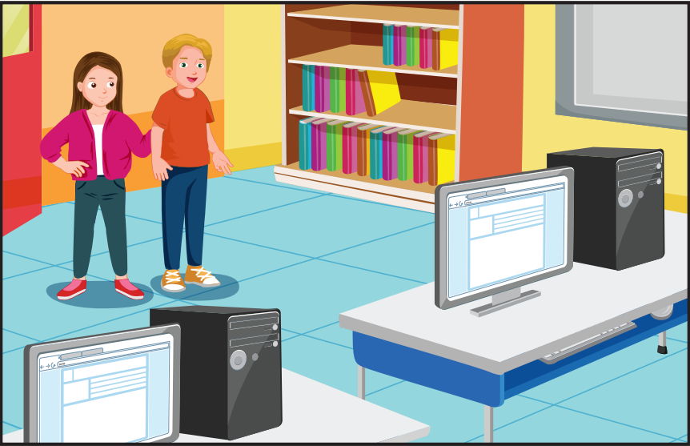
How many pens are there? 3
What is Pat looking for? A mouse
What is Toby looking for? (3)___________
How many books are there? (4)___________
Listen and choose the answer. There is one example. (3 questions)
Questions:
5. When does Toby have P.E.?
A. ☐ | B. ☐ | C. ☐
6. When does Pat have math?
A. ☐ | B. ☐ | C. ☐
7. What does Toby do in his favorite subject?
 |  | 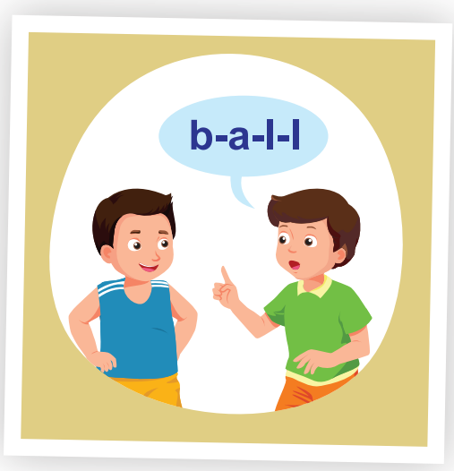
A. ☐ | B. ☐ | C. ☐

PART 2 | Reading and Writing (11 questions)
Look and read. Choose the True or False. There are two examples. (2 questions)
Examples:
 |  | Put the bag next to the fan, please. Sure | ☑ True ☐ False
 | 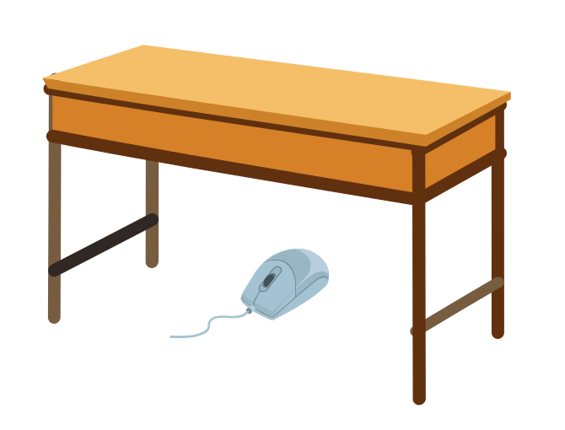 | Put the mouse on the desk, please. OK. | ☐ True ☑ False
Questions:
8. | 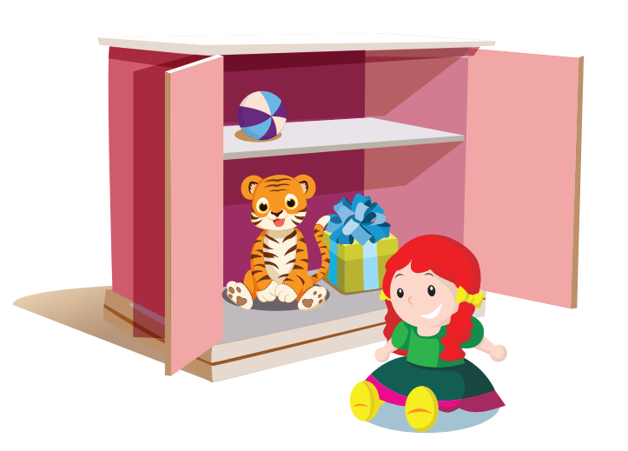 | Put the doll in the cupboard, please. Yes, Mom. | ☐ True ☐ False
9. | 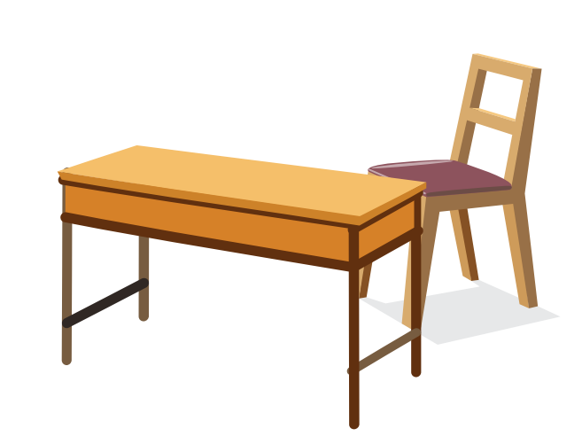 | Put the chair next to the table, please. OK. | ☐ True ☐ False
Look and read. Choose the True or False (2 questions)
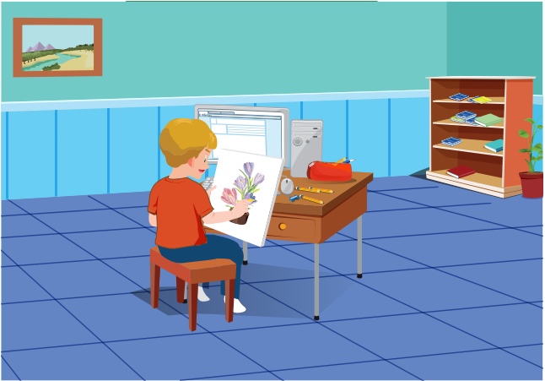
Examples:
Toby is drawing a picture. | ☑ True ☐ False
There are two computers on the desk. | ☐ True ☑ False
Questions:
10. There are pencils on the desk. | ☐ True ☐ False
11. There’s a notebook on the desk. | ☐ True ☐ False
Look at the pictures. Look at the letters. Rearrange the words (2 questions)
Examples:

 | 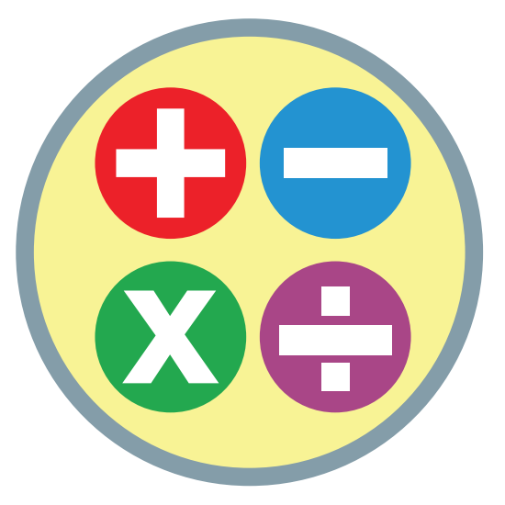 | Keywords: t/a/m/h  → m a t h
Questions:

12. | 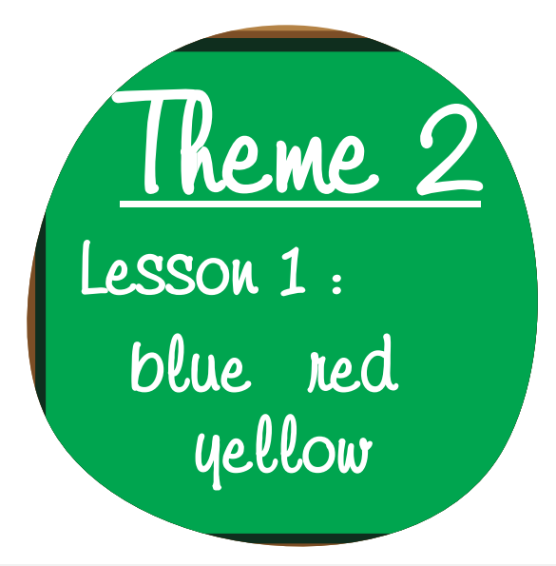 | Keywords: h/E/n/i/l/s/g  → .......................................

13. |  | Keywords: u/s/c/m/i  → .......................................
Read this. Choose a word from the box. Write the correct word. There is one example. (2 questions)
Mothers’ Day
Mother's Day is a special day. I want to give a gift to my mom because I love her. My dad is going to make her a yummy (14)___________ because she loves to eat chocolate. Toby is going to give her (15)___________ and we are going to make a card too.
gift | flowers
cake | salad
Look at the pictures and read the questions. Write one-word answers
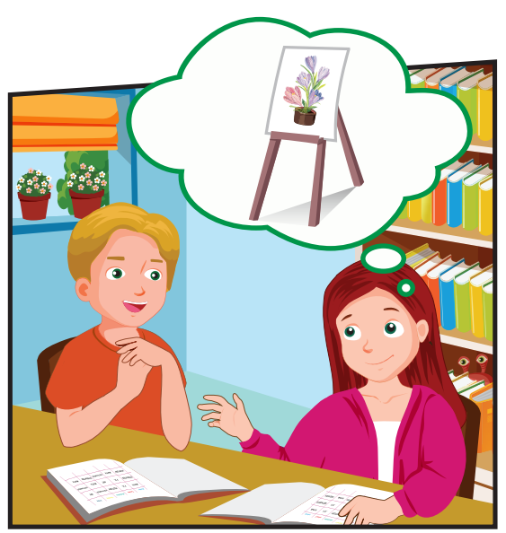
What is Pat's favorite subject?
Art
What does she do in her favorite subject?
She (16)___________ pictures.
Look at the pictures and read the questions. Write one-word answers. (2 questions)
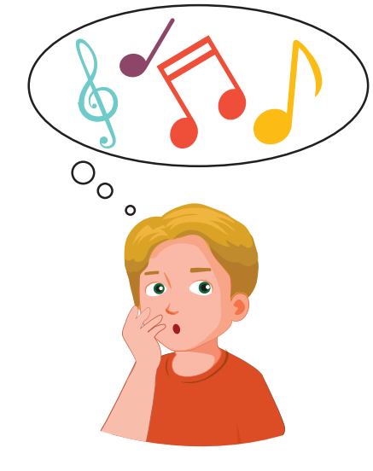
What is Toby's favorite subject?
He likes (17)___________.
What does he do in his favorite subject?
He (18)___________ to music.
---THE END---

