 | ISS GRADE 4 TESTS - THEME 1  Time allotted: 60 | Mã đề: E4-1

PART 1 | Listening (6 questions)
1. Listen and draw lines. There is one example. (2 questions)
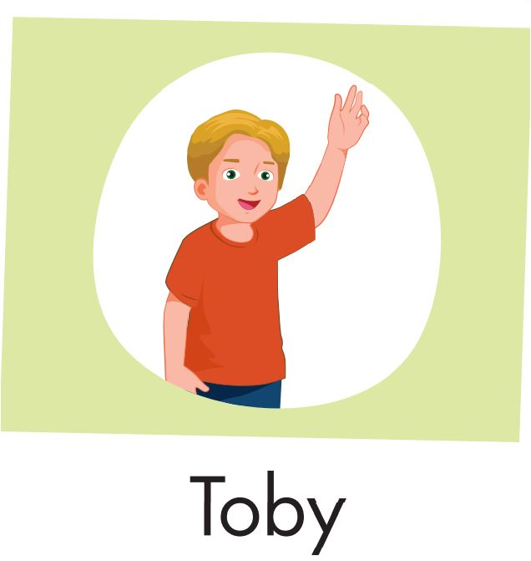 | 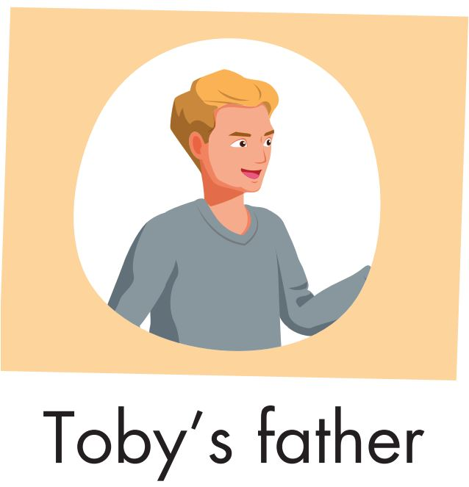
Read the question. Listen and write a name or a number. There are two examples. (2 questions)
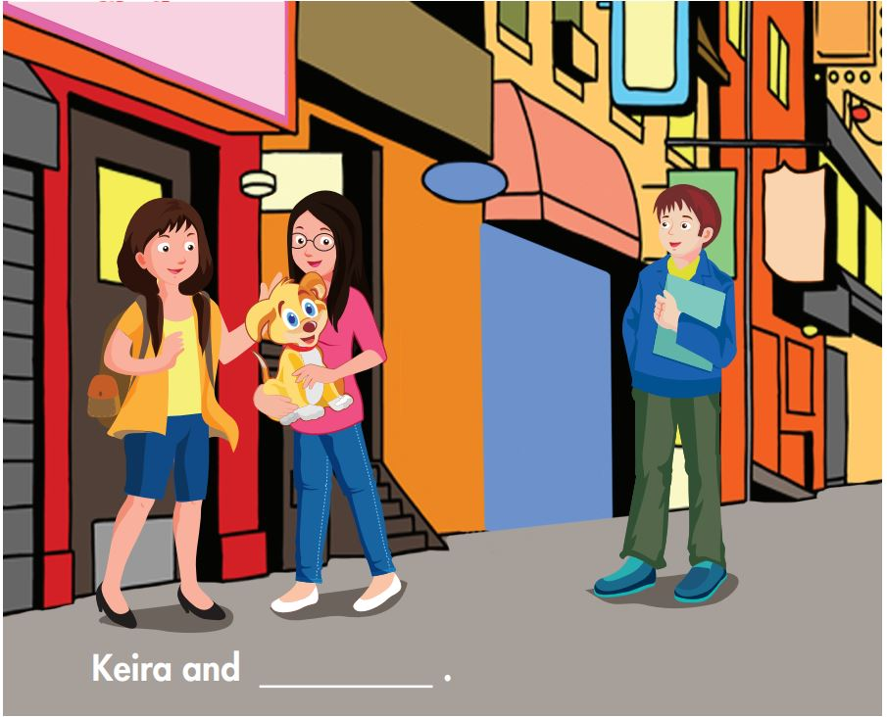
What is the boy’s name? Peter
How old is he? 19
What is the girl’s name? (3)___________
How old is Keira? (4)___________
Listen and choose the answer. There is one example. (2 questions)
Examples:
How many squares can the girl see?
A. ☑ | B. ☐ | C. ☐
Questions:
5. Which picture can the girl see?
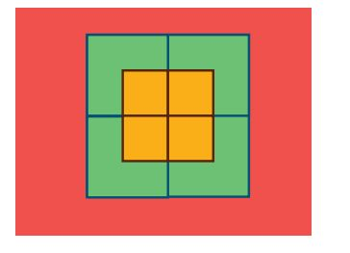 | 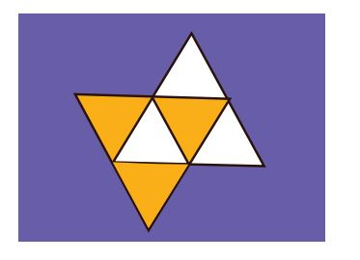
A. ☐ | B. ☐ | C. ☐
6. What can the girl see?
A. ☐ | B. ☐ | C. ☐

PART 2 | Reading and Writing (11 questions)
Look and read. Choose the True or False. There are two examples (2 questions)
Examples:
 | 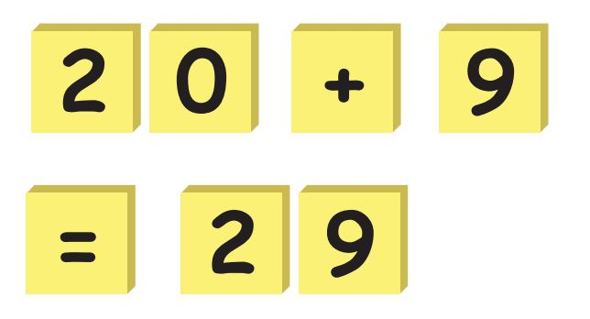 | Twenty plus nine is twenty-nine. | ☑ True ☐ False
 |  | This is a square | ☐ True ☑ False
Questions:
7. | 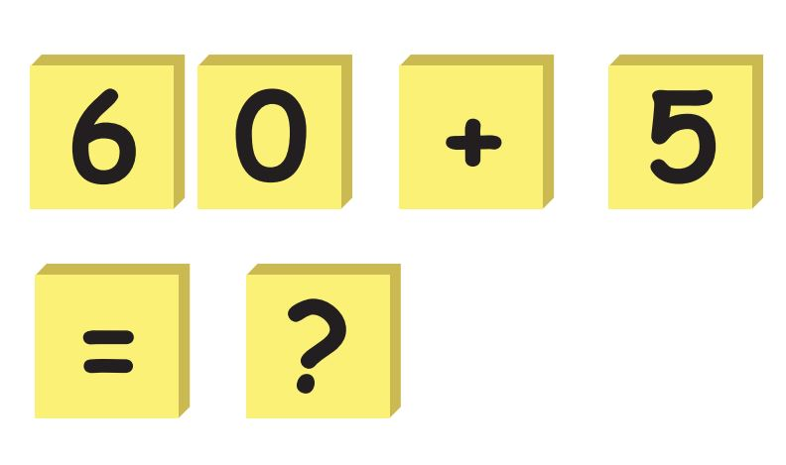 | Sixty plus five is twenty-one. | ☐ True ☐ False
8. |  | This is an oval. | ☐ True ☐ False
Look and read. Choose the True or False. (2 questions)
Examples:
I can see two stars. | ☑ True ☐ False
I can see three circles | ☐ True ☑ False
Questions:
9. I can see four ovals. | ☐ True ☐ False
10. I can see three rectangles. | ☐ True ☐ False
Look at the pictures. Look at the letters. Rearrange the words. (2 questions)
Examples:

 | 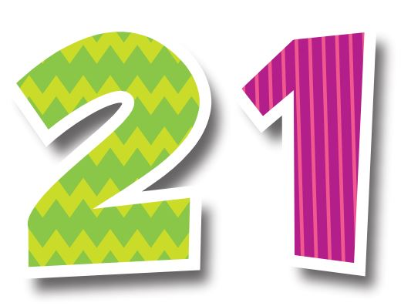 | Keywords: n/e/t/w/y/t/-/n/o/e  → t w e n t y - o n e
Questions:

11. | 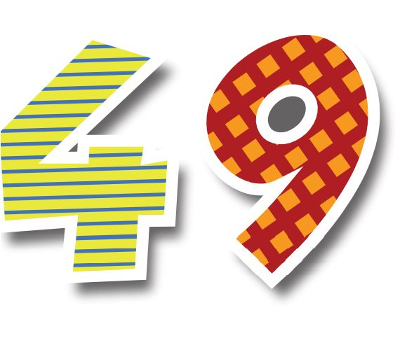 | Keywords: t/r/o/f/y/-/e/i/n/n  → .......................................

12. | 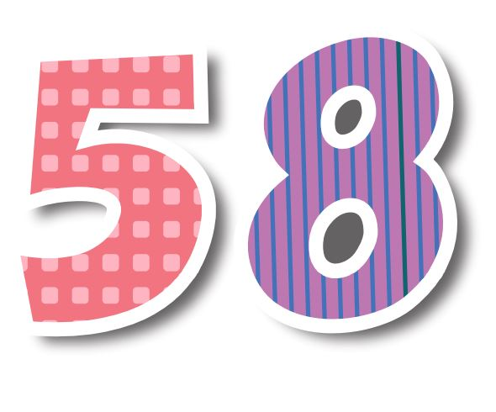 | Keywords: i/f/y/t/f/-/g/e/h/i/t  → .......................................
Read this. Choose a word from the box. Write the correct word. There is one example (2 questions)
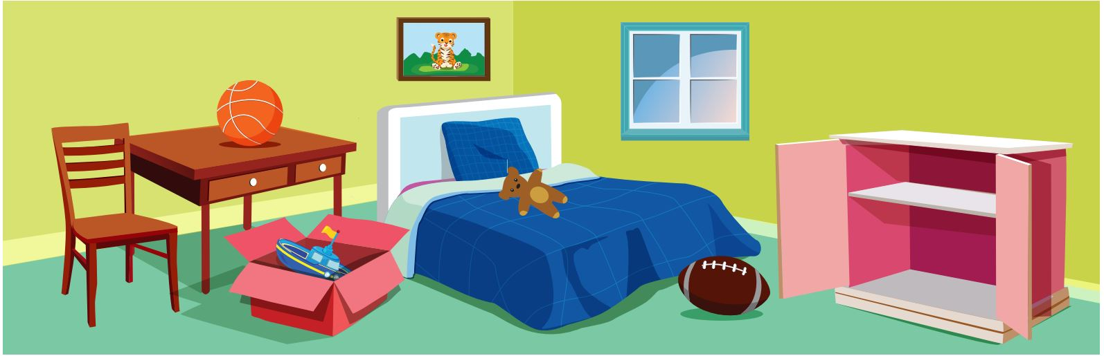
Shapes are everywhere! Look, the window is a square , and the (13)___________ is a rectangle. The (14)___________ is a circle and the football is an oval.
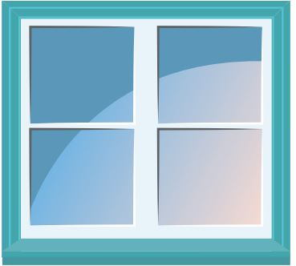  square | 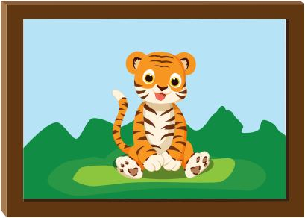  photo
football | basketball
Look at the pictures and read the questions. Write one-word answers.
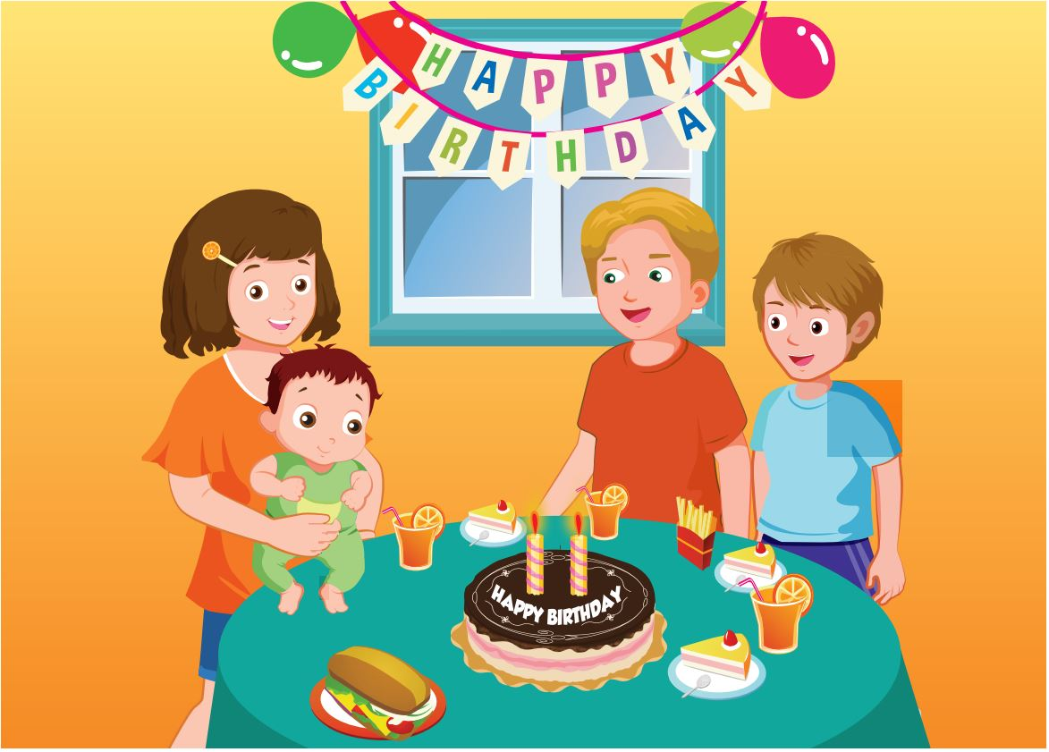
How many balloons are there?
There are four balloons.
What shape is the window?
It's a (15)___________.
Look at the pictures and read the questions. Write one-word answers. (2 questions)
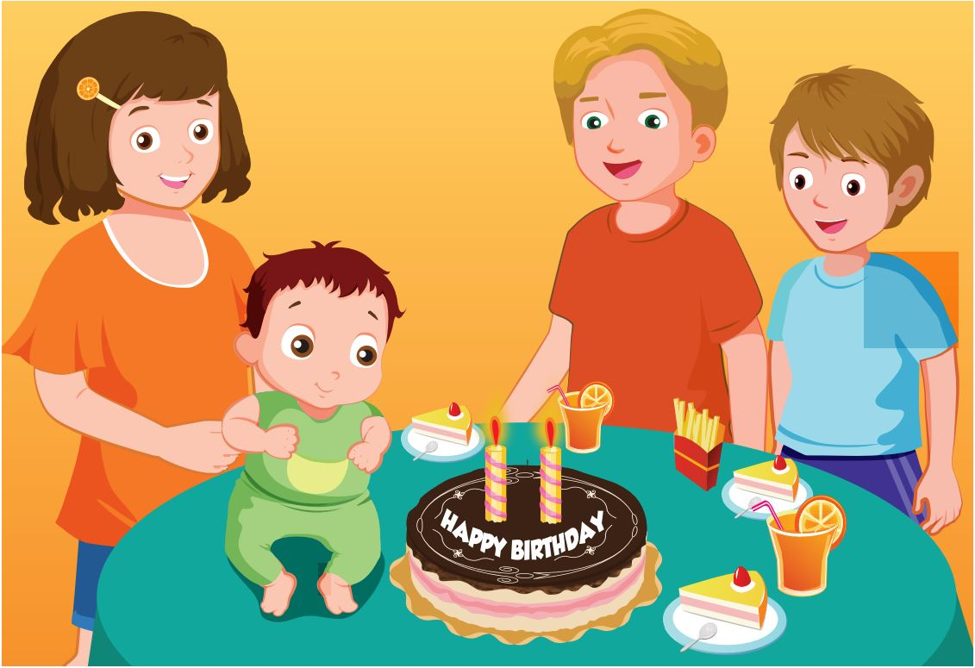
How old is Max?
He’s (16)___________ years old.
What shape is the cake?
It's (17)___________.
---THE END---

