CONTENTS
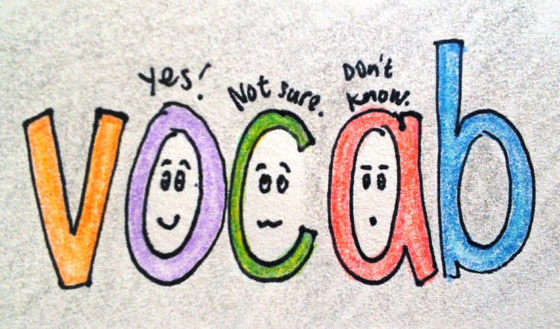
GRADE 6
Unit 1: My new school…………………………………………………............... …..2
Unit 2: My home…………………………………………………………………………….12
Unit 3: My friends…………………………………………………………………….……24
Unit 4: My neighborhood……………………………………………………………....35
Unit 5: Natural wonders of the world……………………………………………..45
Unit 6: Our Tet holiday……………………………………………………………………53
Unit 7: Television……………………………………………………………………………60
Unit 8: Sports and games………………………………………………………………..68
Unit 9: Cities of the world……………………………………………………………….78
Unit 10: Our houses in the future…………………………………………………….88
Unit 11: Our greener world……………………………………………………………..95
Unit 12: Robots……………………………………………………………………………..103
Unit 1: My new school
School supplies
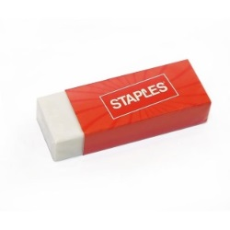 | 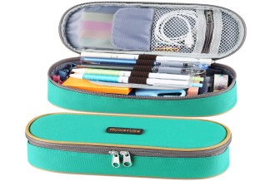 | 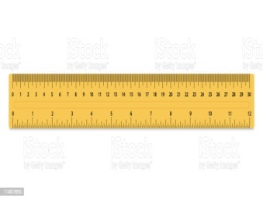 | 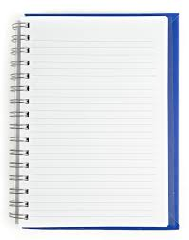
Rubber /ˈrʌbə(r)/ | Pencil case/ˈpensl keɪs/ | Ruler /ˈruːlər/ | Notebook /ˈnəʊtbʊk/
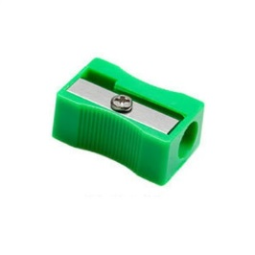 | 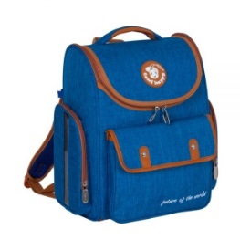 | 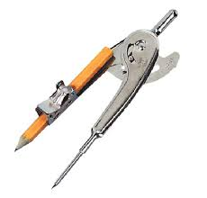 | 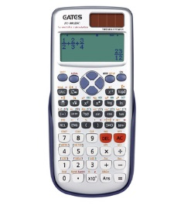
Pencil sharpener  /ˈpensl ʃɑːrpnər/ | School bag  /skuːl bæɡ/ | Compass  /ˈkʌmpəs/ | Calculator  /ˈkælkjuleɪtər/
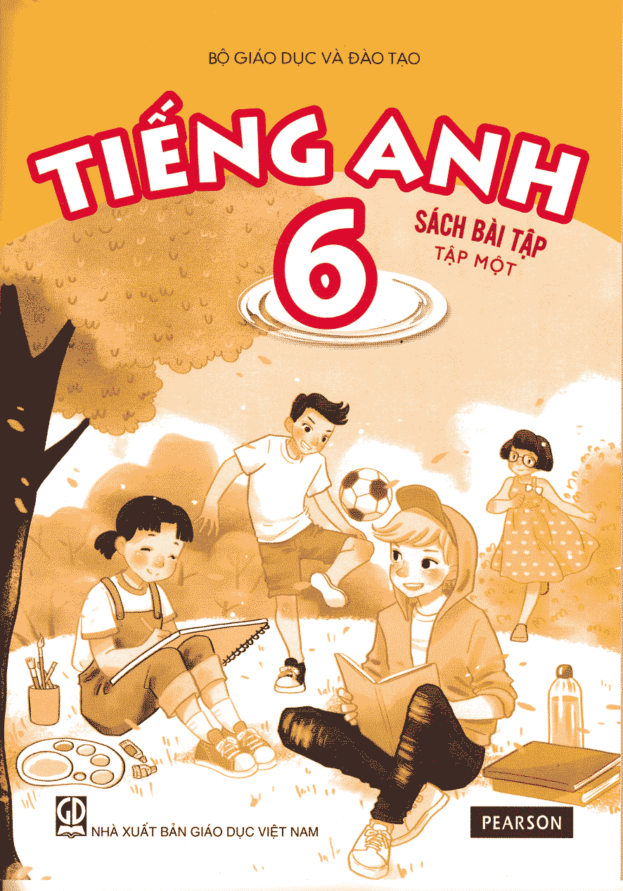 | 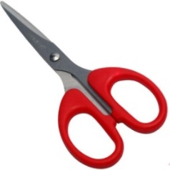 | 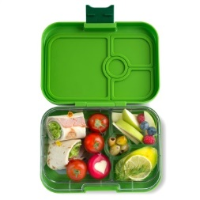 | 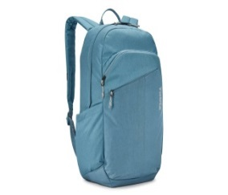
Textbook /ˈtekstbʊk/ | Scissors  /ˈsɪzərz/ | Lunch box  / lʌntʃ bɒks / | Backpack  /ˈbækpæk/
Subjects:
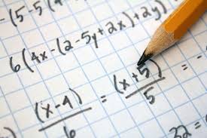 |  | 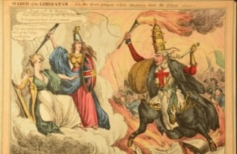
Maths /mæθs/ | Biology /baɪˈɑːlədʒi/ | History /ˈhɪstri/
Literature/ˈlɪtrətʃə(r)/ | Chemistry /ˈkemɪstri/ | Technology (IT) /tekˈnɒlədʒi/
 |  | 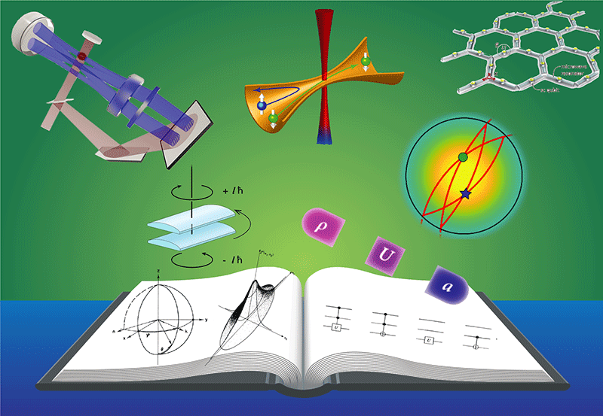
English /ˈɪŋɡlɪʃ/ | Art /ɑːt/ | Physics /ˈfɪzɪks/
Geography /dʒiˈɒɡrəfi/ | Music /ˈmjuːzɪk/ | Drama /ˈdrɑːmə/
Phyical education (PE) /ˈfɪzɪkl /ˌedʒuˈkeɪʃn/ | Science /ˈsaɪəns/ | Dancing /ˈdɑːnsɪŋ/
School rooms
 | 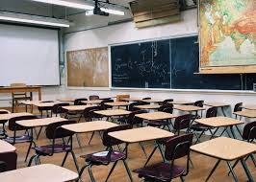 | 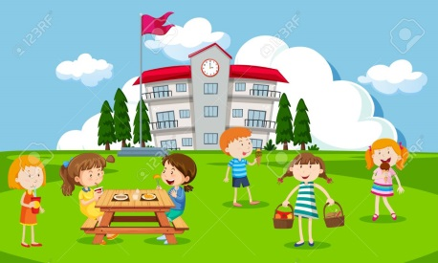
Computer room  /kəmˈpjuːtə(r) rʊm/ | Classroom  /ˈklɑːsruːm | Playground  /ˈpleɪɡraʊnd/
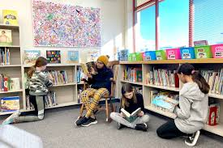 | 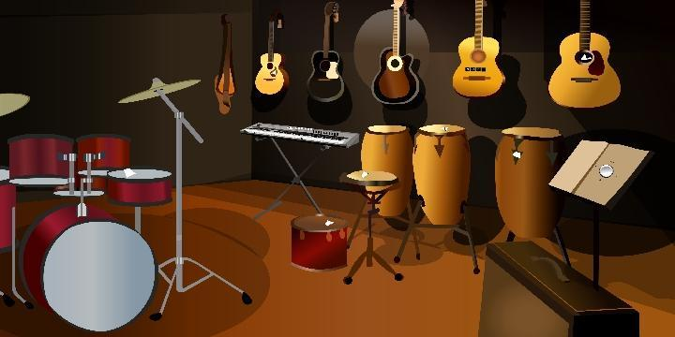 | 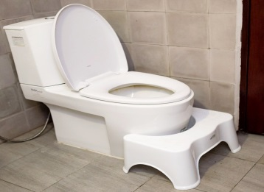
Library  /ˈlaɪbrəri/ | Music room  /ˈmjuːzɪk rʊm/ | Toilet  /ˈtɔɪlət/
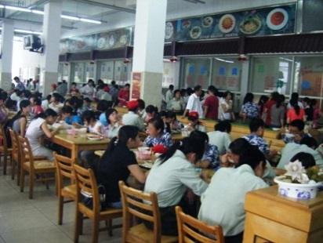 | 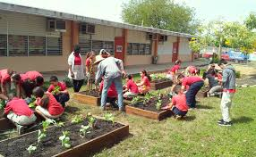 | 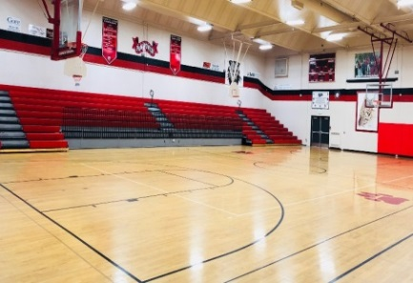
Canteen /kænˈtiːn/ | Garden /ˈɡɑːdn/ | Gym /dʒɪm/
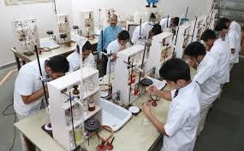 | 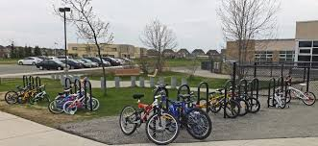 | 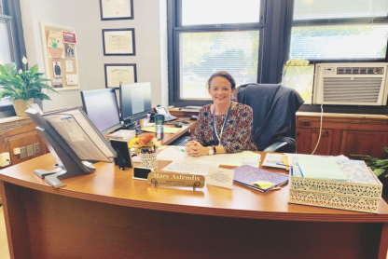
Laboratory (Lab)  /ləˈbɒrətri/ | Parking lot  /ˈpɑːkɪŋ lɒt/ | Principal’s room  /ˈprɪnsəpl z rʊm/
Ex I:
Part A: Write the word for each picture
 |  |  | 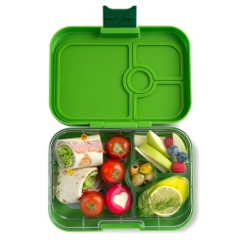
1.p……………… | 2.c…………………….. | 3.c…………………… | 4.l…………………
5.m……………… | 6.l……………………… | 7.p……………………. | 8.b……………….
 |  | 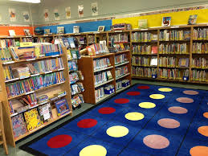
9.c……………… | 10.p……………....... | l………………….. | c………………….

Part B: Find the word which has a different sound in the part underlined
- A. compass B. parking lot C. classroom D. garden
- A. pencil case B. canteen C. computer D. science
- A. garden B. geography C. playground D. language
- A. read B. meat C. bread D. teach
- A. chemistry B. chalk C. children D. church
- A. badminton B. hard C. map D. mathematics
Ex II: Put the word in two groups
some, phone, among, toe, money, bone, shoulder, wonder, show, mother, mosquito, young, company, coat, tomorrow, nothing

/əʊ/ | /ʌ/

Ex III: Odd one out
- A. close B. open C. chose D. month
- A. cousin B. October C. coal D. photo
- A. hold B. know C. wonderful D. grow
- A. cold B. enough C. load D. bowl
- A. go B. does C. arrow D. tomato
- A. honey B. window C. goat D. hole
- A. other B. dove C. love D. post
- A. country B. potato C. trouble D. touch
- A. couple B. double C. tough D. slow
10.A. mother B. flood C. old D. does
Ex IV: Choose the best answer
 | 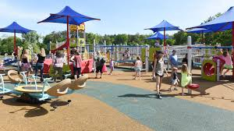
1.A.reading  B. asking  C. answering  D. eating | 2. A. computer room  B. library  C. canteen  D. playground | 3. A. physics  B. English  C. geography  D. math
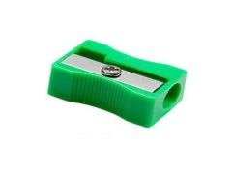 | 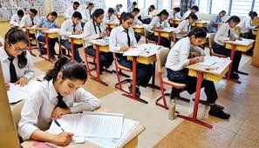 | 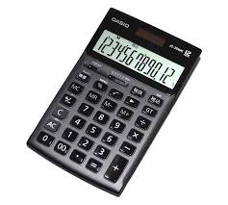
4. A. scissors  B. pencil sharpener  C. rubber  D. ruler | 5. A. exam  B. break time  C. lunch time  D. sleeping time | 6. A. calculator  B. homework  C. compass  D. teacher
 | 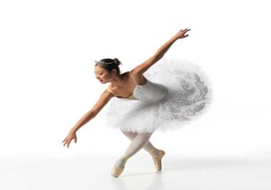
7.A.cleaner  B. student  C. teacher  D. driver | 8.A. paint  B. dance  C. walk  D. wash | 9. A. literature  B. library  C. textbook  D. biology
 | 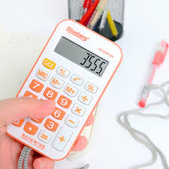 | 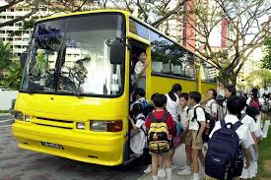
10.A.experiment  B. laboratory  C. assignment  D. test | 11. A. explaining  B. calculating  C. drawing  D. teaching | 12. A. mini board  B. subject  C. classroom  D. school bus
Ex V: Put the words in the correct column
canteen, chemistry, pencil sharpener, notebook, playground, mathematics, rubber, science, classroom, school bag, computer room, physical education, scissors, lunch box, library, art, principal’s room, textbook, physics

School supplies | School rooms | School subjects

Ex VI: Put the words in the correct column
English, badminton, breakfast, yoga, English, lesson, Math, shopping, football, games, exercise, lesson, exam, jump rope, cooking, chemistry

Play | Do | Have | study

Ex VII: Match the words in A with the ones in B
- play |  | A. Chinese
- do |  | B. dinner
- have |  | C. tennis
- study |  | D. the washing up
Ex VIII: Odd one out
- A. physics B. schoolbag C. chemistry D. science
- A. scissors B. calculator C. literature D. pencil case
- A. library B. explain C. answer D. experiment
- A. basketball B. football C. biology D. volleyball
- A. garden B. canteen C. classroom D. school bus
- A. notebook B. literature C. music D. art
- A. teacher B. homework C. principal D. student
- A. exam B. exercise C. compass D. mark
- A. lunch B. snack C. dinner D. music
10.A. write B. discuss C. open D. read

Ex IX: Write a word next to each sentence
- You put your pen, pencils, rulers, erasers into this. ………...
- You use this to erase your wrong answers. ……………
- You go to this room to play musical instruments. …………...
- You have lessons with your classmates in this room. ……………
- You can go to this place to play where you have a break. ……………
- This place is large for students to have lunch. ……………
- You have to write and understand poems in this subject. ……………
- You know about plants, animals in this subject. ……………
- Students do physical exercises in this subject. ……………
10.Students go to this room to study technology. ……………

Ex X: Fill in the gap with a suitable word
excited | bicycle | pencils | question | uniforms
playground | lessons | homework | canteen | cinema

- We often have English …………………..on Mondays and Wednesdays.
- The children are ……………….about the first day at school.
- Mark and Jim have to wear ………………….on Mondays.
- Jack has new books, a new pen and ………………..
- My friends and I usually have lunch at the ………………
- I get up at six and go to school at seven by ………………..
- Our English teacher gives us some …………………..for our Math.
- If the students have any…………………, they should ask the teacher.
- Where is Tom? He is at the ………………….behind our school.
10. Every Saturday, my father takes me to the ………………to see films.
Ex XI: Add more words to the following groups
1.School subjects: maths,………………………………………………………………........
2.School supplies: book,…………………………………………………………………………
3. School room: classroom,……………………………………………………………………
4. School verbs: stand up,………………………………………………………………………
5. Jobs: teacher………………………………………………………………………………………
Ex XII: Put the word given in the correct form
1. We are so …………………..about the first day at school. EXCITING
2. They are ………………….because they play sports every day. HEALTH
3. Where do you often ……………………..football after school? PLAYER
4. Mr. John……………………..us English on Wednesdays. TEACHER
5. I feel ………………….after watching that long film. BOREDOM
6. We join many …………………………….clubs in our school. INTEREST
7. Some creative students do ……….and paintings in the art club. DRAW
8. Why do you enjoy ………………………English? LEARN
9. What ……………….do you do in a chemistry lesson? ACT
10. The children like Jim because he is a ……………………boy. FRIEND
11. The whole class is ………………to have a small party today. HAPPINESS
12. This shirt is too …………………….for me to buy. EXPENSE
13. My son has a box of many…………………… crayons. COLOUR
14. My Tam is a famous …………………..in Vietnam. SING
15. She works as a ……………………..in small school in the town. LIBRARY
16. Let’s go swimming now. The water is so …………………WARMTH
17. I don’t like the ……………….of the sun in the summer. HOT
18. I use this small book because it has blank papers for ……………..important notes. WRITE
19. The boy is …………………and he wants to eat a cake. HUNGER

