CÔNG TY CỔ PHẦN GIÁO DỤC VÀ ĐÀO TẠO VICTORIA

Han� Ou�
4

TÀI LIỆU
BỔ TRỢ

NICE TO SEE YOU AGAIN
UNIT 1

Fill in the gaps with the right words.
night
again
good
tomorrow
1
- Nice to see you
- morning, Miss Hien.
- See you
- Good
2

Read and match

1. Good morning, class. | 1. | A. Nice to see you, too.
2. How are you, Mai? | 2. | B. Bye, Hoa. See you tomorrow.
3. Goodbye, Miss Hien. | 3. | C. Good night.
4. Nice to see you again | 4. | D. Good morning, Miss Hien.
5. Good night. | 5. | E. I’m very well, thank you.

Put the words in order.
3
- to/see/you/again/Nice/./ =>
- later/you/./See =>
- I/./well/very/am =>
- are/How/you/? =>
4

Read and complete.

thanks
fine
afternoon
hi
how

Nam: Good , Miss Hien.
Miss Hien: , Nam.

are you?

Nam: I’m , thank you. And you?
Miss Hien: Fine, .

Read and circle the correct answer.
5
Hello, my name is Le Nam. I am from Ha Noi. I study at Nguyen Du Primary School. It is a big school in Ha Noi. I have many friends. Tony, Phong, Linda and Mai are my friends.

- Is Le Nam a primary pupil?
- Is his school in Ha Noi?
- Is his school small?
- Is Linda his friend?
A. Yes, he is B. No, he isn’t
A. Yes, it is B. No, it isn’t
A. Yes, it is B. No, it isn’t
A. Yes, she is B. No, she isn’t

UNIT 1
2
2
NICE TO SEE YOU AGAIN

I’M FROM JAPAN
UNIT 2
Write the name of the country under each picture.
1

Singapore | Vietnam | France | England
China | America | Japan | Australia
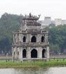
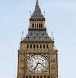
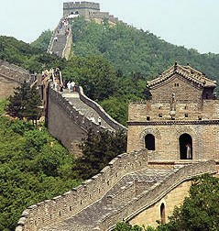

1.

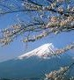

5.
2.

6.
3.
7.
4.
8.

Choose the right option.
2
- Where are you from, Lisa? from America.
  - I am B. My name C. You are D. Her name
- I’m Vietnam.
  - to B. into C. from D. up
- Hello, my Mary.
  - name B. name’s C. named D. names
- This my friend, Tom. She is from England.
  - is B. are C. was D. were
- to meet you, too.
  - Fine B. She C. He D. Nice
- His name’s Louise. ’s from Scotland.
  - You B. She C. He D. I
- Silvia is a doctor. hospital is in Rome.
  - Her B. She C. I D. His
- Where Luigi from?
  - be B. Italy C. is D. are
3

I’M FROM JAPAN
UNIT 2

Read and match.
3

1. Where are you from? | 1. | a. Nice to meet you, too.
2. How are you, Mai? | 2. | b. Bye Hoa, see you tomorrow.
3. What nationality are you? | 3. | c. She is Vietnamese.
4. What’s your name, please? | 4. | d. Yes, come in.
5. Goodbye, Miss Hien. | 5. | e. I’m very well, thank you. And you?
6. Hi, Hoa. It’s nice to meet you. | 6. | f. I’m Peter.
7. Sorry, I’m late. | 7. | g. I’m from France.
8. What nationality is your mother? | 8. | h. I’m English.

Read the passages and answer the questions.
4
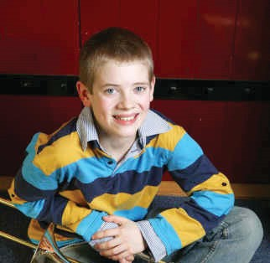
Hi. My name is Peter. I’m ten years old. I am a student. I am in class 4 in Oxford Primary School. I am from America.

This is my friends, Mary. She is eleven years old. She is a student, too. She is from Australia.

1. What’s his name?
2. How old is he?
3. What does he do?
4. Where is he from?
5. What’s her name?
6. How old is she?
7. What does she do?
8. Where is she from?

Write about you, using the suggestions.
5

- name
- age
- birthday
4. job
5. class/school
6. come from

UNIT 2 I’M FROM JAPAN
4

WHAT DAY IS IT TODAY?
UNIT 3

Match one in A with one in B.
1

1. help my | 1. | a. swimming
2. do my | 2. | b. mum
3. visit my | 3. | c. TV
4. go | 4. | d. homework
5. have a | 5. | e. music lesson
6. watch | 6. | f. grandma
Tick (√) and write about you after school. (viết về bạn sau giờ học)
2

After school | Yes | No
- do my homework  - go swimming  - watch TV  - play with friends  - read books  - draw pictures  - have music lesson  - help my mum | √ | √

Example: 1 - I do my homework after school. 2 - I don’t go swimming after school.

3
4.
5.
6.
7.
8.
5

WHAT DAY IS IT TODAY?
UNIT 3

Odd one out. *Tìm từ khác loại)
6
3

1. A. evening | B. morning | C. afternoon | D. going
2. A. Tuesday | B. today | C. Monday | D. Wednesday
3. A. afternoon | B. morning | C. late | D. evening
4. A. zoo | B. school | C. book | D. home
5. A. has | B. do | C. listen | D. help
6. A. weekend | B. Saturday | C. today | D. Sunday
7. A. class | B. teacher | C. kite | D. pupil
8. A. fish | B. plane | C. parrot | D. turtle
Find the mistakes and correct them. (Tìm lỗi sai và sửa)
4

- Today is on Tuesday.

- What does we have on Friday?

- We has English.

- Hoa and Lan have England on Mondays and Wednesdays.

- Does you have English on Thursday?

- What day are it today?

- My father is listening music.

- What do you do on morning Saturday?

- I go to swimming.

Put the words in correct order.
5
- class/in/are/What/you/?

- am/class/4a5/in/I/.

- do/you/What/do the/weekend/at/?

UNIT 3 WHAT DAY IS IT TODAY?

- my/visit/grandparents/I/.

- school/to/go/from/Monday/Friday/I/to/ .

- in/afternoon/the/about/How/?

- go/I/swimming/afternoon/the/in/ .

- you/have/When/English/do/?

- she/go/school/Does/to/every/day/? – does/she/Yes/, /

- name/her/What/is/? – Nhi/is/She/.

- morning/school/go/to/I/in/the/.

- Mondays/have/on/English/and/Fridays/I/.

- She/not/Vietnamese/on/Thursdays/have/does/.

- from/France/Hakim/Is/? – not/is/he/No/.

Read the text and tick in (true) or F (false) column.
6
My name is Lan. I’m in grade 4. Today is Wednesday. I go to school five days a week, from Monday to Friday. I do not go to school on Saturdays and Sundays. At weekend, I go for a picnic with my parents and visit my grandparents. I like my school very much because I can meet my friends and learn the interesting subjects.

 | T | F
- Lan is in grade 5

- Today is Wednesday.

- Lan goes to school six days a week.

- She goes for a picnic with her friends and visits her uncle.

- She likes her school very much.

WHAT DAY IS IT TODAY?
7
UNIT 3

Read and match.
1
UNIT 4
WHEN’S YOUR BIRTHDAY?

1. What day is it today? | 1. | a. We’re fine, thank you.
2. Where is Linda from? | 2. | b. I visit my grandparents.
3. What nationality is Tom? | 3. | c. It’s on Wednesday.
4. What is the date today? | 4. | d. We have English.
5. When is the next English class? | 5. | e. He’s American.
6. What do you do on Sunday morning? | 6. | f. It’s the sixteenth of August.
7. What do we have on Fridays? | 7. | g. She’s from England.
8. How are you? | 8. | h. It’s Sunday.

Complete the table.
2

MONTHS OF A YEAR
1. | 2. | 3.
4. | 5. | 6.
7. | 8. | 9.
10. | 11. | 12.

Put these sentences in correct order to make a dialogue.
3
- It’s on the fifth of March.
- Happy birthday, Linda.
- Oh! What a nice cake!
- Thank you.
- When’s your birthday, Nga?
- Yes, it’s my birthday today.

Correct order:

UNIT 4 WHEN’S YOUR BIRTHDAY?
8

Read and then answer the questions below.
4
Dear pen friend,
My name’s Peter. I’m from London, England. Today is Sunday, the sixth of May.
It’s my birthday. I’m happy. I have many birthday presents from my friends. What about you? When’s your birthday?
Write to me soon, Peter.

- What’s his name?
- Where is he from?
- Is he Vietnamese?
- What day is it today?
- What is the date today?
- Is he happy?
- Does he have many presents?

Make a birthday invitation card.
5
Please come to my birthday party.
To:
Date: Time:

Address:
From:

Write the answers.
6
- What day is it today?
- What is the date today?
- What is your name?
- How old are you?
- When’s your birthday?
- When’s your father birthday?
- When’s your mother birthday?
- When’s your brother’s (sister’s) birthday?
9

WHEN’S YOUR BIRTHDAY?
UNIT 4

Odd one out.
1
CAN YOU SWIM?

  - A. table tennis B. football C. guitar D. volleyball
UNIT 5
  - A. dog B. cat C. fish D. pig
  - A. swim B. book C. cook D. skate
  - A. father B. teacher C. mother D. sister
  - A. have B. goes C. swim D. sing
  - A. play B. kites C. guitar D. piano
  - A. June B. Sunday C. July D. September
  - A. what B. when C. who D. Wednesday
  - A. your B. you C. he D. she
  - A. Vietnamese B. England C. Japan D. America
  - A. badminton B. football C. sing D. basketball
  - A. guitar B. chess C. piano D. song
  - A. name B. sing C. nationality D. day
  - A. nice B. big C. read D. small
  - A. old B. young C. beautiful D. cannot

Give English words.
2

1. Bơi | 1. | 2. Nước Anh | 2.
3. Hát | 3. | 4. Thứ tư | 4.
5. Cờ tướng | 5. | 6. Sinh nhật | 6.
7. Cầu lông | 7. | 8. Khi nào | 8.
9. Sở thú | 9. | 10. Nhật Bản | 10.
11. Công viên | 11. | 12. Tháng 2 | 12.
13. Tháng 10 | 13. | 14. Người Malaysia | 14.
15. Thứ năm | 15. | 16. Nước Úc | 16.

Fill in the blank with suitable words.
3
- I go to school Mondays to Fridays.
- We don’t go to school Saturdays and Sundays.
- My family often watches TV the evening.
- Tuan and Hoang go swimming the weekends.
- The books are the table.
- There are many pictures the wall.
- She is Japan. She is Japanese.
UNIT 5 CAN YOU SWIM?
10

- My birthday is the fifteenth of August.
- The boys play football the afternoon.
- My mother is the kitchen. She is cooking dinner.
- Where is your father? - He is reading his room.
- She doesn’t go out the evening.

Fill in the blank with the words given below.
Yes sing it can pet
4
Nam: Do you have a (1) , Quan? Quan: (2) , I do. I have a parrot. Nam: What (3) it do?
Quan: It can fly, (4) and climb a tree. Nam: Can it speak?
Quan: Yes, it can. (5) can count to ten in English. Nam: Oh, it’s wonderful.
5

Write about your family.
- My mother can
- She can’t
- My father can
- He can’t
- I can
- I can’t
6

Find mistakes and correct the sentences.
- She from England.
- Today is Sunday. We not go to school.
- He name is Tuan.
- Dog cannot walk.
- Can he plays the piano?
- My mother can play the guitar and she can plays the piano, too.

- What are you from?
- What is your birthday?
- Who is it? – It’s an English book.
- Today is on the fifth of December.
- My birthday is in the ninth of June.
- Nga, Tuan and Hoang is playing chess.
- I likes playing chess, table tennis and football.
- She does can not play volleyball.
- Can Mr. Tuan sings an English song?
11

CAN YOU SWIM?
UNIT 5

WHERE’S YOUR SCHOOL?
UNIT 6

Fill one letter in each gap to complete the word.
1

1. _tream  5. d_strict | 2. _lass  6. l_ke | 3. r_n  7. vo_ _eyball | 4. _chool  8. ad_ress
9. _treet | 10. w_tch | 11. w_ _re | 12. _ity
13. s_ipping | 14- v_llag_ | 15. m_r_ing | 16. _oun_rys_de

Circle the odd one out.
2

- A. street  - A. see  - A. school | B. school  B. watch  B. hospital | C. Son  C. chess  C. teacher | D. stream  D. listen  D. pupil
4. A. run | B. skip | C. sing | D. hot
5. A. blue | B. green | C. yellow | D. sunny
6. A. red | B. is | C. am | D. are
7. A. street | B. village | C. nationality | D. district
8. A. old | B. basketball | C. new | D. young
9. A. class | B. sunny | C. windy | D. hot
10. A. nice | B. to | C. from | D. in

Fill one word in each gap to complete the sentence.
3
- I go to from Monday to Friday.
- Linda and Mai like rope.
- My is Nguyen Hue Primary School.
- I am in 4a3.
- My friend’s school is in Cau Giay .
- My uncle lives in Ho Chi Minh .
- Lan’s school is in Ba Trieu .
- Where do you ?
- They like reading .
- What class she in?

Reorder the words to make sentences.
4
- in/is/My/Street/school/Le Qui Don/.
- way/This/I/to/ school/is/go/the/.

UNIT 6 WHERE’S YOUR SCHOOL?
12

- class/you/in/are/What/?
- 4a5/in/She/class/is/.
- at/Nghia Tan/study/We/School/Primary/.
- Her/Quang Trung/school/is/Street/in/.
- are/going/school/to/We/.
- colour/her/schoolbag/is/What/?
- Linda/England/from/is/.
- the/December/Her/is/on/birthday/fifth/of/.

Match the question with the answer.
5

1. Where do you live? | 1. | a. It’s on the ninth of February.
2. Is your school big? | 2. | b. Yes, I like it very much.
3. What class are you in? | 3. | c. Yes, I can.
4. What day is it today? | 4. | d. They’re Vietnamese.
5. What nationality are Lan and Minh? | 5. | e. Yes, it is.
6. Can you swim? | 6. | f. It’s Friday.
7. Do you like English? | 7. | g. I’m in class 4a4.
8. When’s your mother’s birthday? | 8. | h. I live at 27 Le Lai Street.

Find and correct the mistake.
6
- Her school are in Cau Giay District.
- The stream are long.
- She can sings very well.
- Lan doesn’t goes to school at the weekends.
- I live in a village small in the south of the country.
- My uncles lives in City Ha Noi.
- I go to school on the morning.
- The dog can fly.
- My school is Nguyen Hue School Primary.
- Where your school is?

_______________________
_______________________
_______________________
_______________________
_______________________
_______________________
_______________________
_______________________
_______________________
_______________________

WHERE’S YOUR SCHOOL? UNIT 6
13

WHAT DO YOU LIKE DOING?
UNIT 7

Choose the word which the underlined part is pronounced differently from the others.
1

1. A. fly | B. windy | C. rainy | D. daily
2. A. sunny | B. summer | C. such | D. autumn
3. A. hot | B. cold | C. slow | D. hotel
4. A. small | B. day | C. fall | D. tall
5. A. big | B. fine | C. winter | D. spring

Read and match.
2

1. Good night children. | 1. | a. I visit my grandparents.
2. What can your father do? | 2. | b. Yes, he can.
3. What’s your hobby? | 3. | c. It’s on the third of August.
4. What do you do on Sunday morning? | 4. | d. It’s in Cau Giay District.
5. What nationality is Peter? | 5. | e. Good night dad and mom.
6. Can your grandfather ride a bike? | 6. | f. I like sailing a boat and making models.
7. Where’s your school? | 7. | g. He can play chess, football and cook.
8. When’s your birthday? | 8. | h.He’s English.

Fill in the blank with a suitable word.
3
- He’s Lang Son.
- Mai likes collecting .
- My grandparents like TV in the evening.
- Hung and Tuan go to English Club Tuesday and Thursday afternoon.
- Today is the tenth October.

- I go to school
- I study at Nguyen Hue Primary
the morning.
.

- are you from?
- What’s your – I like cooking very much.
- Her sister likes listening to .
- The girl doesn’t like kites.
- They like taking .
- Riding a is really cool.
- Akiko is from Japan. She is .
- What is it today?
- I like reading books.
UNIT 7 WHAT DO YOU LIKE DOING?
14

Write “like/likes/don’t like/doesn’t like” in the sentence, follow the model.
4

- Carl (like) playing volleyball. He (not like) fishing.
-> Carl likes playing volleyball. He doesn’t like fishing.
- Jo and Sue (like) doing gymnastics. They (not like) playing the piano.
- Jenny (like) reading comics. She (not like) playing chess.
- Lee (like) skate boarding. He (not like) painting.
- John and Gary (like) taking photos. They (not like) flying a
kite.
- Emma (like) riding a bike. She (not like) watching TV.

Reorder the words to make sentences.
5
- playing/cousin/Our/chess/likes.

- cinema/doesn’t/My/going/the/aunt/like/to.

- you/What/like/do/doing?

- don’t/brothers/My/eating/like/cheese

- you/guitar/the/like/playing/Do?

- the/parents/watching/like/My/evening/TV/in.

- Jenny/at/get/Does/up/7.00?

- your/What/sister’s/is/hobby?

Answer questions about you.
6
1. What’s your name? __________________________________________
2. How old are you? __________________________________________
3. Which class are you in? __________________________________________
4. Where’s your school? __________________________________________
5. What do you like doing? __________________________________________
6. What can you do? __________________________________________
7. When is your birthday? __________________________________________
8. What day is it today? __________________________________________
15

WHAT DO YOU LIKE DOING?
UNIT 7

Odd one out.
1
UNIT 8
WHAT SUBJECTS DO YOU HAVE TODAY?

- A. Maths  - A. green | B. IT  B. black | C. favourite  C. yellow | D. Science  D. colour
3. A. have | B. has | C. do | D. swing
4. A. morning | B. swimming | C. cooking | D. dancing
5. A. Thursday | B. Monday | C. yesterday | D. Sunday
6. A. five | B. fifth | C. third | D. first
7. A. on | B. collect | C. in | D. to
8. A. my | B. I | C. her | D. his
9. A. stamp | B. model | C. make | D. toy
10. A. bike | B. kite | C. boat | D. sail
11. A. two | B. three | C. nine | D. second
12. A. does | B. have | C. goes | D. has
13. A. month | B. year | C. large | D. day
14. A. Art | B. subject | C. Music | D. English
15. A. school | B. teacher | C. mother | D. brother
16. A. new | B. colour | C. big | D. old
17. A. timetable | B. sing | C. collect | D. sail
18. A. today | B. tomorrow | C. yesterday | D. Tuesday
19. A. fine | B. good | C. hot | D. skate
20. A. toy | B. car | C. collect | D. doll
Look at the timetable and write what you have each day.
2

Monday | Tuesday | Wednesday | Thursday | Friday
Maths | Art | PE | English | PE
Vietnamese | History | Geography | Music | Maths
English | Science | Vietnamese | IT | English
1. I have Maths, Vietnamese and English on Monday

2.
3.
4.
5.
6.
3
Use the timetable in Ex 2 answer the questions below.
- Do you have English on Tuesday?
- What do you have on Monday?
- What is your favourite subject?
- When do you have Vietnamese?
- When do you have PE?

UNIT 8 WHAT SUBJECTS DO YOU HAVE TODAY?
16

- When do you have Music?
- Do you like Maths?
- Do you like IT?
4

Fill in the blank with a suitable word.
- My subjects are Maths and English.
- We have IT and PE Thursday and Friday.
- They are badminton.
- What do you like ? – I like stamps.
- What is your ? – I like swimming and sailing a boat.
- Taking is my hobby.
- What do you have today? – I Music, Vietnamese and History.
- She likes models.
- He goes school from Monday to Friday.
- What do you have on Tuesday? – I have Maths, Science, and Music.
- Phong and I study in the same . It’s Nguyen Hue Primary School.
- It’s on Nguyen Du .
- I really a pen friend.
- I’m planting a new .
- We’re for school. Let’s run.
5

Find and correct the mistake.
- She have Maths, Art and English.
- I like play chess and table tennis.
- My mother cans cook very well.
- My friends like take photographs very much.
- She doesn’t has Science on Tuesday.
- We’re late to school. Let’s run.
- Music and Art is my favourite subjects.
- IT is physical education.
- When do he have Science? He has it on Monday and Wednesday.
- I am a pupil on Quang Trung Primary School.
6
Read the text and choose the correct answer for each blank.
Hello everybody! My name is Hung. I get up at six every day. I clean myself. Then I eat a small breakfast. I go to school (1) seven o’clock. I have
(2) from 7.30 to 11.00. I go home at 11.10. At half past eleven, I have lunch. (3) the afternoon, I do my exercise and learn vocabularies. In the evening, I (4) television. I do my homework. I go (5) bed at ten o’clock.
- A. in  - A. classrooms | B. at  B. floors | C. on  C. schools | D. for  D. classes
3. A. In | B. At | C. On | D.
4. A. listen | B. play | C. watch | D. get
5. A. to | B. for | C. from | D.

WHAT SUBJECTS DO YOU HAVE TODAY?
17
UNIT 8

WHAT ARE THEY DOING?
1
UNIT 9

Look at the pictures, use the words given to write full sentences in present continuous.

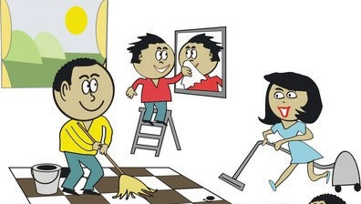
They/do/housework.
- They are doing the housework.

He/have/breakfast.

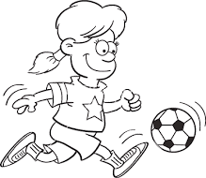
3.

She/play/soccer

5.

Her brother/go/to school

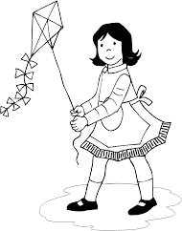
7.

His mother/fly kites

9.

The baby/have/a bath

11.
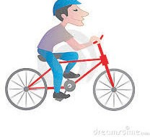 He/ride/a bike

13.

UNIT 9 WHAT ARE THEY DOING?
18

Mrs. Brown/wash/the dishes.
2.
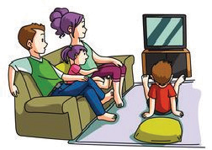 They/watch/TV.

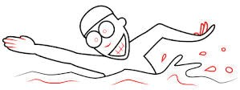
4.

My father/swim

6.

The elephant/jump rope

8.

The boy/brush/his teeth

10.

Peter and Mary/do/ puzzle

12.
Linda/cook

14.

Use the verbs in brackets in present continuous form.
2
Example: 1. They (go) are going to school.
- Lan and Hoa (have) breakfast.
- My father (read) a book.
- The students (do) their HW.
- They (brush) their teeth.
- Mr and Mrs Smith (travel) to Hanoi.
- My sister (not do) her homework. She (sleep).
- His parents (not work) in the factory. They (do) the gardening.
- The girl (not do) the housework. She (watch) TV.
- Nga (read) a book now?
- they (play) a game in the yard?
- the children (wash) their clothes?
- your mother (travel) to Danang now?
- What Mr Hung (read) now? He (listen) to the radio.
- she (travel) to work by car?

Use the words given to write sentences in present continuous form.
3
Example: 1. They/play/soccer/at present. → They are playing soccer at the moment.
- She/listen/to music/in the room. →
- My sister/read/books/in her room. →
- My mother/work/in the garden/now. →
- Nga and Phuong watch/TV/now. →
- - What/she/do/at the moment.? →
  - She/cook/in the dinner. →
- - Where/you/go/now? →
  - I/go/to the post office. →
- - What/the students/do/in the class/now? →
  - They/talk. →
- He/do/his housework/now? →
4

Reorder the words to make sentences.
Example: 1. doing/is/mother/what/your? → What is your mother doing?
- An/Hung/are/What/doing/now/and? →
- That/Hanoi/to/going/businessman/is →
- truck/is/He/driving/his. →
- waiting/is/Who/he/for? →
- driving/to/Quang/is/Hue. →
- vegetable/the/market/to/taking/is/He/the. →
- Nha Trang/The/is/train/to/going. →
- the garden/The/are/children/playing/in. →
- brushing/teeth/Mai/her/is. →
19

WHAT ARE THEY DOING?
UNIT 9

WHERE WERE YOU YESTERDAY?
UNIT 10

Fill in the blank with WAS or WERE.
1
- The teacher nice.
- The students very clever.
- One student in the classroom.
- We sorry for him.
- He tall and thin.
- I happy.
- You at the zoo this morning.
- She in London last week.
- He on the beach last weekend.
- It Cold yesterday.
- We at school.
- You at school this morning.
- They at home last night.
- The cat in the garden.
- The children at the zoo.
- Kien at school this morning.
2

Read and match.

1. Washed | 1. | a. Her homework
2. Went | 2. | b. Dinner
3. Watered | 3. | c. A mask
4. Watched | 4. | d. A song
5. Read | 5. | e. Basketball
6. Did | 6. | f. My hair
7. Made | 7. | g. The flowers
8. Painted | 8. | h. A video
9. Cooked | 9. | i. To music
10. Played | 10. | j. To bed
11. Listened | 11. | k. A text
12. Sang | 12. | l. A paper boat
Put the word in correct order.
3
- the/basketball/They/playing/are/gym/in/.

- yesterday/beach/They/were/on/the/afternoon/.

20 UNIT 10 WHERE WERE YOU YESTERDAY?

- Where/yesterday/Linda/was/morning/?

- the/in/flowers/the/morning/watered/I/.

- evening/the/I/TV/watched/in/.

- did/do/night/What/she/last/?

- was/the/Tuan/at/zoo/.

- this/painted/mask/We/a/nice/afternoon/.

- evening/piano/the/Did/you/yesterday/play/?

- this/TV/Mai/brother/and/her/watched/morning/.

Choose the correct answer.
4
- They are (paint/paiting/paints/painted) a nice picture in the classroom.
- What did you (do/doing/did/does) yesterday morning?
- Was she English? – Yes, she (isn’t/is/was/wasn’t)
- My mother can (plays/play/playing/played) the piano very well.
- The teacher (is/aren’t/are/am) reading a dictation for the class.
- Mai and Kien (watch/are watching/watches/watched) a video last night.
- Mai (gets up/got up/getting up/get up) late this morning.
- (What/Who/Where/How) natioanlity is Hakim?
- He is (English/England/France/America).
- I (making/makes/maked/made) a paper puppet with my friends.
5

Read and match.

1. What nationality is Tom? | 1. | a. They are doing their homework.
2. Did they play chess? | 2. | b. It’s the ninth of December.
3. Do you like Physical Education? | 3. | c. I’m in the music room.
4. Where were you yesterday? | 4. | d. No, they didn’t.
5. Where are you Linh? | 5. | e. He’s American.
6. What’s the date today? | 6. | f. Yes, I do.
7. What subjects do you have today? | 7. | g. I was at home with my parents.
8. What are Kien and Nam doing? | 8. | h. English, Vietnamese and Maths.

WHERE WERE YOU YESTERDAY?
21
UNIT 10

Find and correct the mistake.
6

- I am Ha Noi. I’m Vietnamese.

- Where is she? – She is Linda.

- I play football with my friends yesterday afternoon.

- At the yellow table, the girls are paint a paper plane.

- Today is Monday, the eight of March.

- I like listen to music in the evening.

- Where are you last weekend?

- What are she doing?

- Linda’s read a text and Mai’s writing a dictation.

- Mai and Peter are stand next to the door.

- My favourite subjects is IT and Literature.

- In school, she has Maths, Vietnamese, English, and Science.

- Lam study at Hoa Hong Primary School.

- I have a new kite. Let’s flying it.

- My grandparents like watch TV.

- Her hobby are taking photographs.

- My mother can likes cooking very much.

- My school is in Street Tay Son.

- Her birthday is in the February.

22 UNIT 10 WHERE WERE YOU YESTERDAY?

WHAT TIME IS IT?
UNIT 11

Circle the odd one out.
1

- A. this  - A. open | B. how  B. close | C. what  C. stand | D. who  D. nice
3. A. your | B. my | C. she | D. its
4. A. school | B. library | C. classroom | D. friend
5. A. hello | B. thanks | C. goodbye | D. hi

Write the time in 2 ways.
2
Example: 6:10 – It’s six ten – It’s ten past six.

1. 5: 15
2. 5: 30
3. 6: 24

4. 6: 45
5. 7: 05
6. 8: 29

7. 9: 38
8. 10: 50
9. 2: 10

10. 1: 40

Ask and answer.
3

Example: She/get up/6.00
What time does she get up? => She gets up at 6.00 o’clock.
- He/go to school/6.30

- Lan/have breakfast/6.15

- You/go to bed/10.00

- They/have lunch/11.30

- Your father/go to work/7.30

WHAT TIME IS IT?

UNIT 11
23

Read and complete the sentences.
4
Phong studies at Nguyen Du Primary school. Every day he gets up at 6.30. He goes to school at 7 a.m School starts at 7.30 a.m and finishes at 4.30 p.m. He goes home at 5 o’clock. He has dinner at 7.15 in the evening. Then he does his homework or listens to music. He goes to bed at 9.45.
- Phong goes to school at
- He goes home at
3. He at 7.15
4. He at 9.45

Put the words in order to make sentences.
5
- gets/My/early/up/father

- I/afternoon/the/go/school/to/in

- ten/at/My/to/o’clock/bed/brother/goes

- in/morning/do/the/What/you/eat?

- mother/up/does/your/time/get/What?

Make 10 sentences about what you do in a day.
6

1.
2.
3.
4.
5.
6.
7.
8.
9.
10.

24 UNIT 11 WHAT TIME IS IT?

WHAT DOES YOUR FATHER DO?
UNIT 12

Put a suitable word under each picture.
1

farmer | nurse | driver | factory worker
teacher | student | pupil | clerk
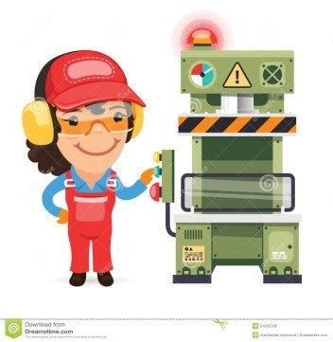

1.
5.

Odd one out.
2
2.

6.
3.

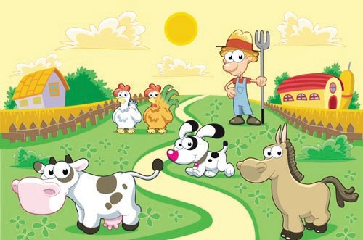

7.
4.

8.

1. A. farmer | B. month | C. nurse | D. teacher
2. A. doctor | B. teacher | C. school | D. nurse
3. A. ruler | B. worker | C. rubber | D. book
4. A. father | B. mother | C. teacher | D. grandma
5. A. pupil | B. notebook | C. pencil | D. rubber
6. A. forty | B. fourth | C. fifteen | D. twenty
7. A. get | B. go | C. stay | D. early
8. A. where | B. what | C. went | D. how
9. A. did | B. goes | C. got | D. drew
10. A. factory | B. clerk | C. school | D. hospital
11. A. office | B. police | C. doctor | D. clerk
12. A. sister | B. farmer | C. worker | D. singer

WHAT DOES YOUR FATHER DO?
25
UNIT 12

13. A. grandpa | B. grandma | C. pupil | D. uncle
14. A. next | B. at | C. to | D. past
15. A. dinner | B. eat | C. lunch | D. breakfast
16. A. morning | B. evening | C. afternoon | D. singing
17. A. finish | B. start | C. listen | D. homework
18. A. milk | B. in | C. on | D. at
19. A. field | B. doctor | C. hospital | D. factory
20. A. she | B. her | C. his | D. your

Find and correct the mistake. (Tìm và sửa lỗi sai)
3

- I go to school at 6.40 o’clock.

- My school finishes in 11.30.

- What does your sister do? – She’s an pupil.

- My father waters the flowers every morning. She likes the flowers.

- He goes on bed at 9.45.

- My mother gets up early on the morning.

- Mr. Tuan is a doctor. He works in the field.

- Her grandfather plants rice, vegetable and raises pig, chicken. He is a factory worker.

- Mrs. Lien teaches English at my school. She is a pupil.

- There is four people in my family: my father, my mother, my brother and me.

26 UNIT 12 WHAT DOES YOUR FATHER DO?

Read and match.
4

1. What time did you go to school yesterday? | 1. | a. It’s on the second of April.
2. What time does she have breakfast? | 2. | b. I work in a factory.
3. Were you at the zoo this morning? | 3. | c. At 9 p.m.
4. Where does your mother work? | 4. | d. No, he’s a student.
5. Where do you work? | 5. | e. She’s a clerk.
6. What time is it now? | 6. | f. At 6.30 a.m.
7. What does your mother do? | 7. | g. I went to school at 7.00.
8. What time do you go to bed? | 8. | h. It’s half past ten.
9. Is your brother a farmer? | 9. | i. No, I wasn’t. I stayed at home.
10. When’s her birthday? | 10. | j. She works in an office.
Make sentence using given words. (Tạo thành câu hoàn chỉnh với từ gợi ý)
5
- Nam and Quang/student Nam and Quang are students.
- Her uncle/driver
- My father and her uncle/factory worker
- My mother/nurse
- Mr. Huong/doctor
- I/teacher
- Mr. Nam/go to work/6.45
- We/ get up/6.00
- What/her sister do/? – She/student/.
- What time/Peter/do homework/? - /7/evening/.
- A doctor/work/hospital/
- A clerk/work/office/
- A worker/work/factory/
- A teacher/teach/school/
- She/read/a book/now/

Answer questions about you.(Trả lời câu hỏi về bản thân)
6
- What do you do?
- What time do you get up?
- What time do you go to bed?
- What time do you have lunch?
- What does your father do?
- Where does your father work?
- What subjects do you like?
- When’s your birthday?
- What can you do?
- When do you have English?
27

WHAT DOES YOUR FATHER DO?
UNIT 12

UNIT 13
WOULD YOU LIKE SOME MILK?

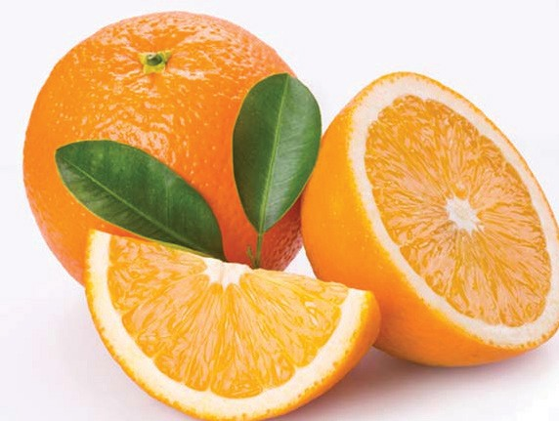
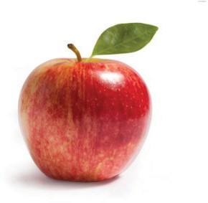
1 Put a word under each picture.

1.

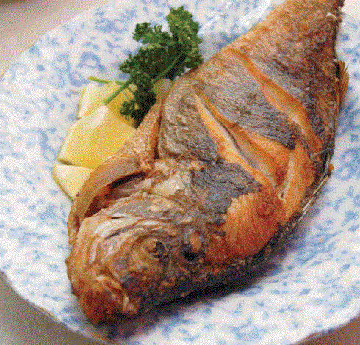
5.
9.

Odd one out.
2
2.

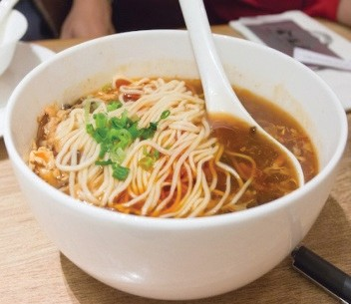
6.
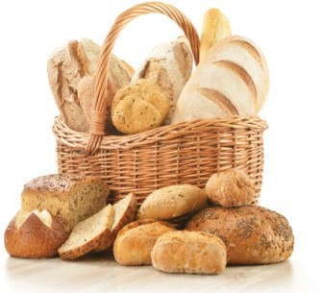
10.
3.
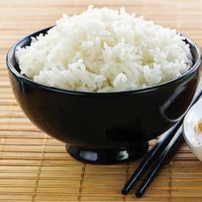
7.
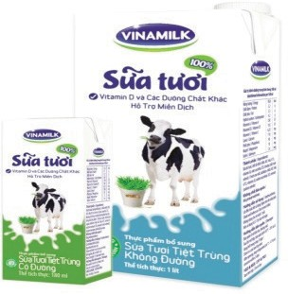
11.
4.
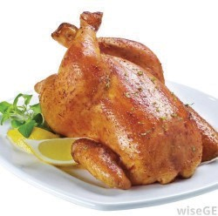
8.
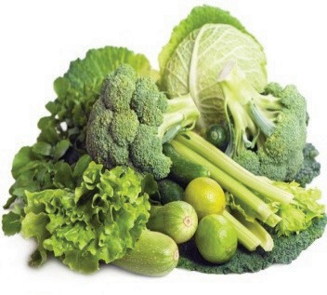
12.

- A. fish B. pork C. beef D. fruit juice
- A. bread B. nurse C. noodles D. food
- A. doctor B. worker C. rubber D. teacher
- A. clerk B. field C. factory D. office
- A. drink B. milk C. water D. apple
- A. banana B. apple C. fruit D. tailor
- A. drink B. noodles C. bread D. fish
- A. lemonade B. fruit juice C. orange juice D. chicken
- A. vegetable B. breakfast C. lunch D. dinner
- A. rice B. orange C. banana D. apple
- A. orange juice B. milk C. water D. fish
- A. bread B. noodles C. hungry D. fish
- A. thirsty B. banana C. apple D. lemonade
- A. math B. teacher C. history D. music
- A. subject B. pencil C. rubber D. sharpener
- A. England B. American C. Japan D. China
- A. her B. his C. nationality D. your
- A. get up B. go home C. name D. sing
- A. PE B. IT C. On D. Art
- A. eat B. pork C. chicken D. bread
28 UNIT 13 WOULD YOU LIKE SOME MILK?

Put the words in correct order.
3
- like/I/apple juice/would/some/.

- What/your/drink/favourite/is/?

- Mary’s/food/is/What/favourite/?

- drink/is/juice/favourite/My/orange/.

- parents/fish/rice/like/My/and/

- have/you/breakfast/do/What/for/?

- is/drink/your/favourite/What/?

- mother/home/late/goes/evening/the/in/My/.

- Her/factory/worker/works/in/, /he/is/father/a/a/.

- She/some/like/water/an/would/and/apple/.

Read and match.

1. What’s your favourite drink? | 1. | a. Yes, please.
2. Does she like her job? | 2. | b. Yes, you can.
3. Would you like some lemonade? | 3. | c. In a factory.
4. What does she do? | 4. | d. Yes, please. I love noodles.
5. May I come in, sir? | 5. | e. It’s apple juice.
6. Do you like your job? | 6. | f. No, she doesn’t.
7. Would you like some noodles? | 7. | g. She’s a clerk.
8. Where does he work? | 8. | h. Yes, I do.
9. What time do you go to school? | 9. | i. On Tuesday and Thursday.
10. Where are you from? | 10. | j. No, she’s American.
11. What did you do last night? | 11. | k. It’s two fifty six.
12. Did you go to school yesterday? | 12. | l. I did my homework and watched TV
13. Is she Malaysian? | 13. | m. At a quarter to seven.
14. What time is it now? | 14. | n. Yes, I did.
15. When do you have English? | 15. | o. Tokyo, Japan.

WOULD YOU LIKE SOME MILK?
29
4
.
UNIT 13

Choose the correct answer.
5
- Would you like beef? (an/a/some/any)
- My father his job. (like/loves/do/have)
- What Lan do? (is/am/do/does)
- Our friends to school in the morning. (goes/when/go/did)
- What you do yesterday? (do/does/did/doed)
- Lan at the zoo last weekend. (is/was/beed/am)
- My drink is lemonade. (like/favourite/love/drink)
- I go to at 10 p.m. (school/work/bed/thezoo)
- My grandfather is a farmer. He works in the . (factory/school/office/field)
- Every day I get at 6 o’clock. (up/in/to/next)
- His favourite drink is . (chicken/beef/fruitjuice/beef)
- Sometimes I have some bread with milk for . (school/breakfast/class/friend)
- I am hungry. I would like some . (water/milk/coffee/noodles)
- Mr. Tuan is a doctor. He works in a . (field/factory/hospital/policestattion)
- My uncle is a in a primary school. (tailor/singer/teacher/driver)
- My grandparents are working in the rice now. (field/office/hospital/school)
- What does your brother get up? (colour/time/food/drink)
- does she work? – in an office. (what/who/when/where)
- My school starts at 7 o’clock and at 11.15. (does/teaches/finishes/watches)
- dinner, I do my homework or listen to music. (at/after/before/in)

Fill in the blank with a suitable word.
6

- I go to school Monday to Friday.
- She was school this morning.
- She goes to bed 9 p.m
- What time do you get ?
- Pupils don’t go to school Saturdays and Sundays.
- Lan goes to English club Monday, Wednesday and Friday afternoon.
- My mother’s birthday is the eighth of February.
- She has breakfast half past six.
- They usually play football the afternoon.
- yellow table, the girls are painting some masks.
- There are two maps the wall.
- There is a fence in of my house.
- My birthday is December.
- The teacher is sitting the bench and reading a book.
- I have music and IT Tuesday.

30 UNIT 13 WOULD YOU LIKE SOME MILK?

WHAT DOES HE LOOK LIKE?
UNIT 14

Circle the odd one out.
1

1. A. breakfast |  | B. lunch | C. dinner |  | D. shower
2. A. watch |  | B. listen | C. do |  | D. homework
3. A. Saturday |  | B. Tuesday | C. today |  | D. Sunday
4. A. volleyball |  | B. housework | C. game |  | D. soccer
5. A. timetable |  | B. Literature | C. Math |  | D. English
2 Write the words follow the model. (tall-> taller). (viết so sánh hơn)
1. long |  | 6. wide
2. small |  | 7. big
3. quiet |  | 8. deep
4. short |  | 9. high
5. young |  | 10. Slow

Write the sentences follow the model. (Viết so sánh hơn của từ trong ngoặc)
3
- The USA is (big) bigger than Spain.

- Mount Everest is (high) than Tam Dao mountain.

- Cars are (fast) than bike.

- Grapes are (small) than apples.

- Lake Baikal is (deep) than Hoan Kiem Lake.

- Turtles are (slow) than rabbits.

Reorder the words to make sentences.
4

- is/than/the/smaller/The/horse/goat.
- are/Snakes/longer/dogs/than.
- giraffe/taller/is/the/than/zebra/The.
- The/bigger/is/than/elephant/monkey/the.
- is/donkey/the/than/faster/cow/The.
- train/A/slower/is/than/plane/a.
31

WHAT DOES HE LOOK LIKE?
UNIT 14

Read and write true (T) or false (F).
5
My mum’s a doctor. She gets up at 5 o’clock. She has breakfast at 6 o’clock. She
goes to work at 7 o’clock. She has lunch in her office.
She goes home at 5. 30 and she cooks dinner. She reads books at night. She goes to bed at 10.45.
- My mother is a teacher.

- She gets up at five o’clock.

- She goes to work at eight o’clock.

- She doesn’t have lunch in her office.

- She goes home at half past five.

- She goes to bed at ten o’clock.

Read and answer the questions.
6

My name is Lan. I’m ten years old and I live in Ha Noi. There are five people in my family: my father, my mother, my two twin brothers and me. My father is a teacher of history. He is forty-one years old, and he is quite fat and tall. My mother is thirteen- eight years old. She is a teacher, too. She is beautiful and kind. My two twin brothers are students at High School. They are sixteen years old. They’re tall but they are slimmer than me.

- What does Lan’s father do?

- What does her father look like?

- What does her mother look like?

- How old are the twin brothers?

- Are Lan’s twin brothers slimmer than her?

32 UNIT 14 WHAT DOES HE LOOK LIKE?

Odd one out.
1
UNIT 15
WHEN’S CHILDREN’S DAY?

1. A. old | B. young | C. fish | D. slim
2. A. chicken | B. lemonade | C. pork | D. beef
3. A. bread | B. apple | C. noodles | D. rice
4. A. banana | B.strong | C. thin | D. thick
5. A. smaller | B. thinner | C. thicker | D. sister
6. A. short | B. tall | C. milk | D. weak
7. A. Tet | B. Christmas | C. Market | D. Children’s Day
8. A. grandparents | B. parents | C. grandfather | D. grandmother
9. A. big | B. milk | C. water | D. lemonade
10. A. orange | B. beef | C. apple | D. banana
11. A. decorate | B. wear | C. clean | D. gift
12. A. lucky money | B. banh chung | C. firework | D. floor
13. A. Teachers’ Day | B. Teacher | C. Women’s Day | D. New Year
14. A. farmer | B. clerk | C. office | D. worker
15. A. nurse | B. doctor | C. hospital | D. school
16. A. field | B. office | C. school | D. driver
17. A. car | B. driver | C. ship | D. plane
18. A. factory | B. lunch | C. breakfast | D. dinner
19. A. student | B. farmer | C. small | D. nurse
20. A. orange juice | B. pink | C. black | D. red

When’s this festival?
2

- Teachers’ Day

- New Year

- Children’s Day

- Christmas .

- Women’s Day

- Independence Day

WHEN’S CHILDREN’S DAY?
33
UNIT 15

Read and match.
3

1. What time is it? | 1. | a. I get up at 6 a.m.
2. What’s your favourite drink? | 2. | b. She works in an office.
3. When is your birthday? | 3. | c. I was at home.
4. What does your grandfather do? | 4. | d. She’s a nurse.
5. What subjects does he like? | 5. | e. I like chicken and beef.
6. Would you like some coffee? | 6. | f. She did her homework.
7. Do you like your job? | 7. | g. Yes, I like noodles.
8. What time do you get up? | 8. | h. Maths, English and IT.
9. What did she do last night? | 9. | i. It’s on the third of April.
10. Where does Lan work? | 10. | j. It’s half past eleven.
11. What’s your favourite food? | 11. | k. It’s Monday, the eleventh of June.
12. What time does your family have lunch? | 12. | l. No, thanks.
13. Where was you yesterday? | 13. | m. He’s a farmer.
14. Is she a driver? | 14. | n. They are old but strong.
15. Who is shorter, Nam or Linh. | 15. | o. I visit my grandparents.
16. What do you do at Tet? | 16. | p. No, she is a clerk.
17. What does your grandparents look like? | 17. | q. Linh is.
18. Would you like some noodles? | 18. | r. Yes, I do.
19. What is the date today? | 19. | s. It’s apple juice.
20. What does your mother do? | 20. | t. We have lunch at 12 o’clock.
Read and answer questions.
4
Hi. My name is Linda. I like beef. It is my favourite food. My favourite drink is orange juice. I don’t like vegetables. My younger brother Peter doesn’t like beef. He loves chicken. It is his favourite food. He loves lemonade too. Lemonade is his favourite drink. He drinks it every day.
- What’s her name?
- What food does she like?
- What is her favourite drink?
- Does she like vegetables?
- What’s her younger brother’s name?
- Does he like chicken?
- What’s Peter favourite drink?
- When does Peter drink his favourite drink?

34 UNIT 15 WHEN’S CHILDREN’S DAY?

Read and write.
5
Dear Jane,
My name’s Marry. I’m nine years old and I live in Da Nang. There are four people in my family: my father, my mother, my brother and me. My father’s 34 years old. He’s a teacher; and he’s tall and slim. My mother’s 31 years old. She’s a doctor. I think she’s very beautiful. My brother and I are pupils at Hoa Hong Primary School. I’m older than my brother but he’s taller than me.
Best wishes, Marry

1. What does Marry’s father do?
2. What does her father look like?
3. What does her mother do?
4. What does her mother look like?
5. What do Marry and her brother do?
6. How old is Marry?
7. Who is younger, Marry or her brother?
8. Who is shorter, Marry or her brother?

Put the words in correct order.
6

1. like/mother/What/your/does/look/?
2. me/brother/is/older/My/than/.
3. What/grandparents/do/like/your/look/?
4. are/their/house/decorating/They/.
5. is/father/strong/My/and/big/.
6. she/does/What/do/?
7. slim/brother/My/is/tall/and/.
8. parents/young/My/are/strong/and/
9. doing/are/What/you/Lan/and/?
10. father/my/is/brother/than/taller/My/.

WHEN’S CHILDREN’S DAY?

UNIT 15
35

Odd one out.
1
LET’S GO TO THE BOOKSHOP

- A. school B. sweet C. pharmacy D. bakery
UNIT 16
- A. film B. buy C. water D. book
- A. see B. watch C. go D. firework
- A. banh chung B. flower C. lucky money D. visit
- A. New Year B. Tet C. Women’s Day D. Month
- A. firework display B. pork C. rice D. beef
- A. thick B. thin C. how D. small
- A. morning B. lunch C. afternoon D. evening
- A. get up B. vegetable C. go to bed D. go home
- A. chicken B. water C. lemonade D. apple juice

Put the words in correct order.
2
- bed/to/at/o’clock/She/10/goes/.
.
- Let’s/swimming/go/to/pool/the/.
.
- firework/like/to/She/would/watch/display/.
.
- am/I/and/hungry/I/like/some/would/noodles/.
.
- father/home/at/5.30 pm/My/goes/.
.
- some/to/books/want/I/buy/.
.
- animals/see/She/wants/the/to/.
.
- do/Mai/go/and/Tony/Where/?
.
- like/They/would/to/to/the/go/sweetshop/.
.
- the/want/pharmacy/go/to/to/would/I/like/because/I/to/medicine/buy/some/.
.

36 UNIT 16 LET’S GO TO THE BOOKSHOP

Fill in the blank with suitable words.
3
- Linda wants to buy some chocolate, she would like to go to the .

- Tony wants to see a film, he would like to go to the .

- I want to buy some bread. Let’s go to the .

- My mother wants to buy some medicine. Let’s go to the .

- Our grandparents want to buy some food. They would like to go to the .

- Her sister wants to buy some pencils, pens and a ruler. She would like to go to the

.

- My uncle drives a bus. He is a bus .

- The children want to swim. They go to the. .

- We wear new clothes, get lucky money at. .

- The first of June is .

What time is it?
4

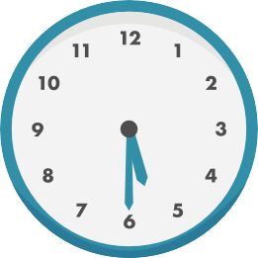  1. | 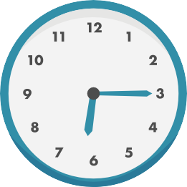  2. | 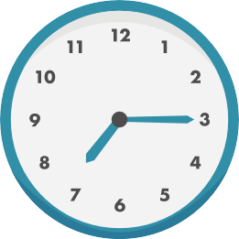  3. | 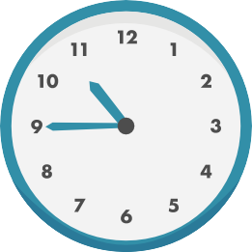  4.
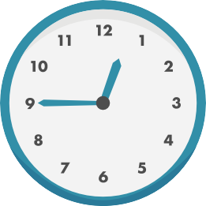  5. | 6. | 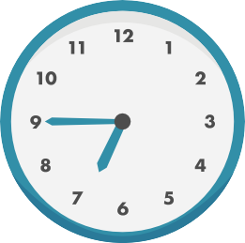  7. | 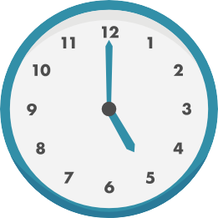  8.

LET’S GO TO THE BOOKSHOP

UNIT 16
37

Fill in the blank with suitable word.
5
Orange juice
drinking
seven
thirty
family

It is five (1) now. Hoa’s family is already awake. The
(2) is at the dining table now. Hoa and her father like eating eggs and bread, and (3) tea for breakfast. Her mother likes eating banh chung and meat, and drinking (4) . They are ready to leave for work at (5) o’clock.
Grade
student
nurse
school
four

My name is Quan. There are (1) people in my
family: my parents, my brother and me. We all do different things. My dad is a primary
- teacher. My mum is a (3) in a hospital. My brother is a (4) of Ha Noi University, and I am in the fourth (5) at my dad’s school. I love my family and I am happy at my school.
6

Put the words below in correct column.

Farmer | Teachers’ Day | Field | thin | nurse | Christmas
Orange juice | school | driver | Women’s Day | young | fish
milk | Chidren’s Day | office | beef | slim | student
tea | factory | chicken | strong | hospital | worker
coffee | pork | water | meat | tall | Tet

Holiday | Drink | Food | Adjective | Place | Job

38 UNIT 16 LET’S GO TO THE BOOKSHOP

HOW MUCH IS THE T-SHIRT?
1
UNIT 17

Complete the words.

1. blo se | 2. umper | 3. j cket | 4. ca
5. c at | 6. san als | 7. s arf | 8. T-shi t
9. nic | 10. s oes | 11. ski t | 12. sli pers
13. m ch | 14. t ousers | 15. jean | 16. soc s
Write the questions with “ How much” and answer.
2
Example: Cap/20,000đ
→ How much is the cap? – It’s twenty thousand dong.
- blue jacket/150,000đ
2. pen/2,500đ
- pink skirt/75,000đ
- those jumpers/300,000đ
- brown shoes/200,000đ
- her sandals/115,000đ
- this T-shirt/63,000đ 8. jeans/210,000đ 9. scarf/48,000đ
10. small blouse/34,000đ

Read and match.
3

1. What colour is the skirt? | 1. | a. It’s one hundred thousand dong.
2. Where does your dad work? | 2. | b. Sorry, I can’t.
3. How much are these socks? | 3. | c. Yes, very much.
4. Why do you want to go to the supermarket? | 4. | d. I’m going to the bookshop.
5. What colour are the jeans? | 5. | e. Thank you.
6. What do you do, Mary? | 6. | f. She’s a cook.
7. What do they want to drink? | 7. | g. It’s pink.
8. How much is your cap? | 8. | h. They’re blue.
9. Why do you want to go to gym? | 9. | i. Because I want to buy something to eat
10. Excuse me. Can I have a look at that cap? | 10. _ | j. They would like some apple juice.
11. Do you like this T-shirt? | 11. _ | k. Because I want to play basketball.
12. Oh, your T-shirt is very nice! | 12. _ | l. Sure. Here you are.
13. What does your mother do? | 13. _ | m. He works in a school.
14. Where are you going, Phong? | 14. _ | n. They’re twenty thousand dong.
15. Let’s go to the zoo, Linda. | 15. _ | o. I’m a student.

HOW MUCH IS THE T-SHIRT?
39
.
UNIT 17

Read and answer the questions.
4
My name is Mai. I am a primary pupil. On hot days at school, I wear a blouse, a short skirt, a red scarf and a pair of sandals. On cold days I wear a jacket over a jumper, a long skirt, a red scarf and a pair of socks and shoes. At home, I wear different things. On hot days, I wear a blouse, a pair of shorts and a pair of slippers. On cold days. I wear a jumper, a pair of trousers and a pair of socks and shoes.
- What does Mai do?
.
- What does she wear on hot days at school?
.
- What does she wear on hot days at home
.
- Does she wear short on cold days at home?
.
- Does she wear jumper on cold days at school?
.
- What colour is her scarf?
.

Fill the words in the blanks.
5
T-shirt clothes pair wears sandals

Nam wears different clothes for schooldays. On hot days, he often (1)
blue cap, a red scarf, a white (2) , a pair of blue shorts and a pair of
- On cold days, he wears a cap, a scarf and a yellow jacket over a brown jumper and a (4) of black shoes. Nam likes hot days because he can wear light (5) to school.

Read the passage again and write tick in the True or False column.
6

 | T | F
- Nam wears a green T-shirt on hot days.
- His shorts are blue.
- He wears a cap on cold days.
- His jacket is blue.
- His shoes are black.

40 UNIT 17 HOW MUCH IS THE T-SHIRT?

WHAT’S YOUR TELEPHONE NUMBER?
UNIT 18

Choose the word which the underlined part is pronounced differently from the others.
1

- A. home  - A. wear | B. hour  B. hear | C. him  C. near | D. hot  D. year
3. A. see | B. sun | C. sure | D. son
4. A. free | B. meet | C. see | D. beer
5. A. how | B. know | C. brown | D. cow
Circle the odd one out.
2

1. A. America | B. English | C. China | D. Japan
2. A. desk | B. table | C. chair | D. subject
3. A. ride | B. science | C. dance | D. sing
4. A. map | B. book | C. big | D. notebook
5. A. Maths | B. music | C. history | D. like

Reorder the words to make sentences.
3
- elephants/because/they/I/bulky./like/are/don’t

- apple juice?/like/some/Would/you

- join/School/the/I’m/going to/Lantern Parade.

- you/Ho Chi Minh city?/When/come/back/did/from

- with my/play football/friends/on Sunday./I often

- my uncle/weekend/my house./Last/stayed at

- T-shirt/wearing/and/He’s/jeans./a

- and mountains/country./in my/a lot of rivers/There are

- usually stay/Do they/by the sea?/in a small house/or flat

- their friends/What do/like to/talk/about?

WHAT’S YOUR TELEPHONE NUMBER?
41
UNIT 18

Choose the right option.
4

- do you want to the post office? – Because I want some stamps.
  - When B. What time C. Why D. Who
- is she wearing? – She’s wearing a pink dress.
  - Where B. What C. Who D. How
- She got brown hair.
  - have B. has C. having D. to have
- are Peter and Mary? – They are at the school party.
  - Who B. What C. Where D. What time
- What are Linda’s shoes? – They are white.
  - clothes B. jeans C. weather D. color
- is the T-shirt over there? – It’s 150.000 dong.
  - Why B. How much C. How D. What
- What are you ? – I am reading.
  - reading B. drawing C. doing D. singing
- They are going to some sports and games.
  - read B. dance C. walk D. play
- do you prefer, badminton or football?
  - Where B. How C. What D. Which
- Where you go last summer? – I went to Nha Trang with my aunt.
  - do B. does C. did D. are
- did you come back from Singapore? – I came back l ast weekend.
  - Who B. When C. How D. Why
- My brother goes in the summer.
  - fishing B. fish C. to fish D. fishes
- I often do my homework the evening.
  - from B. at C. in D. on
- This weekend we are going a picnic with our new friends.
  - from B. for C. of D. with
- Can I have a look at the shirt?
  - I don’t know. B. Sure. Here you are. C. Don’t look. D. Fine, thanks.

42 UNIT 18 WHAT’S YOUR TELEPHONE NUMBER?

Complete the conversation using the expressions in the box.
5
would you like
‘d like
do you like
no, thanks
would you like
I’d like

Waitress: Hello. What (1) to eat?
Hellen: I don’t know.
Waitress: (2) ice cream? Hellen: Yes, of course I do. Chocolate is my favorite. Waitress: Ok, some chocolate ice cream for you.
Mum: And I (3) some fruit.
Waitress: (4) some ice cream with your fruit?
Mum: (5) , but (6) a glass of water.

Read and answer the questions.
6

This is my new friend. Her name is Jane. She is from England. She is a student in Hanoi International School. She likes singing. She can sing very well. In her free time she goes to the music club. She is very friendly.

- Where is Jane from?

- What does she like?

- What does she do in her free time?

- Can she sing well?

- Is she friendly?

WHAT’S YOUR TELEPHONE NUMBER?
43
UNIT 18

WHAT ANIMAL DO YOU WANT TO SEE?
1
UNIT 19
Find the word which the underlined part is pronounced differently from the others.
- A. read B. head C. weather D. ready
- A. watch B. church C. school D. chair
- A. name B. game C. same D. want
- A. face B. grade C. name D. start
- A. shower B. window C. down D. how
2

Odd one out.
- A. an elephant B. a bear C. a giraffe D. crocodiles
- A. thirsty B. thirteen C. fifty D. twenty
- A. hospital B. school C. field D. factory worker
- A. a shirt B. a dress C. trousers D. a skirt
- A. lemonade B. bread C. fried chicken D. noodles
- A. New Year B. moon cake C. Children’s Day D. Tet
- A. carefully B. cheerful C. bulky D. lovely
- A. sunglassess B. A. raincoat C. a camera D. umbrella

Fill in the blanks with the given words.
3
giraffes
market
sporty
zoo
swing
animals
T-shirt
sweets
- Today, Linda is wearing a (1) , jeans and shoes. She looks (2) . Tet is coming soon. She goes to Tet (3) with her mother because she wants some
- and fruit.
- I am Mai. I often go to the (5) with my mother. I like monkeys because they can (6) . My mother likes (7) because they are pretty. We like
(8) very much.
books
fruit
doll
stamps
toys shop

- LiLi and Peter want to do shopping. First, they go to the (1) because LiLi
wants to buy a new (2) . Second, they go to the post office. They want some
(3) . Third, they go to the bookshop. Peter wants some (4) . Finally, they go to the supermarket because they want some (5) .

44 UNIT 19 WHAT ANIMAL DO YOU WANT TO SEE?

Math | tigers | circus | dogs
birds | bananas | monkeys | bike
- My family is at the (1) now. We all like the animals very much. My
brother likes the (2) because they can jump. But I don’t like the tigers, I like the (3) because they can swing and ride a (4) . My sister likes (5) because they can learn (6) . My parents like the
(7) because they can sing. We are very happy together.

Read the passage and then choose the best answer to fill in each blank.
4

There (1) many places near our school: a post office, a supermarket, a
food stall and a bookshop. We go to the (2) to buy stamps and (3)
letters. We go to the (4) to buy books, pens, and (5) . We go to the supermarket to (6) some shopping. Well, I (7) very hungry and I want to eat now. Let’s go to the (8) .
- A. am  - A. supermarket | B. is  B. food stall | C. are  C. bookshop | D. be  D. post office
3. A. buy | B. like | C. send | D. eat
4. A. supermarket | B. food stall | C. bookshop | D. post office
5. A. milk | B. stamps | C. meat | D. pencils
6. A. eat | B. do | C. send | D. buy
7. A. is | B. am | C. are | D. be
8. A. supermarket | B. food stall | C. bookshop | D. post office

Reorder the words to make sentences.
5

- plays/father/after/Her/often/tennis/work/ .

- father/weekends/What/does/do/your/at/?

- mother/a/of/My/bottle/oil/needs/cooking/.

- having/lesson/an/are/They/English/the/moment/at/.

- between/My/is/house/bookshop/a/and/a/cinema/.

WHAT ANIMAL DO YOU WANT TO SEE?
45
UNIT 19

WHAT ARE YOU GOING TO DO THIS SUMMER?
1
UNIT 20
Choose the word which the underlined part is pronounced differently from the others.

1. A. pink | B. mirror | C. skirt | D. thick
2. A. bowl | B. soup | C. sofa | D. no
3. A. badminton | B. lamp | C. blanket | D. snake
4. A. salad | B. plate | C. cake | D. day
5. A. eraser | B. tennis | C. eleven | D. English
2 Circle the odd one out.
1. A. weather | B. sunny | C. rainy | D. cloudy
2. A. fly | B. jump | C. hop | D. dog
3. A. bird | B. spider | C. cake | D. rabbit
4. A. blue | B. pizza | C. purple | D. green
5. A. her | B. you | C. his | D. my
6. A. cat | B. ice cream | C. bread | D. rice
7. A. tree | B. flowers | C. umbrellas | D. clouds
8. A. how | B. What | C. Where | D. now
Choose the correct option.
3
- I hungry. I want an apple.
  - am B. is C. are D. can
- What do want? I want a plum.
  - he B. she C. you D. they
- I want bread ice cream.

A. and | B. a | C. the | D. but
4. I’m thirsty. I want
A. bread | B. orange juice | C. rice | D. fish
- Do you want fish? No, I do . I want meat.
  - no B. and C. fish D. not
- Can you drink ? Yes, I can.
  - milk B. bread C. rice D. chicken
- What’s your favorite color? I like blue. What you?
  - the B. about C. this D. and
- Do you like frogs? , I doT
  - No B. Yes C. Not D. And
- What do you ? I like dogs.
  - want B. do C. like D. wants
- There is a .
  - cats B. bird C. pens D. eraser
46 UNIT 20 WHAT ARE YOU GOING TO DO THIS SUMMER?

Circle the correct answer.
4

- What is his name?

A. My name is Nam  2. Do you want cake? | B. He is Nam | C. It is sunny
A. Yes, I do not | B. No, I don’t | C. I want cake
3. What do you like?
A. I want frogs | B. I likes blue | C. I like rabbits
4. Where is the ruler?
A. It is under the table | B. It on the bag | C. They’re by the table
5. Can you drink milk?
A. Yes, I can | B. Yes, I do | C. No, I do not
6. How is the weather?
A. It sunny | B. It’s cloudy | C. I’m fine

Complete the sentences using “be going to”.
5

- We (have) are going to have a picnic tomorrow.
- He (not watch) TV tonight.
- They (visit) their grandmother.
- She (buy) sun cream.
- Alan (not study) English at school. He (study) French.

Complete the sentences using “be going to”.
6

A | Answer | B
1. I’m tired. | 1. | a. We’re going to buy her a present.
2. She can’t find her purse. | 2. | b. They’re going to live in the countryside.
3. We’ve a lot of homework. | 3. | c. We’re going to start it now.
4. It’s mum’s birthday. | 4. | d. I’m going to put on the light.
5. We’re all hungry. | 5. | e. I’m going to sleep.
6. I haven’t got nice clothes to wear. | 6. | f. Mum’s going to cook a big meal for us.
7. My parents don’t like noisy cities | 7. | g. I’m going to help her look for it.
 |  | h. I’m going to buy some new clothes.

WHAT ARE YOU GOING TO DO THIS SUMMER?
47
UNIT 20

UNIT 1: NICE TO SEE YOU AGAIN UNIT 2: I’M FROM JAPAN

BOOK MAP
UNIT 3: WHAT DAY IS IT TODAY? UNIT 4: WHEN’S YOUR BIRTHDAY? UNIT 5: CAN YOU SWIM?
UNIT 6: WHERE’S YOUR SCHOOL? UNIT 7: WHAT DO YOU LIKE DOING?
UNIT 8: WHAT SUBJECTS DO YOU HAVE TODAY? UNIT 9: WHAT ARE THEY DOING?
UNIT 10: WHERE WERE YOU YESTERDAY? UNIT 11: WHAT TIME IS IT?
UNIT 12: WHAT DOES YOUR FATHER DO? UNIT 13: WOULD YOU LIKE SOME MILK? UNIT 14: WHAT DOES HE LOOK LIKE?
UNIT 15: WHEN’S CHILDREN’S DAY? UNIT 16: LET’S GO TO THE BOOKSHOP UNIT 17: HOW MUCH IS THE T-SHIRT?
UNIT 18: WHAT’S YOUR TELEPHONE NUMBER? UNIT 19: WHAT ANIMAL DO YOU WANT TO SEE?
UNIT 20: WHAT ARE YOU GOING TO DO THIS SUMMER?
____ Page 2
____ Page 3
____ Page 5
____ Page 8
____ Page 10
____ Page 12
____ Page 14
____ Page 16
____ Page 18
____ Page 20
____ Page 23
____ Page 25
____ Page 28
____ Page 31
____ Page 33
____ Page 36
____ Page 39
____ Page 41
____ Page 44
____ Page 46

